
WHO ARE THE MASTER GARDENERS?

Master Gardeners are volunteers. They are people like you
from all walks of life who have an interest in gardening,
a willingness to learn and a desire to help others solve University of Arkansas
their gardening problems. Cooperative Extension Service

Master Gardeners are trained by the University of Arkansas
and Cooperative Extension Service faculty, experienced Master Gardeners and other experts. They must complete 40 hours of basic horticulture training. After training, MG’s are qualified to work under the supervision of the local county Extension Agent as a Master Gardener. New MG’s are required to volunteer a minimum of 40 hours of working time to the county Cooperative Extension Service and Master Gardener program during the year after training. They must also gain 20 hours of learning or education. In each subsequent year they must gain 20 hours of work time and 20 hours of learning time.

What do Master Gardeners do?
Master Gardeners have worked on beautification projects for city and county buildings; developed demonstration flower, vegetable and herb gardens; and worked with gardening projects at elementary and high schools and gardening projects at local nursing homes. They present seminars and plant fairs for the public. Answering telephone requests for gardening information and staffing plant clinics are common tasks. There are also many educational opportunities throughout the year – seminars, tours, conventions – that are fun Master Gardener events all over the state.

What does “Master Gardener” mean?

The title Master Gardener is used by persons who have successfully completed the Arkansas Master Gardener Program. The title is valid only when the volunteer is participating in the Arkansas Master Gardener Program. When you cease active participation, your designation as Master Gardener
becomes void.

Application

Request form

Be a part of the Arkansas Master Gardener Program. Not only will you receive comprehensive training and gain valuable insight, you will enjoy the satisfaction that comes from helping others.

Master Gardener training sessions for ___________ County are scheduled in __________. To request an application, fill out the form below and mail or bring to the __________ ______County Extension Office,
___________________________(Mailing Address)
__________________________________(City, Zip)
For more information call _____________(Ext. #)

Name______________________________________

___________________________________________

Address____________________________________

Telephone__________________________________

Email______________________________________

Master Gardener

Opportunities . . .

- Education
- Gardening
- Community Projects
- Volunteerism
- Social Activities
- Travel Opportunities
- Workshops
- Fellowship With Other Gardeners

Application Request Inside

The Arkansas Cooperative Extension Service offers its programs to all eligible persons regardless of race, color, sex, gender identity, sexual orientation, national origin, religion, age, disability, marital or veteran status, genetic information, or any other legally protected status, and
is an Affirmative Action/Equal Opportunity Employer.

Are you
Interested in
Joining the

MASTER
GARDENER
PROGRAM?

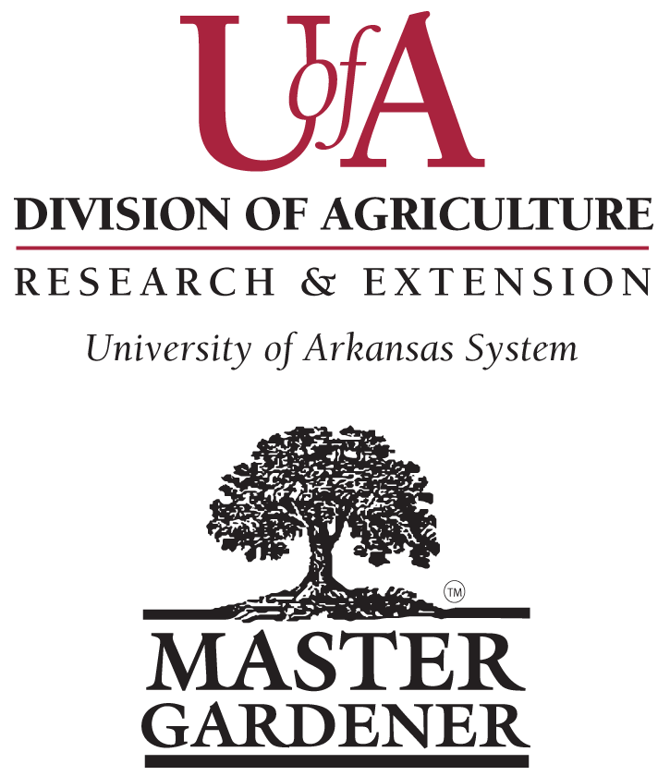

University of Arkansas, United States

Department of Agriculture, and

County Governments Cooperating

