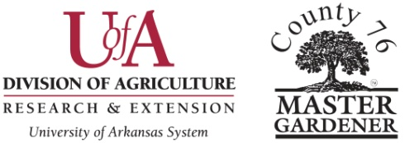

**Advanced Training – Level V**

Criteria

The requirements for attaining Level V of Advanced Training are to have completed one hundred and fifty (150) hours of Advanced Training Courses and create a project of his/her choosing from the list below. The project must be educational in nature and make a significant contribution to a local community, school or Master Gardener (MG) Program. The project must be on a pre-approved horticulture topic.

The candidate for Level V will submit a proposed topic to the County 76 Training Project Chairperson and State Master Gardener Coordinator. The Advanced Training Project Chairperson will submit the topic for approval to the members of the Advanced Training Project and will notify the candidate of the group’s decision. The project may be done anytime after completing Level IV. Possible projects can be from the following categories.

Possible Service Projects

~Provide support to counties with small Master Gardener groups as they need or request help. For example, support could be assistance with monthly meetings, such as arranging speakers, or giving advice about implementing a successful project, but would not be limited to these.

~Establish and mentor a community-based hands-on project in a public sustainable garden with a life of at least one year. The garden should be instructive with appropriate plant labels. This project would involve working with community residents who are not Master Gardeners.

~Develop and document an educational project for the public. This could be a specific educational seminar or a series of workshops such as pruning techniques with demonstrations of various types of plants, raised bed gardening, vegetable gardening, etc.

~Teach a serious of lessons as part of a school curriculum and integrate it with a horticulture or garden topic. It could be during the school day or an after-school hours project. Topics such as butterflies or pollinator gardens, environmental issues or other subjects interesting to students could be taught. The lessons should be part of the school’s curriculum, and the objective would be to further student interest in gardening or to further student awareness of environmental issues.

~Chair or co-chair an Advanced Training Class in your county or in cooperation with another county.

An outline of what the candidate proposes should be sent to the County 76 Advanced Training Project Chairperson and to the State Master Gardener Advanced Coordinator who will set up a review process which would approve the proposed project and evaluate the project upon completion. The approved project would be peer reviewed by a committee of two Master Gardeners who have attained at least Level III, IV, or V Advanced Training status, two members of the County 76 Advanced Training Project and the County 76 President or County 76 Vice President.

Upon completion of the project, the candidate will submit documentation of the project to the County 76 Advanced Training Project Chairperson and to the State Master Gardener Training Coordinator. Documentation will include a written description and summary or power point of the project by the candidate which includes three (3) reliable resources such as books or website.

Upon the recommendation of the peer review team, an Advanced Training Level V project will be approved, and Advanced Master Gardener Level V will be awarded by County 76.

When awarded Advanced Master Gardener Level V, the Master Gardener may present his or her project at a County 76 meeting or PNG (Plant Nurture Grow) MG Leadership Conference.

__________________________ is a Master Gardener in good standing in

__________________________ County.

He/she has completed the above requirement as follows:

_______________________________

Cooperative Extension Agent Signature