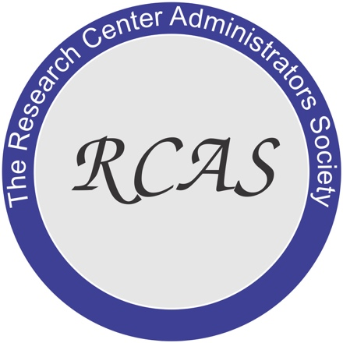
Media contact: Don Hubbell
RCAS Awards Committee chair
870-793-7432
dhubbell@uark.edu
Feb. 19, 2021

(275 words)
Arkansas station director honored with Distinguished Service Award
(Newsrooms: with downloadable art here: https://flic.kr/p/2kz1Sry )

FAYETTEVILLE, Ark. – The Research Center Administrators Society has bestowed its 2021 Distinguished Service Awards to Vaughn Skinner, resident director of the Milo J. Shult Research and Extension Center in Arkansas.

Don Hubbell, awards committee chairman and director of the Livestock and Forestry Research Station in Arkansas, presented the award to Skinner during the society’s annual conference Jan. 29, held virtually for the first time. Research center directors from 30 states were able to attend this first RCAS virtual winter meeting.

This is the second straight year an Arkansas center director has won. Larry Earnest at Rohwer Research Station earned the award in 2020.

Hubbell said Vaughn is the RCAS communications officer and as part of that job, Vaughn maintains the website, Facebook page, meeting records and distributes to applicable sites and platforms. During his multi-year tenure as communications officer, he built the Facebook page and revamped the website to make it more user-friendly and accessible. He is also getting all of the historical records for the Society scanned and stored for easy access nationally.

“The Research Center Administrators Society has been an excellent group to associate with, in the years I have been a member,” Vaughn said. “I am very honored to receive this award from the RCAS, an organization that has greatly helped my professional development as a Research and Extension Center director.

“This organization continues to provide information and ideas that are such a benefit to our station by improving the service we provide to our faculty, staff and students,” he said.

Nathan McKinney, assistant director of the Arkansas Agricultural Experiment Station, noted Skinners’ “broad and growing skillset. He is a role model for professional development and this award is a nice recognition of his accomplishments and dedication.”

About RCAS
The Research Center Administrators Society is a national non-profit organization whose membership is comprised of agricultural research station managers, directors, university, college and USDA administrators.

To learn more about RCAS, visit http://www.thercas.org/.

The society mission is to advance the acquisition and dissemination of scientific knowledge concerning the nature, use, improvement, and interrelationships of research center administration scientific research, and new technology.

# # #

