

**COVID-19 Impacts on Arkansas’ Agricultural and Rural Economies**

**UPDATE:**

***Cattle on Feed* Update**

**Prepared by:**

**John Anderson**

**Department of Agricultural Economics and Agribusiness**

**August 24, 2020**

USDA National Agricultural Statistics Service released the August *Cattle on Feed* (*COF*) inventory report on Friday afternoon last week. Key numbers in the report are summarized in table 1.

**Table 1.** *Cattle on Feed* Inventory Summary: August Report

|  |  |  |  |
| --- | --- | --- | --- |
|  | 1,000 head | percent of 2019 | Pre-Report Estimate* |
| On Feed July 1 | 11,438 |  |  |
| Placements in June | 1,893 | 111.0 | 106.7 |
| Marketings in June | 1,990 | 99.4 | 98.9 |
| On Feed August 1 | 11,284 | 101.5 | 101.0 |
| *Source: Livestock Marketing Information Center. | |  |  |

The most significant figure in this month’s report was the placements figure. At 1.893 million head, July placements were considerably higher than anybody’s pre-report expectations. This is the highest July placements figure since 2011, and it can likely be attributed to a couple of things. First, it suggests that feedlots are trying to refill their pens from the gap in placements that occurred earlier this spring. As has been noted in previous updates, due to COVID-related disruptions, feedlots have had relatively large inventories of cattle with a relatively long time on feed. With a total on-feed inventory at, or even below, the prior year’s level, this suggests a relatively small inventory of newer placements, consistent with the huge drop in placements in the February-to-April timeframe. This big July placement figure will help feedlots fill in that gap.

Second, the July placement figure suggests that dry conditions, which expanded around the country in July, may have forced more cattle off of pasture and into feedlots. July is typically at or near the seasonal low in placements. However, dry summer weather can significantly influence placement decisions by affecting forage availability. Dry conditions became considerably more widespread across the Southeast and Midwest over the past month.

Marketings in July were about even with the prior year. With feedlots at least keeping pace with year-ago marketings, the backlog in fed cattle that built up during the disastrous April and May experience has been reduced considerably. The calculated number of cattle on feed for more than 120 days as of August 1 is, based on last week’s report, about 9 percent higher than a year ago. That is down from 23 percent higher than a year ago on June 1. If progress in August has come close to matching July, the backlog of fed cattle that resulted from COVID disruptions should by now be just about taken care of. That should be good news for the cattle market heading into fall.

Data Source: USDA National Agricultural Statistics Service

1. Placements
2. On-feed Inventory

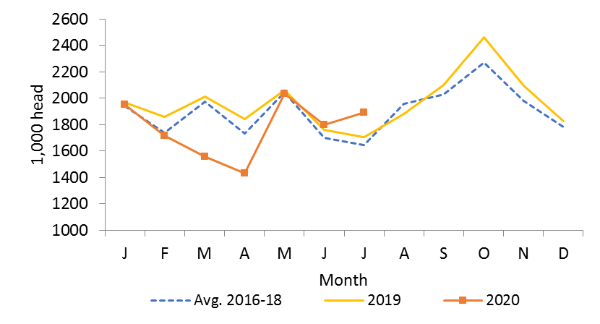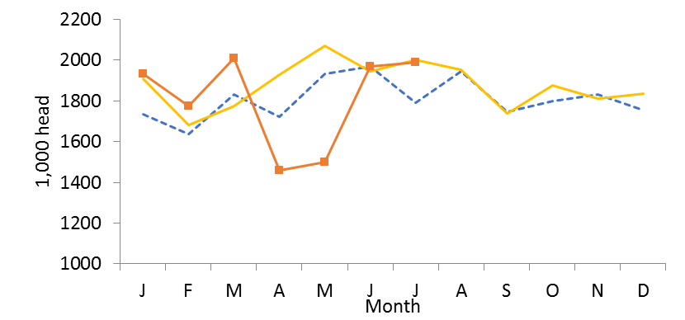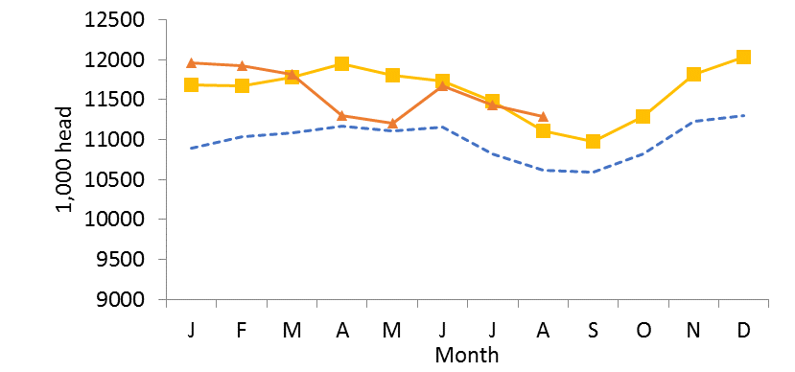

1. Marketings

**Figure 1a-c.** Cattle on Feed Inventory, Monthly Marketings, and Monthly Placements

The University of Arkansas System Division of Agriculture offers all its Extension and Research programs and services without regard to race, color, sex, gender identity, sexual orientation, national origin, religion, age, disability, marital or veteran status, genetic information, or any other legally protected status, and is an Affirmative Action/Equal Opportunity Employer.