

**COVID-19 Impacts on Arkansas’ Agricultural and Rural Economies**

**UPDATE: Retail Meat Prices and Farm-to-Wholesale Price Spreads**

**Prepared by:**

**John Anderson**

**Department of Agricultural Economics and Agribusiness**

**August 13, 2020**

***Retail Meat Prices***

On August 12, USDA Economic Research Service (ERS) released their monthly update of retail beef, pork, and chicken prices. The average retail price for all three of the major species dropped fairly sharply in July. Significant month-to-month declines in retail meat prices are unusual; but, of course, these are unusual times. Retail meat prices had climbed rapidly in May and June, largely reflecting the temporary product shortages due to COVID-related processing plant disruptions. These disruptions resulted in record high wholesale prices which, in turn, fueled sharp increases in retail prices. Figure 1a-c show monthly retail beef, pork, and chicken prices.

In percentage terms, the biggest increase in retail prices in the April-June period was in beef prices. June beef prices were almost 27 percent higher than the 2019 average retail price. June retail prices of pork and chicken were both around 10 percent higher than in 2019. While retail prices retreated substantially from June to July, they remain historically quite high. July retail beef, pork, and chicken prices were still 13.6 percent, 8.2 percent, and 8.0 percent higher, respectively, than they were in February, before COVID-related impacts began to significantly affect the retail meat market.

Looking ahead, it is likely that retail meat prices will continue to decline for another month or so. Processing plant volumes have largely returned to pre-COVID levels. In fact, weekly pork processing volumes have approached 10 percent higher than year-ago levels in most weeks since the end of June. Beef processing volumes have generally been within a percent or two of year-ago levels over that time period. This may not be as fast of a pace as the industry would like in order to work through the backlog of market-ready cattle. It is quite an accomplishment under the circumstances, though; and it has been sufficient to return wholesale beef prices to pre-COVID levels. Somewhat surprisingly, chicken processing remains the furthest from attaining prior-year volumes. The weekly chicken processing volume hasn’t matched the prior year level since early April. In most weeks since the end of June, chicken processing has been three or four percentage points lower than the prior year. This chronic slowdown in production may limit further declines in retail chicken prices over the next couple of months, though competitive pressure from beef and pork may still be sufficient to result in further price declines.

***Farm-to-Wholesale Beef Price Spreads***

The monthly ERS retail meat price update includes information about the spread between prices at various levels of the meat industry: that is, the differences between farm, wholesale, and retail meat prices. This relates to the subject of beef packer margins, which has been a subject of intense interest since last August, when a fire at a Tyson Fresh Meats beef processing facility in Holcomb, Kansas, disrupted markets and contributed to a historically wide spread between farm (i.e., fed cattle) and wholesale (i.e., boxed beef) prices in that sector. Of course, the Holcomb plant fire – significant as it was – pales in comparison to the disruption resulting from COVID-19. COVID-related disruptions led to considerably wider farm-to-wholesale price spreads in the beef sector than were observed in the wake of the Holcomb fire. Figure 2 shows monthly average farm-to-wholesale price spreads for beef and pork from January 2018 through July 2020. Note that there essentially is no farm price for chicken, given the integrated structure of that market, so the farm-to-retail spread is irrelevant for that sector.

c. Chicken

b. Pork

a. Beef, all fresh

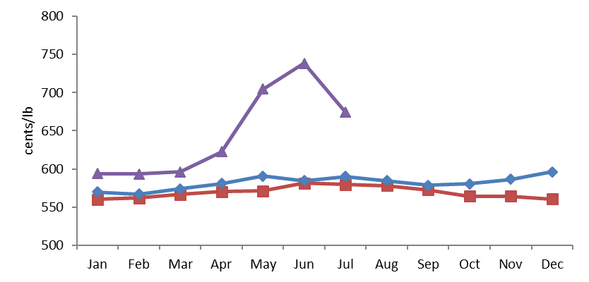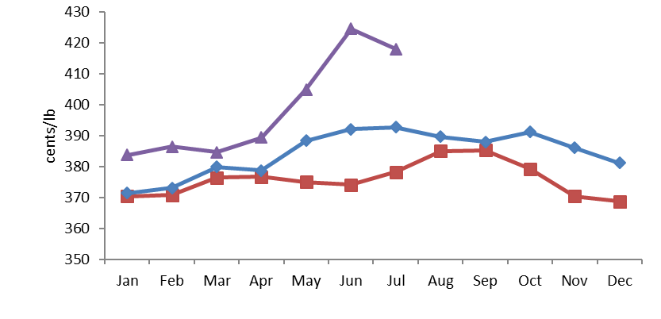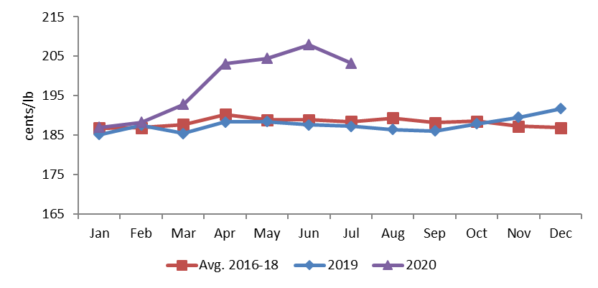

Notes: the all fresh beef price includes prices for all quality grades of fresh beef.

Data Source: UDA Economic Research Service

**Figure 1.** Monthly Average Retail Beef, Pork, and Chicken Prices

Data Source: USDA Economic Research Service.

**Figure 2.** Farm-to-Wholesale Price Spread for Beef and Pork: January 2018-July 2020

A significant point should be made any time price spreads are discussed: a price spread is not the same thing as a profit margin. It is not even the same thing as a gross margin, which would include information about quantity as well as price (e.g., the weight of fed cattle and the quantity of boxed beef and by-products obtained from a carcass). Moreover, the price spread incorporates nothing about cost of production. All of a processing plants operating expenses, and any positive net return, must be taken from the gross margin implied by the spread between farm and wholesale prices. Thus, processing plant profit could actually decline as the price spread increases if, for example, operating costs increase by more than the gross revenue associated with the increase in the spread.

Recognizing that price spreads and profits are not the same thing, they are likely rather closely correlated. For example, if the Holcomb fire did not affect processing costs generally across the sector, then the increase in the farm-to-wholesale spread in August-November (see figure 2) would have been associated with higher processing sector profits. With respect to COVID-related disruptions, the picture – while far more dramatic – may actually be less clear. Without a doubt, the processing sector incurred substantially higher costs of production as a direct result of COVID-related problems: increased bonus/overtime pay, plant modifications to accommodate more physical separation, increased cleaning/sanitizing costs, etc. Did costs go up enough to eat up a 389.5 cent/pound farm-to-wholesale price spread in May? That seems highly unlikely; but the point remains that processing sector profits don’t necessarily map cleanly onto farm-to-wholesale price spreads.

From the cattle industry perspective, concern over wider farm-to-wholesale price spreads relates to market power. In simple terms, the argument is that if the processing sector were more competitive, higher profits to the processing sector associated with higher wholesale beef prices would more readily be bid into higher fed cattle prices, thus keeping the price spread from exploding (e.g., see May 2020 in figure 2). Given the highly concentrated nature of the meat processing sector, this argument has to be taken seriously: few industries are as concentrated as this one. However, this argument is far from decisive: the exercise of market power is not the only thing that could result in a widening farm-to-wholesale spread. Price dynamics can be complicated, particularly in the face of dramatic and unforeseen simultaneous shifts in supply and demand, as clearly occurred in the pandemic. In May, real capacity constraints stemming from COVID-related disruptions reduced processors’ ability to take cattle and also greatly constrained wholesale beef availability at a time when demand was strong, with retailers attempting to replenish stocks. The fact that the farm-to-wholesale price spread retreated sharply when processing sector constraints relaxed and retailer purchasing behavior returned to normal supports the validity of something like this supply/demand fundamental explanation of the event.

This is not to say that market power could not have played a role in the price behavior observed during the pandemic but rather to illustrate that the price behavior alone does not constitute proof of non-competitive behavior. This is essentially the point that the USDA Agricultural Marketing Service (AMS) makes in a [recently-released report](https://www.ams.usda.gov/sites/default/files/media/CattleandBeefPriceMarginReport.pdf) on their investigation into price behavior in the aftermath of the Holcomb fire as well as during the COVID-19 shutdowns. This is an important and complicated and highly contentious subject. A number of proposals for direct policy intervention into cattle pricing practices are currently being discussed. Such proposals are motivated by a legitimate desire to improve farm-level outcomes in what is undeniably a highly-concentrated industry. Unfortunately, such proposals also carry the risk of unforeseen consequences that could include significant adverse impacts on the competitive position of the industry. As economists have been known to say, there is no such thing as a free lunch.

The University of Arkansas System Division of Agriculture offers all its Extension and Research programs and services without regard to race, color, sex, gender identity, sexual orientation, national origin, religion, age, disability, marital or veteran status, genetic information, or any other legally protected status, and is an Affirmative Action/Equal Opportunity Employer.