

**COVID-19 Impacts on Arkansas’ Agricultural and Rural Economies**

**UPDATE:**

***Cattle on Feed* Update**

**Prepared by:**

**John Anderson**

**Department of Agricultural Economics and Agribusiness**

**July 24, 2020**

USDA National Agricultural Statistics Service (NASS) released the latest *Cattle on Feed* (*COF*) inventory report on Friday afternoon. Key numbers in the report are summarized in table 1.

**Table 1.** *Cattle on Feed* Inventory Summary: July Report

|  |  |  |  |
| --- | --- | --- | --- |
|  | 1,000 head | % of 2019 | Pre-Report Estimate* |
| On Feed June 1 | 11,671 |  |  |
| Placements in June | 1,798 | 102.1 | 104.9 |
| Marketings in June | 1,969 | 101.3 | 100.7 |
| On Feed July 1 | 11,438 | 99.6 | 100.2 |
| *Source: Livestock Marketing Information Center. | |  |  |

This month’s report may be thought of as a return to something like normalcy in terms of feedlot inventories and operation. On balance, the July 1 on-feed inventory is about even with last year’s figure (figure 1a). Overall, after dropping sharply in April and May due to a sharp slow-down in placements, the total on-feed inventory has returned to a fairly normal seasonal pattern at a level close to the previous year. Front-end inventories (i.e., cattle that have been on feed for long enough to be considered essentially market ready) remain large. The number of cattle on feed for 120 days or more dropped in June as marketings rebounded, but they remain almost 20% larger than they were a year ago.

Marketings were up a bit from a year ago but were sharply higher than the past two months (figure 1b). With slaughter levels returning to about even with last year’s pace, feedlots were able to get back to a normal pace of marketings as well.

The biggest discrepancy from a year ago was in the placements figure, and that was a relatively small year-over-year deviation at that (figure 1c). For what it’s worth, COVID seemed to have had little to do with placements in June. The bigger factor was that deteriorating pasture conditions due to a widening western drought were pushing cattle off of rangeland and pasture and into feedlots. This effect was smaller than many pre-report analysts anticipated, as the figures in table 1 suggest.

Data Source: USDA National Agricultural Statistics Service

1. Placements
2. Marketings
3. On-feed Inventory

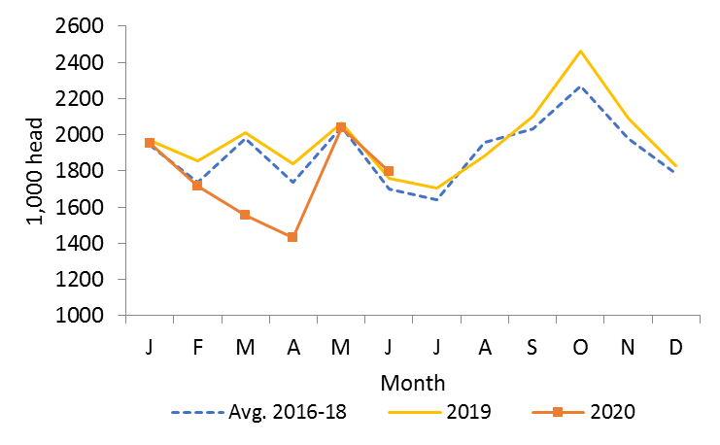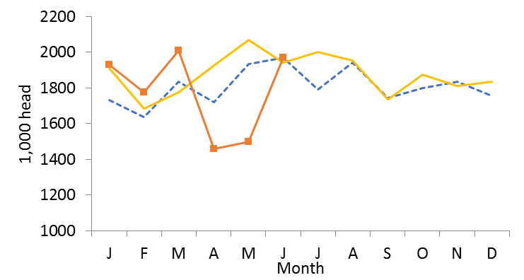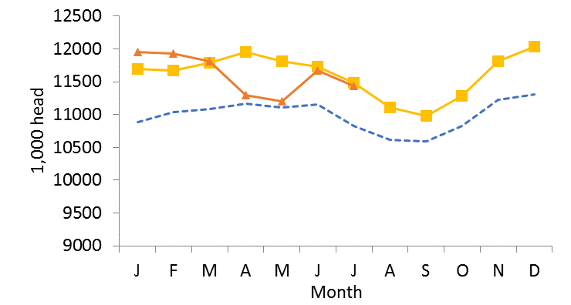

**Figure 1a-c.** Cattle on Feed Inventory, Monthly Marketings, and Monthly Placements

USDA National Agricultural Statistics Service also released the July 1 *Cattle* inventory report on Friday. This mid-year update of cattle inventories is not generally as highly-anticipated as the January inventory report, which is considerably more comprehensive in that it includes state-level inventory figures. This year’s mid-year inventory report is potentially of interest for providing on early read on COVID impacts on cattle numbers. Going into the year, the beef industry was in the contraction phase of the normal cattle cycle. That likely has not changed. Indeed, the July 1 beef cow inventory was down by almost 1% from a year ago.

It may well be, though, that COVID slowed the pace of contraction by making it more difficult to get cows slaughtered. Similarly, the number of heifers reported in inventory for beef replacement was even with last year. This represents a smaller decline in beef replacement heifers from January to July than has been the case in the last three or four years. It may be that uncertainty in the feeding sector that massively disrupted placements encouraged producers to hold onto a few more heifers than they otherwise would have, at least temporarily. It seems unlikely, based on 2020 price signals, that cattle producers would be all that interested in shifting back into expansion mode yet.

The University of Arkansas System Division of Agriculture offers all its Extension and Research programs and services without regard to race, color, sex, gender identity, sexual orientation, national origin, religion, age, disability, marital or veteran status, genetic information, or any other legally protected status, and is an Affirmative Action/Equal Opportunity Employer.