COVID-19 Impacts on Arkansas’ Agricultural and Rural Economies

UPDATE:
The COVID-19 Pandemic Affects Unemployment in Arkansas Counties Differently

Prepared by:

Wayne Miller
Department of Agricultural Economics and Agribusiness

June 4, 2020

The COVID-19 Pandemic Affects Unemployment in Arkansas Counties Differently
While the April 2020 unemployment rate for Arkansas was 10.2 percent, which was less than the national average of 14.7 percent, the unemployment rate varied greatly among counties in the state and underestimated the number of people without work. Also, the number of unemployed grew faster in Urban counties resulting in a somewhat higher average unemployment rate in Urban (10.8 percent) compared to Rural (10.0 percent) counties of the state. Historically unemployment rates have been higher in Rural counties.
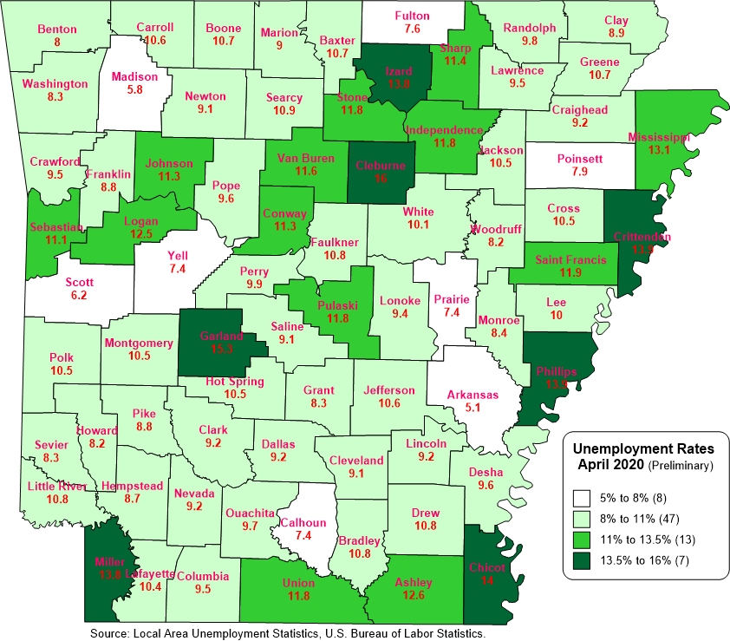
There were vast differences in unemployment rates among both Rural and Urban counties in the state. In Rural counties, the unemployment rate varied from a little more than 5 percent in Arkansas County to 16 percent in Cleburne County (Figure 1). One possible reason for the high unemployment rate in Cleburne County is that the county economy relies heavily on the travel and tourism industry, which has been affected by the travel restrictions related to COVID-19. Other rural counties with high unemployment rates approaching 14 percent are Chicot, Phillips and Izard counties. Although their unemployment rates increased between March and April of this year, these three counties had much higher unemployment rates than the statewide average even before the start of the COVID-19 pandemic.
Figure 1. Unemployment Rates April 2020
The unemployment rate in Urban counties ranged from a low of 8 percent in Benton County to a little more than 15 percent in Garland County. One explanation for the high unemployment rate in many Urban counties, especially Garland County, is that the county is heavily dependent on the travel and tourism industry, which was greatly impacted by the travel restrictions due to COVID-19. Crittenden and Miller are two other Urban counties, that also had high unemployment rates approaching 14 percent.
April 2020 has been the first time the average unemployment rate in Urban counties has been higher than the average for Rural counties for at least ten years.
The unemployment rate in Arkansas increased from 5.0 percent in March to 10.2 percent in April as a result of an increase in approximately 67,600 newly unemployed workers. As shown in Figure 2, Urban counties experienced the sharpest increase in the number of unemployed workers, accounting for 70 percent of newly unemployed workers.

Source: Local Area Unemployment Statistics, U.S. Bureau of Labor Statistics.
Figure 2. Unemployment by Urban and Rural Counties in Arkansas

However, unemployment rates do not provide a true picture of the increase in workers without employment during the COVID-19 pandemic. Unemployment rates are calculated as the percent of people in the labor force that are unemployed. However, between March and April of 2020, many workers dropped out of the labor force and so were not included in the unemployment count (Figure 3). Many workers may have dropped out of the labor force as a result of the COVID-19 pandemic and others may not have been included in the labor force count if they lost their job, but their unemployment insurance claim has not yet been processed. In Arkansas the labor force declined by a little over 67,000 workers, or about 5 percent of the labor force, between March and April of this year.

Source: Local Area Unemployment Statistics, U.S. Bureau of Labor Statistics.
Figure 3. Labor Force in Rural and Urban Counties of Arkansas
Rural and Urban counties alike saw declines in their labor force, declining a little over 5% in Rural counties and slightly less in Urban counties (4.7 percent). Since there is a larger labor force in Urban counties, it is not surprising that nearly 41,000 of the 67,000 workers no longer counted in the labor force are in Urban counties.
Increase in Workers not Employed
If we include those who dropped out of the labor force between March and April as part of the labor force and include them in the unemployment count, we get a somewhat different picture of unemployment in Arkansas. The Arkansas “adjusted” unemployment rate jumps from 10.2 percent to 14.6 percent in April 2020 and the difference between Urban and Rural counties is smaller, with Rural counties having a slightly higher average unemployment rate (14.8 percent) than Urban counties (14.5 percent).
There is also a smaller range between the lowest and highest unemployment rates, ranging from a low of 12.6 percent in Carroll County to a high of 19.5 percent in Garland County (Figure 4).
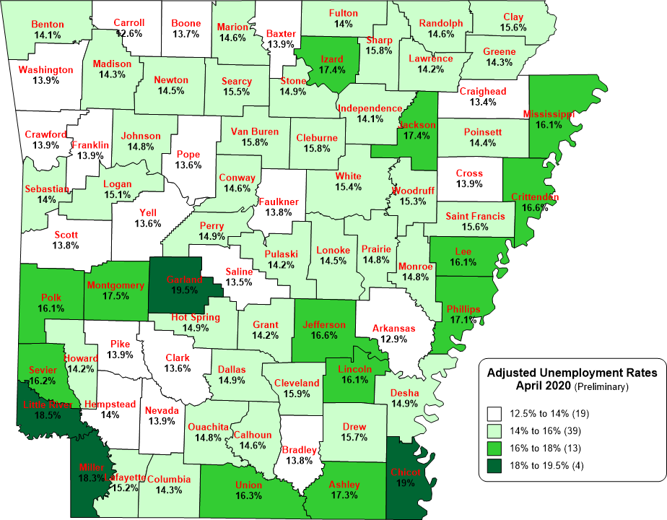
Source: Local Area Unemployment Statistics: U.S. Bureau of Labor Statistics.
Figure 4. Adjusted Unemployment Rates April 2020
While these are only preliminary numbers, they provide us with an estimate of the effect of the COVID-19 pandemic on the number of workers without employment as of the middle of April 2020.

For a classification of Rural and Urban counties in Arkansas, see our publication, Rural Profile of Arkansas 2019 at www.uaex.edu/ruralprofile/. The University of Arkansas System Division of Agriculture offers all its Extension and Research programs to all eligible persons without regard to race, color, sex, gender identity, sexual orientation, national origin, religion, age, disability, marital or veteran status, genetic information, or any other legally protected status, and is an Affirmative Action/Equal Opportunity Employer.

