COVID-19 Impacts on Arkansas’ Agricultural and Rural Economies

UPDATE:
Bureau of Economic Analysis Gross Domestic Product and Personal Income and Outlays Reports

Prepared by:

John Anderson
Department of Agricultural Economics and Agribusiness

May 29, 2020

Last week, the U.S. Department of Commerce Bureau of Economic Analysis (BEA) released a couple of key reports for assessing the impact of COVID-19 on the economy.
First, on Thursday, BEA released its second estimate of first quarter (Q1) gross domestic product (GDP). BEA releases a preliminary estimate of GDP in the month following the close of the quarter. Their second estimate in the following month is a refinement based on more complete data. This second estimate shows a 5% drop in first quarter GDP. This is a relatively sharp quarter-to-quarter swing, as figure 1 shows.
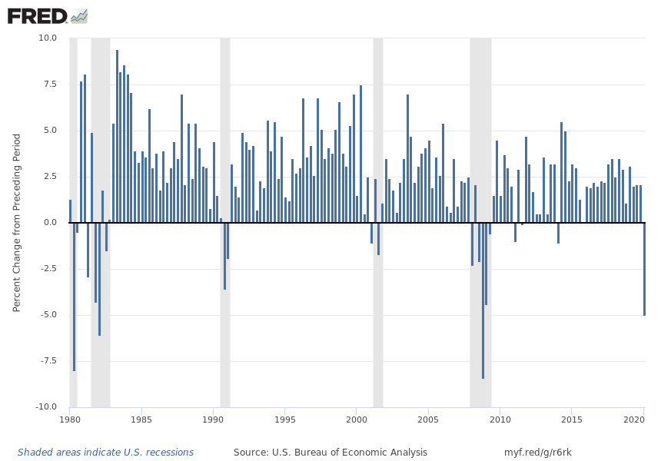
Data Source: US Bureau of Economic Analysis through Federal Reserve Economic Data (FRED), St. Louis Federal Reserve Bank
Figure 1. Real Gross Domestic Product: Quarterly, Period-to-Period Percentage Change, 1980.I – 2020.I
Clearly, the quarterly swing was a large one: the third largest quarter-to-quarter drop in the past forty years. It is worth noting that the major impacts of COVID-19 didn’t start until well into March – almost the end of the quarter. Two months through the second quarter, the economy is still operating far below capacity. Next quarter’s drop will likewise be substantial and will, no doubt, confirm the sharp recession that will have begun in Q1 2020.
This is, to be sure, a rather unique recession – at least in the post-war era – if only for its unique trigger. But the economic data accompanying this recession is also shaping up to be quite interesting. This brings us to the second BEA report released last week: Personal Income and Outlays for April. Perhaps the most notable item in this report was personal income for April. With the economy clearly operating deep in recession territory (see previous), personal income posted a gain of 10.5% in April compared to March. What could account for this surge in income in such a down economy? Lots and lots of government relief money. Other sources of income were mostly lower, not surprisingly. For example, wage and salary income was down by a bit more than 8%. Proprietors’ income was down by around 12%. This was more than offset, though, by a 91% increase in the category of government social benefits to persons. Big gains in transfers came from unemployment insurance and what BEA calls “Other,” which in April would have included a considerable chunk of funds going out under the Coronavirus Aid Relief and Economic Security (CARES) Act.
Most of that relief money was hitting the bank accounts of people stuck in their homes. Personal consumption expenditures did not, consequently, follow personal income higher. In fact, personal consumption expenditures fell by 13.6% in April. Following a big jump in March when we all became preppers, real personal consumption expenditures on food fell by 17.2% in April. Note that this only includes food for at-home consumption; it does not reflect the sharp slowdown in restaurant trade. That is embedded in the “Services” category of spending, which fell by another 12% in April following a 9.3% decline in March.
If personal income was up substantially in April and person consumption expenditures were sharply lower, where did all the money go? Somewhat uncharacteristically for American consumers, it went into savings. In April, Americans saved, in the aggregate, a little over $6.1 billion – almost triple the $2.1 billion saved in March. To be fair, savings in March were actually pretty high, as by then we could all see the mess on the horizon. A better comparison is probably to the average monthly saving from 2019: $1.3 billion, less than a quarter of April’s figure.
Typically, in national accounts, savings is discussed as a percent of personal disposable income: the personal saving rate. With income up and outlays down in April, the personal saving rate hit a record 33%. To appreciate how exceptional that figure is, compare April to the last sixty years.
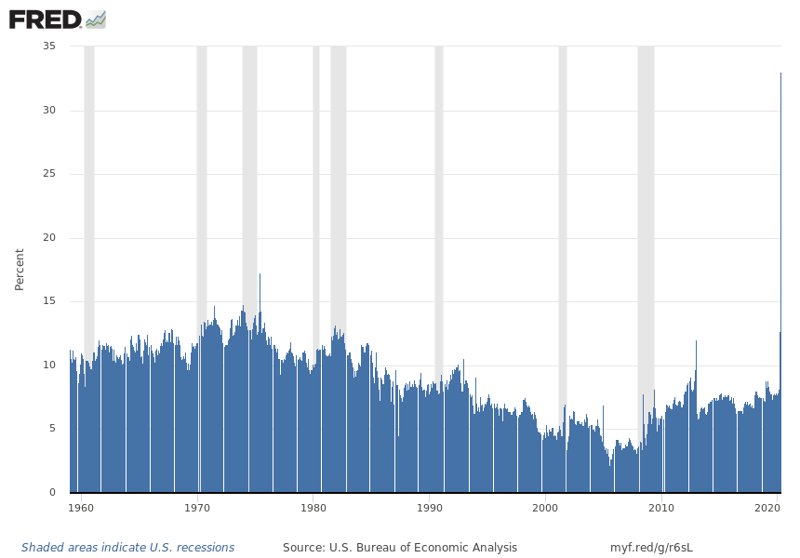
April 2020: 33% personal saving rate
Data Source: US Bureau of Economic Analysis through Federal Reserve Economic Data (FRED), St. Louis Federal Reserve Bank
Figure 2. Personal Saving Rate: January 1960 – April 2020
Why is this significant? Well, it suggests that the liquidity to fuel an economic recovery is in place in the bank accounts, mattresses, and coffee cans of the American public. As activity returns to normal, whenever that may be, the funds to support a return to normal spending have been laid in. This doesn’t mean that the V-shaped recovery, for which we all fervently hope, is a done-deal. COVID-19 will still have something to say about that. A resurgence of cases, or of long plateau that drags on for months, would continue to hamper both supply and demand. However, as consumers decide that the time for a return to normal has come, the currency to support it seems to be on hand.

The University of Arkansas System Division of Agriculture offers all its Extension and Research programs to all eligible persons without regard to race, color, sex, gender identity, sexual orientation, national origin, religion, age, disability, marital or veteran status, genetic information, or any other legally protected status, and is an Affirmative Action/Equal Opportunity Employer.

