

**COVID-19 Impacts on Arkansas’ Agricultural and Rural Economies**

**UPDATE: Beef, Pork, and Poultry Production**

**Prepared by:**

**John Anderson**

**Department of Agricultural Economics and Agribusiness**

**April 17, 2020**

Meat and poultry production appear to be slowing markedly in response to COVID-19. The shutdown of various processing facilities, including a number of large-scale hog and cattle slaughter facilities, has been widely noted in the last couple of weeks. This is undoubtedly one factor in the reduction in production; however, it is not the only factor. Plants that have continued operations are implementing practices and procedures to reduce the likelihood of coronavirus spread among workers. Many of these interventions may have the effect of reducing the efficiency of operations. Finally, plants are almost certainly slowing down in response to reduced demand as the virtually complete shutdown in food service operations continues to impact the market.

Weekly beef and pork production have dropped sharply for the past two weeks. Figure 1a-1b shows weekly beef and pork production in million pounds for the period from 2017 through 2020 (year-to-date). Production for both species has dropped sharply for the past three weeks. This is especially true for beef. For the week ending April 18, preliminary data suggests that beef production was almost 20 percent lower than the prior year. Pork production for the same period was down 6 percent year-over-year. Even allowing for a bit of slowdown on the Monday following Easter these are substantial declines in production.

**Figure 1b.** Weekly Federally Inspected Pork Production

**Figure 1a.** Weekly Federally Inspected Beef Production

Data Source: USDA Agricultural Marketing Service through Livestock Marketing Information Center.

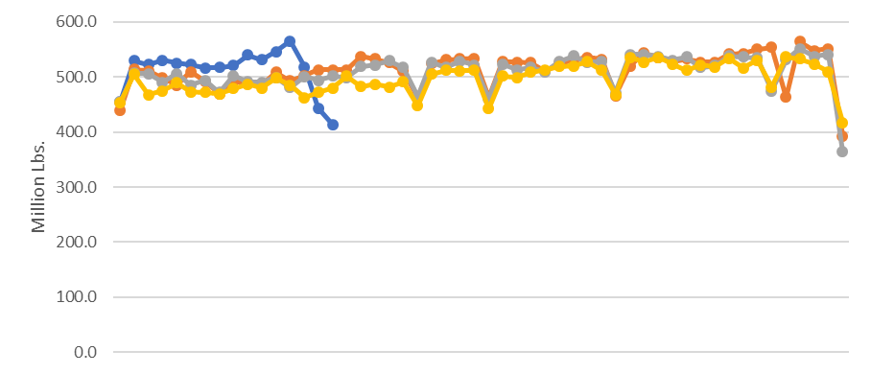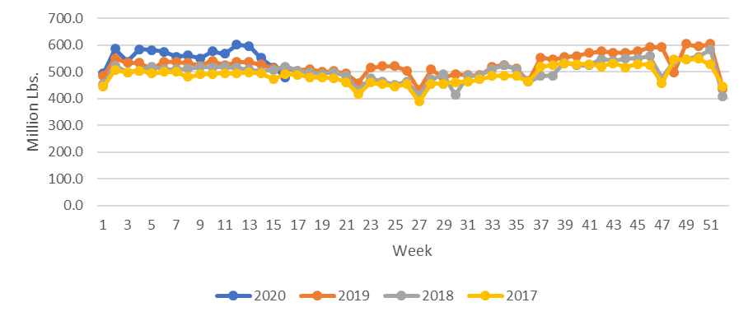

Broiler production data is reported with a one-week lag, but data through the week ending April 11 tells a similar story to beef and pork: production has been consistently lower for the past three weeks. The most recent week’s data shows broiler production down by about 5 percent year-over-year.

Production is not just slowing at the processor level. USDA provides weekly data on broiler chicks placed for meat production. Figure 2 shows weekly chick placements through the week ending April 11.

**Figure 2.** Weekly Broiler Chicks Placed for Meat Production

**Figure 2.** Weekly Broiler Chicks Placed or Meat Production

Data Source: USDA National Agricultural Statistics Service through Livestock Marketing Information Center.

Chick placements have fallen sharply in each of the last three weeks. Note that this is strongly counter-seasonal: chick placements are generally steadily increasing at this time of year. Last week’s chick placements were about 3.5 percent below a year ago. Looking ahead, broiler egg sets suggest further declines in chick placements are on the horizon. Broiler egg sets in incubators for hatching last week were down by over 5 percent from the prior year.

The University of Arkansas System Division of Agriculture offers all its Extension and Research programs and services without regard to race, color, sex, gender identity, sexual orientation, national origin, religion, age, disability, marital or veteran status, genetic information, or any other legally protected status, and is an Affirmative Action/Equal Opportunity Employer.