COVID-19 Impacts on Arkansas’ Agricultural and Rural Economies

UPDATE:
Slaughter Cow Markets

Prepared by:

James Mitchell
Department of Agricultural Economics and Agribusiness

December 1, 2020

Fig. 1.
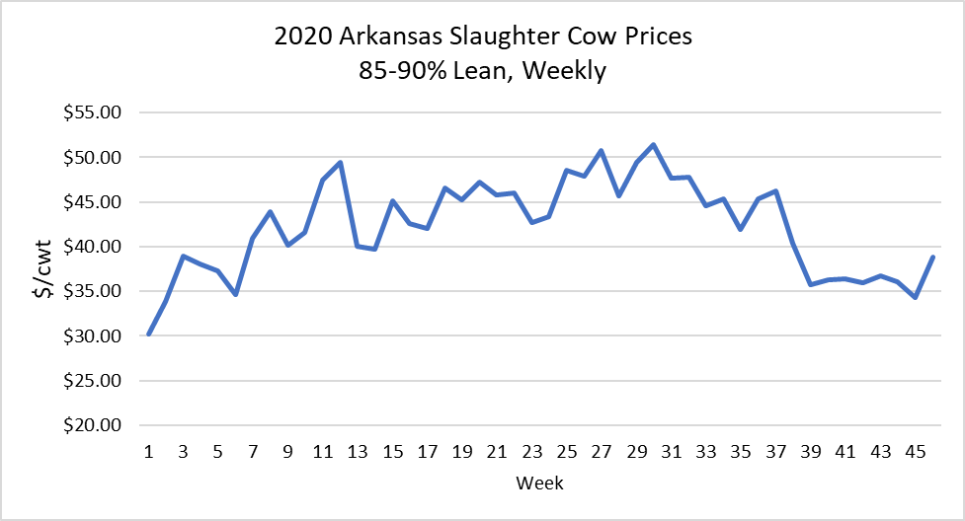
Source: USDA-AMS

As the fall concludes, livestock market analysts have been closely following feeder cattle markets. This fall has been significant as we continue to track the impacts of COVID-19 and more traditional cattle market fundamentals. Feeder cattle markets are not the only markets to watch as we move into the winter months. Cull cow markets are also important for us to monitor. Peel and Doye (2008) show that cull animals represent 10-20 percent of total revenue for the average cow-calf operation. Because they are an important component of a producer’s income stream, an update on cull cow markets is warranted.
The Fall represents a period when many producers make important culling decisions for their cow herds. The above figure provides prices for 85-90% lean slaughter cows sold in Arkansas. The most recent available data is for the week ending November 22, 2020. For that week, average slaughter cow prices were $38.79/cwt. These prices correspond to a 13% week-over-week change.
Cull cow prices tend to reach a seasonal low point in the fall. Still, 2020 cull cow prices remain above 2019 levels. Specifically, cull cow prices for the week ending November 22, 2020, were 19% above 2019 prices for the same week. More broadly, Sep-Nov prices have averaged 6% above 2019 prices. Regional beef cow slaughter has also averaged well-above 2019 in parts of the country. In region 6, which corresponds to AR, LA, NM, OK, and TX, Sep-Nov beef cow slaughter has averaged 11% above 2019 slaughter for the same period.
There are both supply and demand-side factors that have likely contributed to what we have seen play out this year in slaughter cow markets. Beef cows are an input for ground beef production. We have witnessed periods of higher demand for ground beef this year with an uncertain eating environment due to COVID-19. At the same time, COVID-19 stressed processing capacity, and market-ready cattle were held on feed longer. Average dressed weights have been above 2019 average dressed weights. A by-product of heavier dressed weights is more 50/50 trimmings, which requires more lean trimmings for blending to make ground beef at a target lean content. This has likely resulted in higher processor demand for slaughter cows, which might contribute to higher cull cow prices coupled with lower dairy cow slaughter. Drought conditions and the impacts of COVID-19 on cattle prices are likely supply-side contributors.
To conclude, it will be interesting to see what the January cattle inventory report reveals about the beef cow herd.
Fig 2. Percent change in the number of head slaughtered each week vs. the same week a year ago.

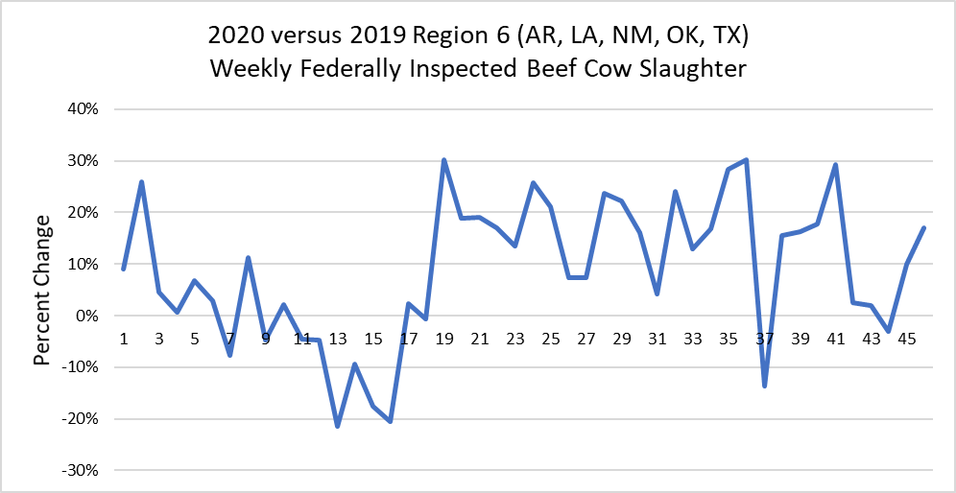
Source: LMIC

References:
Peel, D.S., and D. Doye. 2008. Cull Cow Grazing and Marketing Opportunities. Oklahoma Cooperative Extension Service, Oklahoma State University, Fact Sheet AGEC-613.

Author’s Note:
A similar version of this article appears in the Cattle Markets Notes Newsletter written by James Mitchell. The article is available at: https://mailchi.mp/fdfd41d1d2e0/cattle-market-notes-weekly-18838644?e=35c55ad19b.

The University of Arkansas System Division of Agriculture offers all its Extension and Research programs and services without regard to race, color, sex, gender identity, sexual orientation, national origin, religion, age, disability, marital or veteran status, genetic information, or any other legally protected status, and is an Affirmative Action/Equal Opportunity Employer.

