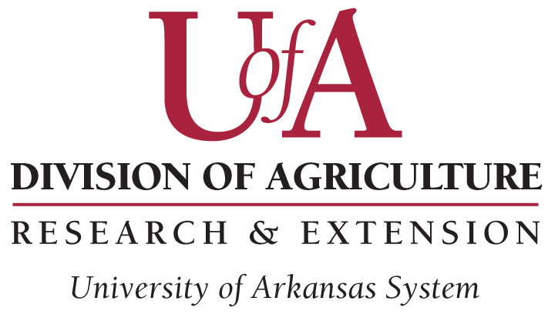
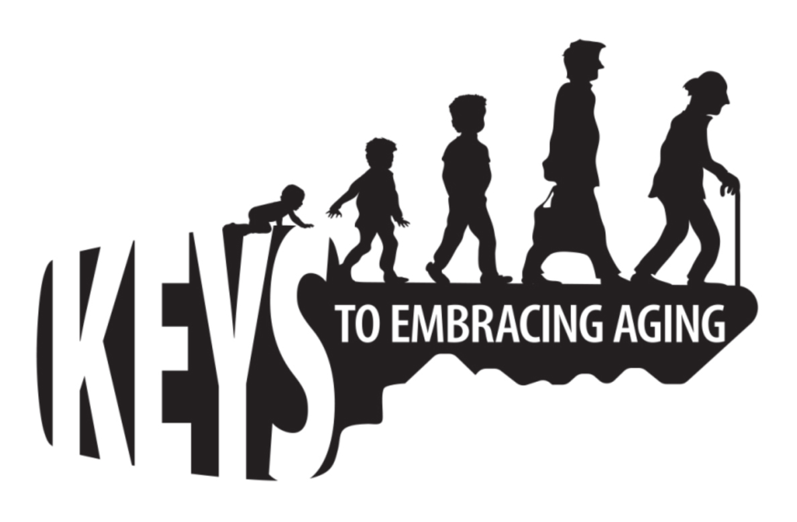
Age is an issue of mind over matter. If you don’t mind, it doesn’t matter.~ Mark Twain

Come to the (add name of county) County
Extension Office
To Learn 12 Keys to Embracing Aging your Life Story

What you do today will affect your future, especially when it comes to aging. Since there is no magic potion to stop the aging process, it is important to take care of yourself . No one knows this better than today’s active centenarians, individuals who are 100 years and older. From them, we have identified 12 healthy behavior practices that encourage optimal aging throughout the life span.

Who Can Participate? We welcome all participants.

When: [Fill in the Dates]

Where: [Fill in the Place]

How to Participate: Contact [fill in contact information]

For More Information: Contact [fill in contact information]

Educational programs of the Kentucky Cooperative Extension serve all people regardless of race, color, age, sex, religion, disability, or national origin.
The Arkansas Cooperative Extension Service offers its programs to all eligible persons regardless of race, color, national origin, religion, gender, age, disability, marital or veteran status, or any other legally protected status, and is an Affirmative Action/Equal Opportunity Employer.

