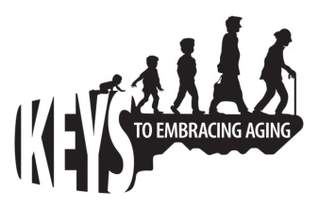

Keys to Embracing Aging
Optional Follow-up Evaluation

As a past participant of the Keys to Embracing Aging program, you learned about twelve “keys” or strategies for embracing aging. We would appreciate additional feedback about your experience with this program. Please take a moment to complete this survey.

- As a result of attending the program, have you tried to have a more positive attitude?
□ Yes □ No

- As a result of attending the program, have you changed your eating habits to be a healthier eater?
□ Yes □ No

- As a result of the program, have you increased your physical activity or added variety into you exercise routine?
□ Yes □ No

- As a result of the program, have you increased your mental stimulation through brain exercise (examples may include word games, puzzles, journaling, driving new routes or traveling to new places)?
□ Yes □ No

- As a result of this program, have you enhanced or increased your social activity?
□ Yes □ No

- As a result of this program, have you tried any new technology?
□ Yes □ No

- As a result of this program, have you done anything to be safer in your daily life (examples may include home, vehicle, internet, recreation, emergency preparedness or health safety)?
□ Yes □ No

- As a result of this program, have you checked your health numbers (examples may include: BMI, waist circumference, cholesterol, triglycerides, blood pressure, or sugar)?
□ Yes □ No

- As a result of this program, have you worked on decreasing your stress level or sought ways to manage it in a healthy way?
□ Yes □ No

- As a result of this program, have you changed your financial behavior?
□ Yes □ No

- As a result of this program, have you tried to obtain more sleep?
□ Yes □ No

- As a result of this program, have you made time for you?
□ Yes □ No

- Gender:
□ Male □ Female

- Age in years:

□ 0-18
□ 19-34
□ 35-44
□ 45-54
□ 55-64
□ 65-74
□ 75-84
□ 85+

- Are you a Baby Boomer (born between 1946-1964)?
□ Yes □ No

- Are you of Hispanic, Latino, or Spanish descent?
□ Yes □ No

- Which of the following best describes you?

□ White
□ Black/African American
□ American Indian/Alaska Native
□ Asian
□ Hawaiian/Pacific Islander
□ Two or more mixed race/color

18. State where I live _______________________________________________

19. County in which I reside _________________________________________

Additional Comments:

