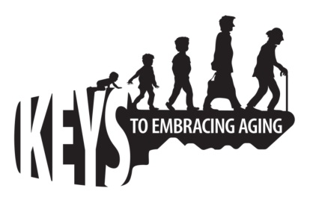
Keys to Embracing Aging Evaluation

As a participant of the Keys to Embracing Aging program, we would appreciate your feedback. Please take a moment to complete this survey.

- As a result of this program, do you have a better understanding of how the choices you make today affect your health and well-being in the future?

□ Yes □ No

- As a result of this program, do you better understand how various life style choices affect each other and why is it important to practice healthy lifestyle behaviors across multiple domains? (e.g., financial problems affect health status and vice versa.)
□ Yes □ No

- Which of the following healthy lifestyle behavior practices do you currently practice on a regular basis? (check all that apply)

□ Positive Attitude
□ Eating Smart and Healthy
□ Physical Activity
□ Mental Activity
□ Social Activity
□ Tuning-in to the times
□ Safety
□ Know Your Health Numbers
□ Stress Management
□ Financial Affairs
□ Sleep
□ Taking Time for You

- As a result of this program, which of the healthy lifestyle behaviors do you intend to embrace? (check all that apply)

□ Positive Attitude
□ Eating Smart and Healthy
□ Physical Activity
□ Mental Activity
□ Social Activity
□ Tuning-in to the times
□ Safety
□ Know Your Health Numbers
□ Stress Management
□ Financial Affairs
□ Sleep
□ Taking Time for You

- Gender:
□ Male □ Female

- Age in years:

□ 0-18
□ 19-34
□ 35-44
□ 45-54
□ 55-64
□ 65-74
□ 75-84
□ 85+

- Are you a Baby Boomer (born between 1946-1965)?
□ Yes □ No

- Are you of Hispanic, Latino or Spanish descent?
□ Yes □ No

- Which of the following best describes you?

□ White
□ Black/African American
□ American Indian/Alaska Native
□ Asian
□ Hawaiian/Pacific Islander
□ Two or more mixed race/color

- State where I live ______________________________________________

- County in which I reside _________________________________________

- Please list things that you do to embrace age and longevity (living a long time):

Additional Comment

