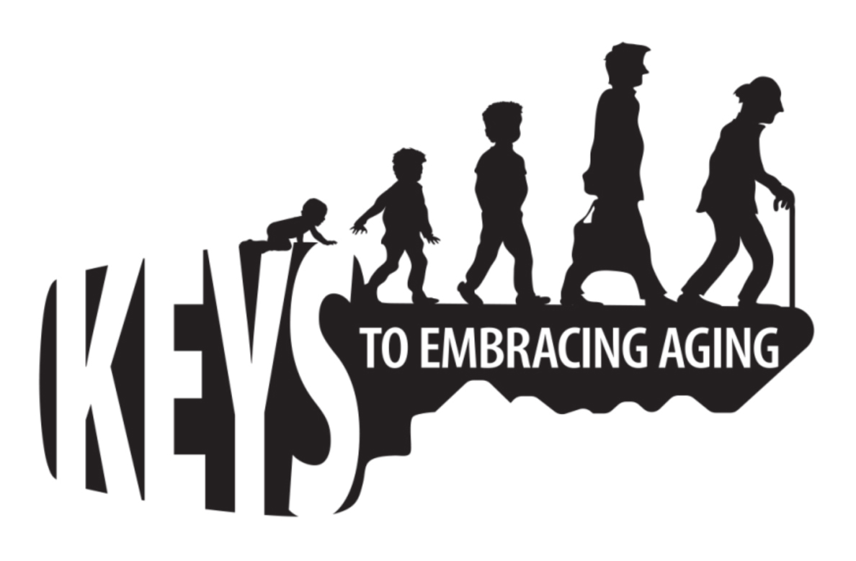To manage your stress, it is helpful to know what resources you have and what resources you need. Many resources fall into broad categories such as supportive social networks, personal skills and interests, as well as your life experiences.
Stress
Management

Directions:
- In column 1, create a list of various resources (people, places, characteristics, things) you have in your life (examples may include, family, friends, counselors, mentors, coping abilities, creativity, church, pet, library, etc.).
- In column 2, create a list of challenges that you currently face or anticipate facing (examples may include the balancing act between caregiving and work, health problems, struggles in school, job loss, divorce, financial problems, etc.).
- With a line, match your existing resources (column 1) to a current stressor (column 2). Note, some resources may connect to more than one stressor.
- Circle any stressors that were not connected to a current resource. In column 3, list what type of resource would be helpful to you to better address that particular stressor.
- As a group, discuss the strengths of identifying existing and new resources AND asking for help. If people have stressors for which they do not have a resource, brainstorm or identify potential resources.

Column 1:  Existing Resource | Column 2:  Current Stressors | Column 3:  Needed Resources

Educational programs of the Kentucky Cooperative Extension serve all people regardless of race, color, age, sex, religion, disability, or national origin.

