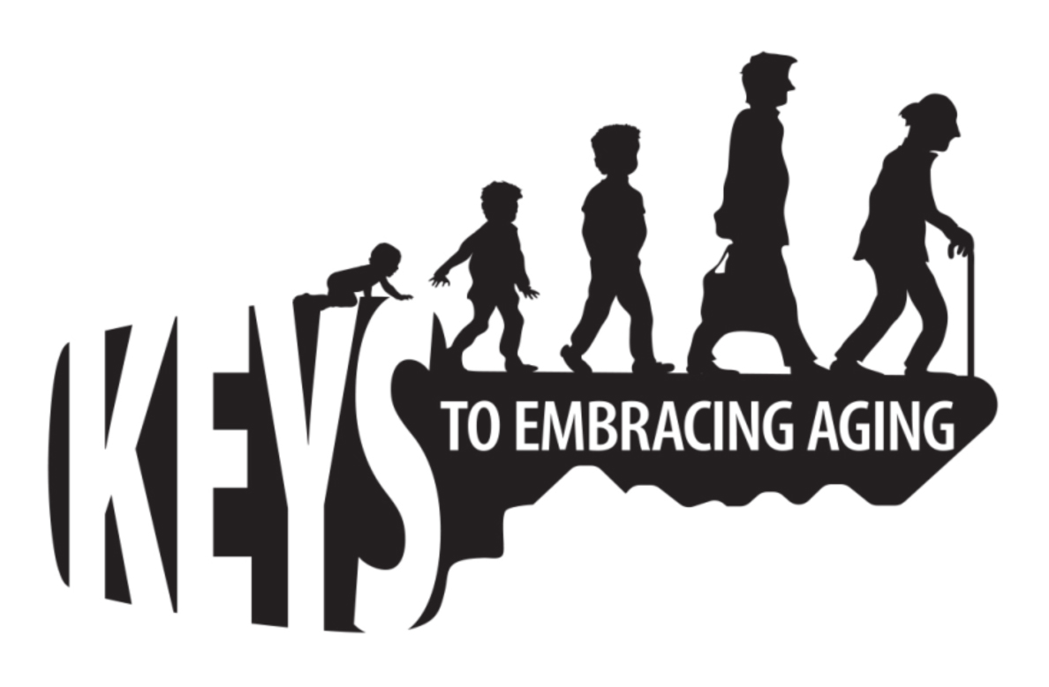

WHAT ARE YOU DOING TO PREPARE?

Are you prepared for an emergency? Quiz yourself on the questions below to see just how prepared you are. If you don’t know the answer to some of the questions, visit Ready.gov or your local Office of Emergency Management for tips and resources that can help make sure you, your family, and your community are Ready.

- Does your local government have an emergency or disaster plan for your community? If so, do you know what it is?
- Do you know how to find the emergency broadcasting channel on the radio?
- Does your city/county have an emergency alert system? Is so, are you signed up to get alerts?
- Do you know your local evacuation routes? How would you get out of town from work? How about from home?
- Does your city/county have a Citizen Corps Council? (If you don’t know, visit www.citizencorps.com)
- In the last year, have you prepared or updated your Emergency Supply Kit with emergency supplies like water, food and medicine that is kept in a designated place in your home? Visit Ready.gov for an Emergency Supply Kit checklist.
- In the last year, have you prepared a small kit with emergency supplies that you keep at home, in your car or where you work to take with you if you had to leave quickly?
- In the last year, have you made a specific plan for how you and your family would communicate in an emergency situation if you were separated?
- Are you prepared to help your neighbor? In most emergencies, the best way to get help quickly is by working with your neighbors. Do you know anyone in your neighborhood who might need a little extra help preparing for or responding to an emergency?
- Have you established a specific meeting place for your family to reunite in the event you and your family cannot return home or are evacuated?
- In the last year, have you practiced or drilled on what to do in an emergency at home?
- In the last year, have you volunteered to help prepare for or respond to a major emergency?
- Have you taken first aid training such as CPR in the past five years?

