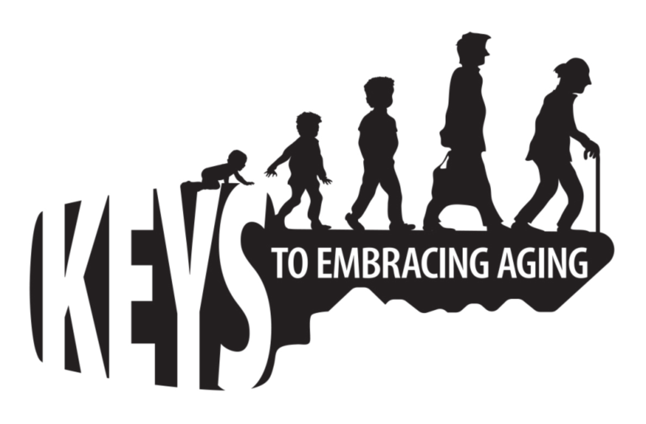

READY ON A BUDGET

It is no secret that many families and individuals are looking to cut back on spending. But with the frequency of disasters, both natural and manmade, can you afford not to be prepared? Preparedness doesn’t have to cost an arm and a leg. September is National Preparedness Month, and we are asking you to help your family and friends prepare for whatever may come. Here are a few tips* on how you can protect those that matter to you without spending a fortune.

• Make a Plan. Work with you family and neighbors to make an emergency plan for the types of disasters that affect your area. Make sure everyone in your family understands where to go and what to do in case of an emergency. You can download Family Emergency Plan templates www.ready.gov/make-a-plan
• Update Contact Information. Having accurate records for family, friends and neighbors will help you stay in contact and possibly help those in need. Make sure updated contact information is posted in visible places throughout your house and workplace.
• Check Your Policy. Review your insurance policy annually and make any necessary changes – renters, too! When a disaster strikes, you want to know that your coverage will get you back on your feet.
• Make a Ready List. You may not need all of the items in ready-made preparedness kits. Choose the essentials that fit your needs and budget. Don’t forget to keep supplies at work and in your car. Sample Ready Lists can be found at www.ready.gov/document/family-supply-list
• Plan Your Purchases. You can save money by thinking ahead. Don’t buy preparedness items just before a storm when they’re expensive and supplies will be in high demand. Buy items at the end of the season when you can get good deals.
• Shop Sales. Shop at sales and used goods stores. Buy preparedness items throughout the year, instead of all at once, and you won’t notice the cost as much.
• Make Sure it Keeps. Store water in safe, containers. You don’t need to buy expensive bottled water, just make sure your water containers are disinfected and airtight
• Request a Gift. We all get things we don’t need. Suggest preparedness supplies as gifts from your friends and family. It just might save your life.
• Trade a Night Out. Trade one night out to fund your 72-hour kit. Taking a family of four to the movies can cost upwards of $80. Just one night staying in could fund your Ready kit.
The best tip: start now.
Take small steps toward preparedness and before you know it, you will be Ready!

