A Recipe for: __________________

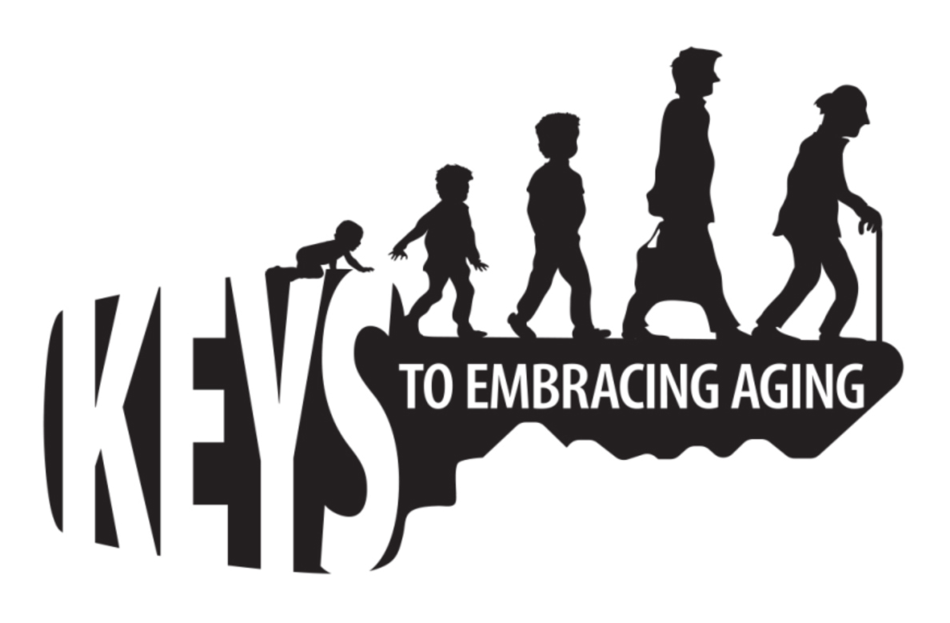

You’re a one-of-a kind design made up of a unique blend of ingredients.
For example, you may be a mix of strength, 8 hours of sleep, and
determination combined with short legs, blue eyes, brown hair and
laugher and passion, to make a complete recipe of you.
Think carefully about your personality, values, what makes you happy,
what makes you special, favorite foods, hobbies, or any other character-
istics that make up you. Use strong adjectives to describe you. Brain-
storm first and then write down your ideas on the front of this card.
Directions: 1. On the front of this card, list the ingredients and
measurements that make you, YOU (1/2 cup love; 1 tsp orneriness). 2. Give directions on how to mix the ingredients together. 3. Name your recipe. 4. If you have a photo of yourself, include it with the recipe.

