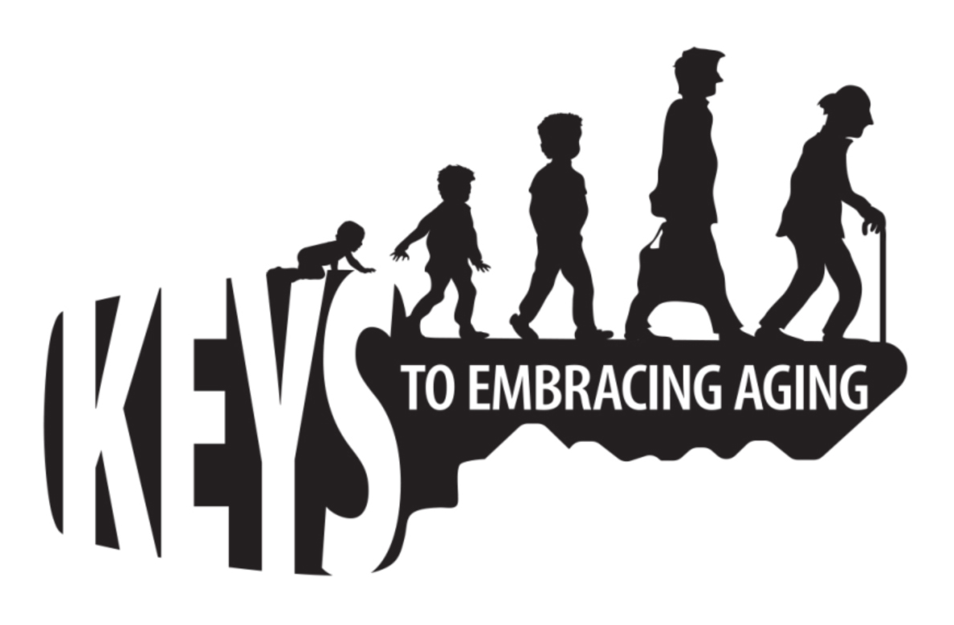
Bucket List

A bucket list is a list of things you want to do before you die. Keep in mind that not everyone wants to jump out of planes or climb mountains. A bucket list can also include dreams, aspirations, plans and decisions for the future.

Directions: In column 1, write down your dreams, aspirations, plans and/or decisions you want to make or anticipate making in the future. Include your age/date that you think these events might take place in Column 2.

Column 1  Dream, Aspiration, Plan or Decision | Column 2  Age or Date
- _________________________________________ | ________
- _________________________________________ | ________
- _________________________________________ | ________
- _________________________________________ | ________
- _________________________________________ | ________
- _________________________________________ | ________
- _________________________________________ | ________
- _________________________________________ | ________
- _________________________________________ | ________
10. _________________________________________ | ________
Educational programs of the Kentucky Cooperative Extension serve all people regardless of race, color, age, sex, religion, disability, or national origin.

