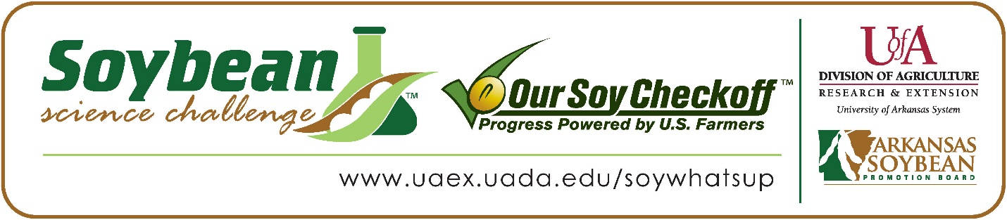

**Levi Foster wins 2023 Arkansas Soybean Science Challenge Junior Division Award at the Northeast Arkansas Regional Science Fair**

Levi Foster, age 13, a 7th grader at Salem High School in Salem, Arkansas, won the Soybean Science Challenge Junior Division award at the 2023 Northeast Arkansas Regional Science Fair held at Arkansas State University on March 10..

Foster received a $200 cash award provided by the Arkansas Soybean Promotion Board. His science project was titled “Comparing the growth of soybeans using different types of water,” also placed first in plant sciences.

Katie Southard, Foster’s teacher, won the $100 Soybean Science Challenge Junior Division Teacher-Mentor Award. Southard stated that the Soybean Science Challenge is a great way to learn about science using an agricultural pathway. “The Soybean Science Challenge gives more students the opportunity to try and win an award, and not just any award, but one that includes a cash prize which is a great motivation tool.  The Soybean Science Challenge is for students that might not have the medical, chemistry, or physics mindset, but still want to participate and feel accomplished in science.,” she replied.

Foster was thrilled, but a bit awed to win the 2023 Junior Division Soybean Science Challenge. “I am excited and shocked to be the 2023 Junior level winner because I did not personally think that I would win,” he explained.

Smith was proud to see Levi receive the award. “My student struggled with finding a topic, however, after mentioning the soybean challenge, he knew he wanted to do something with soybeans.  He made the effort to work on his project throughout the school day and even after school leading up to the fair, including redoing his board during parent teacher conferences to make sure that it looked right and that he hadn’t missed anything.  He worked hard to complete the Soybean Science Challenge Course before the NEARSF.” she responded.

Foster found learning about soybeans and agriculture through the online course to be useful. “The part of the Soybean Science Challenge online course that appealed the most to me was when it talked about what soybeans have in them and how the parts of a soybean are used,” he explained.

Southard feels that the Soybean Science Challenge is a great program for students. “I did not grow up or live near crop land, therefore, I have very little knowledge about soybeans.  The Soybean Science Challenge is broadening my knowledge so that I can help students with future soybean projects. Through my students’ participation in The Challenge, I gained a sense of pride in knowing that my students accomplished a goal that they set themselves.  Seeing one of my students win the Soybean Science Challenge helped eliminate the negative stigma toward science as being a subject for only the brightest students, showed my students that hard work pays off, and increased the enthusiasm and interest for competing in science fairs.  That is a win for me, and I am very thankful that Arkansas farmers are investing in our future scientists,” she replied.

“The Soybean Science Challenge provides an opportunity for Arkansas junior high and high school students to participate in scientific research that can impact the State of Arkansas as well as the world. Soybean Science Challenge student researchers learn about this important commodity crop and its many uses including feeding the world, development of biofuels and sustainable products. The Soybean Science Challenge helps students develop an understanding of the challenges and complexities of modern farming,” said Dr. Julie Robinson, Associate Professor, and director of the program.

“The goal of the Arkansas Soybean Science Challenge is to engage students in “real- world” education to support soybean production and agricultural sustainability,” said Gary Sitzer, a former member of the Arkansas Soybean Promotion Board. “The program also rewards scientific inquiry and discovery that supports the Arkansas soybean industry.”

The Arkansas Soybean Science Challenge was launched in January 2014 to 9-12th grade science students and in 2021, added grades 6-8 for the junior level award. Students who successfully completed the online course were eligible to have their original soybean-related research projects judged at the 2023 ISEF-affiliated Arkansas Science and Engineering Fairs.

Information on the 2023-2024 Arkansas Soybean Science Challenge will be available in summer 2023. For more information, contact Dr. Julie Robinson at [jrobinson@uada.edu](mailto:jrobinson@uada.edu) or Diedre Young at [dyoung@uada.edu](mailto:dyoung@uada.edu).

The Cooperative Extension Service is part of the University of Arkansas System Division of Agriculture.

**Levi Foster, Salem High School, Salem, Arkansas; Teacher, Katie Southard**

**Category: Plant Science**

**Title: Comparing the growth of soybeans using different types of water**

**Abstract:** In order to increase soybean production, does the type of water used to water the plants matter? The purpose of the experiment was to see which water-pond, rainwater, tap or river-makes soybeans grow the most. 16 soybean seeds were planted in the experiment and were allowed to grow for 22 days. Each cup, with one seed each, was watered daily with 2.3 ml of water and received the same amount of light. At the end of the 22-day period, the height of the four plants with the four types of water were measured and averaged. The averages were compared and turned into a bar graph. Based on the results of the experiment, soybean farmers should use river water to irrigate their soybean plants in order to increase soybean growth and should avoid using pond water.

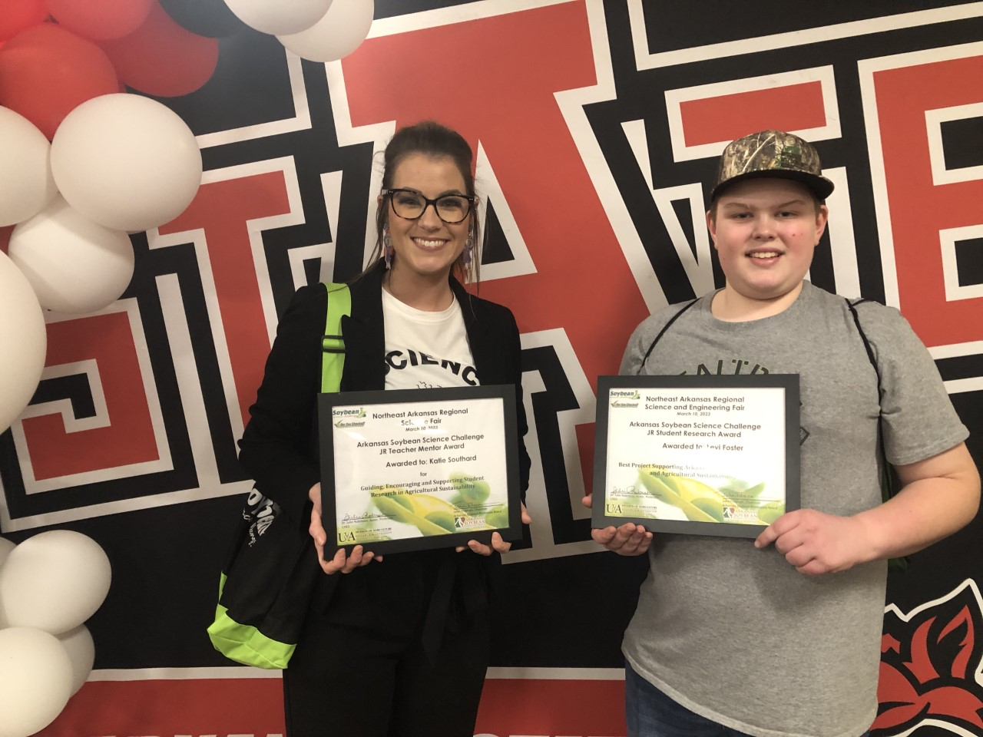

Soybean Science Challenge Junior Division Winner Levi Foster and Teacher-Mentor Katie Southard