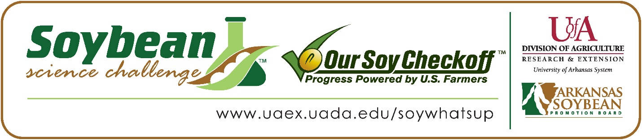

**Jack Snell and Mason Collins** **win the 2023 SR Division Arkansas Soybean Science Challenge Award at the Northwest Arkansas Regional Science and Engineering Fair**

Jack Snell 15, and Mason Collins 16, a freshman and sophomore at Alpena High School in Alpena, won the SR Division Soybean Science Challenge at the 2023 Northwest Arkansas Regional Science and Engineering Fair at the University of Arkansas-Fayetteville on March 10.

Snell and Collins split the $300 cash award provided by the Arkansas Soybean Promotion Board. Their science project titled “Diagnosing Bacterial Blight with Darknet” also won Second Place in Computational Biology/Infomatics.

Zachary Thomas, Snell and Collins’ teacher, won the $200 Soybean Science Challenge Teacher- Mentor Award. Thomas stated that the Soybean Science Challenge is a great way to learn about soybean research. “These students gained a lot of information about soybeans and Arkansas’ production of soybeans. They also were able to make their project very applicable to the state and its soybean producers.” He replied.

Snell was thrilled (and relieved) to win the 2023 Soybean Science Challenge. “Ever since last year's science fair when I heard of such a challenge, I made it my personal goal to win. Hearing me and my partner's name announced was a feeling of relief that all my hard work had paid off! I am honored to be the 2023 winner of the Soybean Science Challenge in my region.,” he stated. Collins was amazed to have won. “Winning was an amazing experience. The feeling of seeing your hard work and research pay off was very fulfilling to me,” he replied.

Shawn Snell, Jack’s dad, was very happy to see him receive the award. “I was super proud that my son chose a subject directly related to our home state,” he replied. Mason’s parents, Mr., and Mrs. Collins were thrilled to see Mason win. “We were very proud to see our son win something he was passionate for. He seemed very excited to tell us that his work had paid off,” they stated.

Snell also feels that the Soybean Science Challenge is a great program for students. “From participating in the Soybean Science Challenge, I gained knowledge about the growth, production, and application of soybeans and why they are so important to our world. I also furthered my computer science knowledge by applying it to something outside of my comfort zone.” he explained. Collins learned about agricultural research. “I gained the opportunity to expand my agricultural knowledge as well as the opportunity to experience impactful research and development that can affect the future of agriculture,” he replied.

“The Soybean Science Challenge provides an opportunity for Arkansas junior high and high school students to participate in scientific research that can impact the State of Arkansas as well as the world. Soybean Science Challenge student researchers learn about this important commodity crop and its many uses including feeding the world, development of biofuels and sustainable products. The Soybean Science Challenge helps students develop an understanding of the challenges and complexities of modern farming,” said Dr. Julie Robinson, Associate Professor and director of the program.

“The goal of the Arkansas Soybean Science Challenge is to engage students in “real- world” education to support soybean production and agricultural sustainability,” said Gary Sitzer, a former member of the Arkansas Soybean Promotion Board. “The program also rewards scientific inquiry and discovery that supports the Arkansas Soybean Industry.”

The Arkansas Soybean Science Challenge was launched in January 2014 to 9-12th grade science students. Students who successfully completed the online course were eligible to have their original soybean-related research projects judged at the 2023 ISEF-affiliated Arkansas Science and Engineering Fairs.

Information on the 2023-2024 Arkansas Soybean Science Challenge will be available in summer 2023. For more information, contact Dr. Julie Robinson at [jrobinson@uada.edu](mailto:jrobinson@uada.edu) or Diedre Young at [dyoung@uada.edu](mailto:dyoung@uada.edu).

The Cooperative Extension Service is part of the University of Arkansas System Division of Agriculture.

**Jack Snell and Mason Collins, Alpena High School, Alpena, Arkansas; Teacher, Zachary Thomas**

**Category: Computational Biology/Infomatics**

**Title: Diagnosing Bacterial Blight with Darknet**

**Abstract:**

Bacterial blight is a disease that spreads throughout many kinds of plants. One of which is soybeans. As bacterial blight reproduces and grows it inevitably causes plant necrosis leading to the leaves decay and rot. From here the plant can spread blight throughout a field causing severe damage to yield. Agriculturalists and farmers alike can use artificial intelligence to detect soybean blight early and provide treatment to the field. With developing image detection software, it becomes even more possible to treat blight in its early stages before it develops into the more harmful stages. We located a library of 75 images of soybeans infected with Bacterial Blight. Then, we annotated these images using the Computer Vision Annotation Tool online by highlighting each instance of the disease with a rectangular bounding box. We installed Darknet, DarkMark, and Darkhelp using the linux Ubuntu 22.10 terminal in WSL2. Then, we borrowed the GPU power of a Darknet expert, as he had a GPU capable of training the model quickly and efficiently. Our results indicate that the neural network model was able to be trained rapidly, thanks to the YOLOV3 mini architecture used. The network was able to quickly identify Bacterial Blight with a mAP% score of 93% and a loss of 2.8 at 4900 iterations. The Neural Network was effective at detecting blight in soybean plants. With neural networks such as these, engineers can construct automated equipment that can be applied in fields.

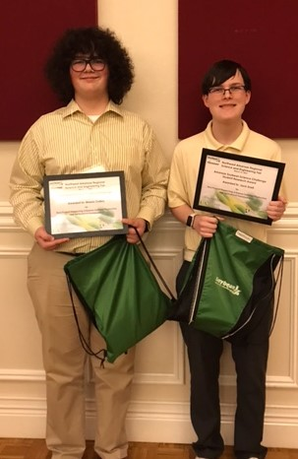 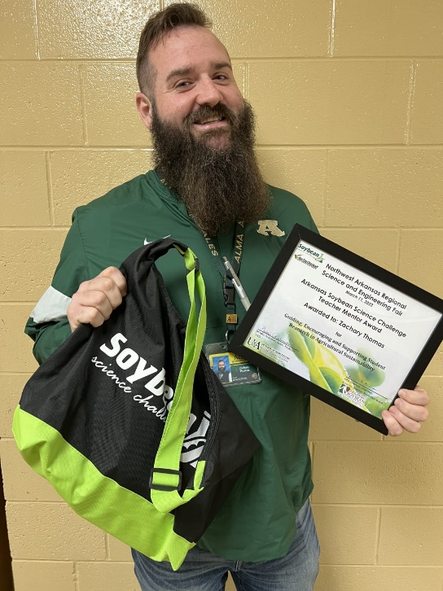

Soybean Science Challenge SR Division team winners Mason Collins and Jack Snell, and Teacher-Mentor Zachary Thomas