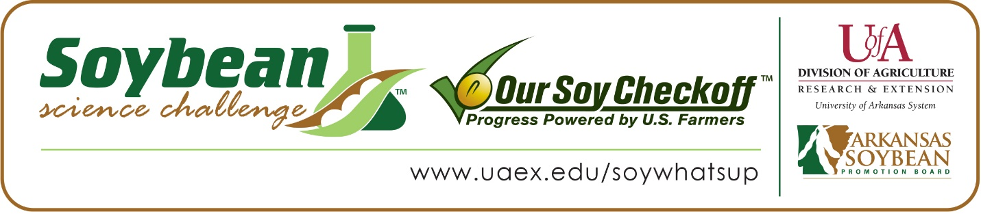
Tori Mattmiller wins 2020 Arkansas Soybean Science Challenge Award at Southwest Arkansas Regional Science Fair
Tori Mattmiller, age 15, a freshman at Emerson High School in Emerson, won the Soybean Science Challenge at the 2020 Southwest Arkansas Regional Science Fair held at Southern Arkansas University-Magnolia March 13.
Mattmiller received a $300 cash award provided by the Arkansas Soybean Promotion Board at the awards ceremony. Her science project titled “The Effect of acid rain on soybean root nodules” also received second place in Agriculture, Earth and Environmental Sciences.
Mattmiller will compete at the Arkansas State FFA Agriscience Fair in Hot Springs in June. Connie Orsak, Mattmiller’s teacher, won the $200 Soybean Science Challenge Teacher Mentor Award. Orsak believes the Soybean Science Challenge is a worthy program for her students. “The decision to ask my student to do the Soybean Challenge project was because she had already considered a project on the effect of acid precipitation on soil and plants. Since The Challenge was there, I suggested she consider the cash crop of Arkansas,” she said.
Mattmiller says it was a surprise to win the 2020 Soybean Science Challenge. “Being the Southwest Arkansas Regional winner was such a shock to me since I knew nothing about soybeans before I started the coursework. Once I started the online course I became captivated with the science of soybeans. Winning the Southeast Arkansas Soybean Science Challenge has really shown me that trying new things can be very rewarding,” she said.
Misti Mattmiller,, Tori’s mother, was ecstatic to learn of her daughter’s award. “Tori has been interested in science since a very young age and this interest has grown each year. She is an excellent student who is dedicated to science,” she replied.
Orzak believes Mattmiller was an excellent fit for the Soybean Science Challenge. “Tori very willingly worked on the tutorials and reran her research to get more data. This is a ninth-grader, who is just learning about research,” she said.
Mattmiller admitted she had no knowledge about soybeans before taking the Soybean Science Challenge online course. “I literally knew nothing about soybeans. My participation in the Soybean Science Challenge has allowed me to gain lots of information about soybeans that I did not know before and I also learned what a huge role soybean play in the world,” she said.
The part of the Soybean Science Challenge course that appealed most to Mattmiller was learning about the emerging issues farmers deal with by growing soybeans. She also enjoyed the module on biofuel and soybean nutrition.
“The Soybean Science Challenge provides an opportunity for Arkansas High School students to participate in scientific research that can impact the State of Arkansas as well as the world. Soybean Science Challenge student researchers learn about this important commodity crop and its many uses including feeding the world, development of biofuels and sustainable products. The Soybean Science Challenge helps students develop an understanding of the challenges and complexities of modern farming,” said Dr. Julie Robinson, Associate Professor and director of the program.
“The goal of the Arkansas Soybean Science Challenge is to engage students in “real world” education to support soybean production and agricultural sustainability,’” said Gary Sitzer, a former member of the Arkansas Soybean Promotion Board. “The program also rewards scientific inquiry and discovery that supports the Arkansas Soybean Industry.”
The Arkansas Soybean Science Challenge was launched in January 2014 to 9-12th grade science students. Students who successfully completed the online course were eligible to have their original soybean-related research projects judged at the 2020 Arkansas Science and Engineering Fairs.
Information on the 2020-2021 Arkansas Soybean Science Challenge will be available in summer 2020. For more information, contact Dr. Julie Robinson at jrobinson@uaex.edu or Diedre Young at dyoung@uaex.edu.
The Cooperative Extension Service is part of the University of Arkansas System Division of Agriculture.

Tori Mattmiller, Emerson High School, Emerson. Teacher: Connie Orsak
Category: Agriculture, Earth and Environmental Science
Project Title: The effect of acid rain on soybean root modules
Abstract:
Farmers have started using rhizobia bacteria-based inoculants to fertilize their soybeans. The rhizobia bacteria create a symbiosis relationship with the legume causing root nodules on the plant. In Arkansas, most of the farmland used to grow crops has acidic soil. Could the acidic soil have an effect on the symbiosis relationship the bacteria and plant have? Can a low pH balance caused by acid rain affect the amount of soybean root nodules? It was determined that a low pH balance could ultimately decrease the amount of root nodules on the soybean. To test this theory, the soybeans were grown using inoculants (rhizobia bacteria); half of the plants were watered with distilled water (control group) while the other half were watered with acidic rain solution (manipulated). After three weeks the plants were taken out of the soil (roots intact), the soybeans were tested by how much area the nodules took up on graph paper. The data proved that low pH balance caused by acid rain decreases the amount of soybean root nodules. The control group had an average area of 8.3% occupied by root nodules; the manipulated group had an average of 4.1% occupied by root nodules. The experiment supported the claim that a low pH balance causes less soybean root nodules. The data found during this experiment can be used to help farmers make intelligent decisions when it comes to using rhizobia bacteria inoculant to fertilize their acidic soil.
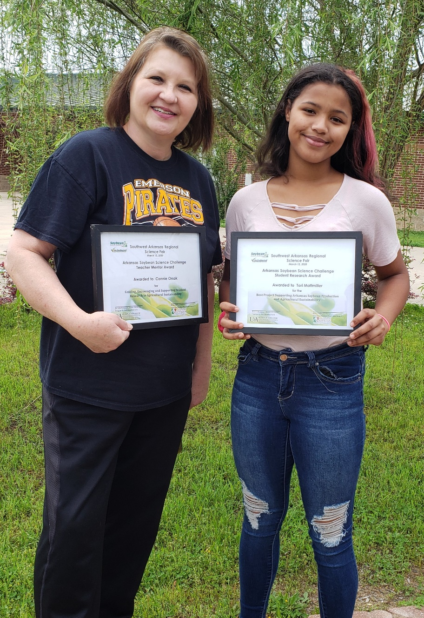
Tori Mattmiller, 2020 Southwest Arkansas Regional Science Fair winner with Teacher Mentor Connie Orsak

