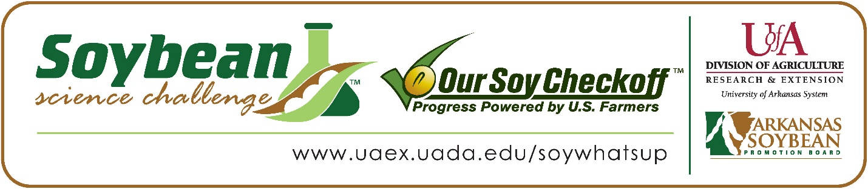

**Thomas Gilliland wins 2025 Arkansas Senior Division Soybean Science Challenge Award at the Ouachita Mountain Regional Science and Engineering Fair**

Thomas Gilliland 15, a freshman at Benton Junior High School in Benton, Arkansas, won the Senior Division Soybean Science Challenge at the 2025 Ouachita Mountain Regional Science and Engineering Fair held in Hot Springs, February 28.

Gilliland received a $400 cash award provided by the Arkansas Soybean Promotion Board. His science project titled “Does continuous fertilizer on soybeans affect soybean growth rate?” also placed first in Plant Sciences.

Greg Wertenberger, Gilliland’s teacher, won the $200 Senior Division Soybean Science Challenge Teacher-Mentor Award. Wertenberger noted that the Soybean Science Challenge allows his students to work with projects that would be a benefit to their area. “I encouraged students who were interested in entering our regional fair to consider participating in the Soybean Science Challenge because this program gives students an opportunity to focus their research on a topic that has relevant impact to our local economy and food supply. I appreciate how the Soybean Science Challenge exposes these students to real challenges that are being addressed through the same scientific and engineering practices that our students are learning in the classroom,” he replied.

Wertenberger also expounded upon what his students learned. “The Challenge helps students see relevant applications for the concepts and skills they are learning in our classrooms, and it helps them to see themselves as scientists and engineers who answer real questions and who solve real problems. They also gain knowledge about a vital part of our economy in Arkansas as they research problems and solutions related to soybean agriculture,” he explained.

Thomas said winning the 2025 Soybean Science Challenge was quite an honor for him. “I was surprised and honored to receive this accolade,” he explained.

Mrs. Gilliland, Thomas’ mother, was thrilled about his award. “I was very proud and excited for him,” she replied.

The part of the Soybean Science Challenge course that appealed most to Thomas was learning about how important careers in agriculture are. “What appealed most to me was how informative the course was in showing the vast opportunities there are in agricultural and biological fields,” he explained.

Wertenberger noted how he has learned more about soybeans through his students working on the SSC online course and competition. “The Soybean Science Challenge has inspired me to conduct further research into problems and potential solutions that are facing industries in our state so that I can help students see the relevance of what they are learning in my science classroom. I have seen how motivating these connections can be for students who begin to see themselves as contributors to the development of solutions for real problems facing them and others in their communities,” he noted.

“The Soybean Science Challenge provides an opportunity for Arkansas junior high and high school students to participate in scientific research that can impact the State of Arkansas as well as the world. Soybean Science Challenge student researchers learn about this important commodity crop and its many uses including feeding the world, development of biofuels and sustainable products. The Soybean Science Challenge helps students develop an understanding of the challenges and complexities of modern farming,” said Dr. Julie Robinson, Professor, and director of the program.

“The goal of the Arkansas Soybean Science Challenge is to engage students in “real- world” education to support soybean production and agricultural sustainability,” said Gary Sitzer, a former member of the Arkansas Soybean Promotion Board. “The program also rewards scientific inquiry and discovery that supports the Arkansas Soybean Industry.”

The Arkansas Soybean Science Challenge was launched in January 2014 for 9-12th grade science students. Students who successfully completed the online course were eligible to have their original soybean-related research projects judged at the 2025 ISEF-affiliated Arkansas Science and Engineering Fairs.

Information on the 2025-2026 Arkansas Soybean Science Challenge will be available in summer 2025. For more information, contact Dr. Julie Robinson at [jrobinson@uada.edu](mailto:jrobinson@uada.edu), Keith Harris at [krharris@uada.edu](mailto:krharris@uada.edu) or Diedre Young at [dyoung@uada.edu](mailto:dyoung@uada.edu).

The Cooperative Extension Service is part of the University of Arkansas System Division of Agriculture.

**Thomas Gilliland, Benton Junior High School, Benton, Arkansas; Teacher: Greg Wertenberger**

**Category: Plant Sciences**

**Project Title: Does continuous fertilizer on soybeans affect soybean growth rate?**

**Abstract:** In developed countries, fertilization has become an extremely common practice for farmers, and for a good reason. The ability to improve crop yields by unheard-of margins is an invaluable tool for both farmers and retailers alike, and such fertilization has both decreased cost and increased surplus products, fueling population and economic growth around the world. Because of this, optimizing fertilization is a universally pursued endeavor, as even small increases in efficiency can mean monumental leaps forward in the agricultural industry. Thus, this experiment endeavors to test the difference in growth between plants that were fertilized once upon planting (referred to here as initial fertilization) and plants that were fertilized multiple times throughout the growing season (referred to as continuous fertilization). The research question is as follows: does continuous fertilization increase or decrease growth as opposed to initial fertilization? Our hypothesis was that if we fertilized continuously, it would increase the amount of nutrients available in the soil and, thus, the growth rate and health of the plant overall. We also tested whether the presence of protein in the soil increased the amount of protein in the soybeans. Our hypothesis for this is that if we increase the amount of protein in the soil, it will not increase the amount of protein in the cell because most of the protein in the cell is produced by the cell itself and not incorporated from the environment.

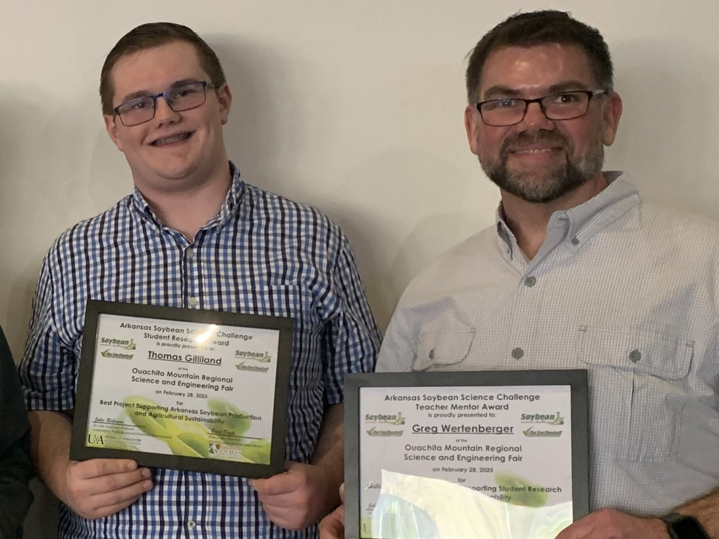

Ouachita Mountain Regional Science and Engineering Fair Senior Division Thomas Gilliland and teacher-mentor Greg Wertenberger