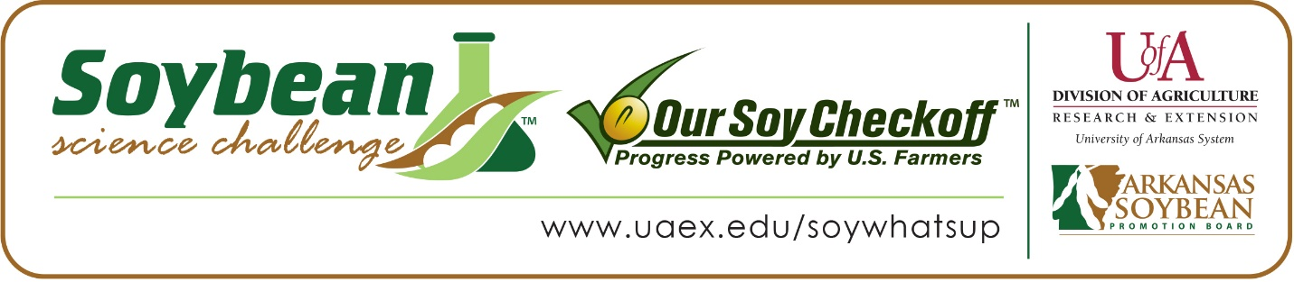

Emilee Webb and Taylor Melton win 2020 Soybean Science Challenge Awards at State and Regional Science Fairs
Emilee Webb, 17 and Taylor Melton,18, both seniors at Poyen High School in Poyen won the 2020 Soybean Science Challenge (SSC) Honorable Mention Award at the virtual Southwestern Energy State Science and Engineering Fair, April 3. The team also won the Regional SSC Award at the Ouachita Mountain Regional Science and Engineering Fair held at the Mid-America Science Museum in Hot Springs, March 6.
Webb and Melton received a $250 cash award for their State Fair Honorable Mention and a $300 cash regional award to be split among them. The awards were provided by the Arkansas Soybean Promotion Board. Their science project titled ‘Deadly Deterioration, what’s really in your drink’ also received first place in Materials Science at the regional fair and was awarded an ISEF Finalist position.
Amanda Jones, Webb and Melton’s teacher, won the $100 Soybean Science Challenge Honorable Mention Teacher Mentor Award for state and the $200 SSC Teacher Mentor award for regional. Jones noted The Soybean Science Challenge provides students across the state an excellent opportunity to learn more about soy products and their impact on the state’s economy. “It is a great learning experience for my students to develop their own research project while learning about such a valuable product to our state. This program also offers monetary awards to students for their research efforts which is a huge incentive to students,” she stated.
Webb and Melton said they were very happy to win the 2020 Soybean Science Challenge at state and regional, feeling it was quite an honor. “Our project was very eye-opening and we are glad we got to share our findings with our region and to be able to continue to share them at the state and international level. We hope that our research can help make a difference and inspire others to do further work with this topic. These awards are an incredible honor, and we are so thankful to have been given them,” they replied.
Both Emilee’s and Taylor’s parents were very excited they won an award at both the regional and state level. They were glad to see their children’s hard work pay off and to present their findings to others.
The part of the Soybean Science Challenge course that appealed most to Emilee and Taylor was learning about how much soybeans impact the state’s economy. “This topic directly relates to my life and the lives of all Arkansans,” Emilee stated. Taylor agreed, “Soybeans are used in some way by almost all Arkansans on a day-to-day basis and it is important that we are able to maintain a stable yield for years to come,” he replied.
Jones noted Emilee and Taylor gained a wealth of knowledge about soybeans from the Soybean Science Challenge. “They both enjoy learning about new topics and this process was very exciting for them as their research provided a way to learn something new each day. This entire procedure was a wonderful experience for each of them as they learned about the importance of research, product development and the scientific process throughout The Challenge. They also gained the experience of working collaboratively to solve a scientific problem and gained valuable presentation skills by submitting their project for judging,” she stated.

“The Soybean Science Challenge provides an opportunity for Arkansas High School students to participate in scientific research that can impact the State of Arkansas as well as the world. Soybean Science Challenge student researchers learn about this important commodity crop and its many uses including feeding the world, development of biofuels and sustainable products. The Soybean Science Challenge helps students develop an understanding of the challenges and complexities of modern farming,” said Dr. Julie Robinson, Associate Professor and director of the program.
“The goal of the Arkansas Soybean Science Challenge is to engage students in “real world” education to support soybean production and agricultural sustainability,” said Gary Sitzer, a former member of the Arkansas Soybean Promotion Board. “The program also rewards scientific inquiry and discovery that supports the Arkansas Soybean Industry.”
The Arkansas Soybean Science Challenge was launched in January 2014 to 9-12th grade science students. Students who successfully completed the online course were eligible to have their original soybean-related research projects judged at the 2020 ISEF-affiliated Arkansas Science and Engineering Fairs.
Information on the 2020-2021 Arkansas Soybean Science Challenge will be available in summer 2020. For more information, contact Dr. Julie Robinson at jrobinson@uaex.edu or Diedre Young at dyoung@uaex.edu.
The Cooperative Extension Service is part of the University of Arkansas System Division of Agriculture.

Emilee Web and Taylor Melton, Poyen High School. Teacher: Amanda Jones
Category: Materials Science
Project Title: Deadly Deterioration: What’s really in your drink?
Abstract:
Styrofoam may be thought of as a convenient product to make cups, however, what most people do not know is that they are actually consuming part of their cup. After noticing our teacher’s drink had obvious holes forming in her cup after drinking limeade, we decided to take a deeper look into what was actually causing this deterioration. To test this, we took Styrofoam cups from a popular fast food restaurant and put the proportional amount of lemons or limes in each cup that the restaurant would put in. Soda and water were also tested with water as the control. After just one hour, holes in the cups with the lemons and limes began to form. This Styrofoam is now part of the drink. The World Health Organization has recently named Styrofoam as a probable carcinogen. To prevent this harmful substance from leaking into drinks, we believed soybean oil would produce a protective coat on the cup. When a soybean coating surrounded the interior of the cup, no holes formed after one hour. After 24 hours, only a few holes formed and not every cup had holes. Soybean oil is a cheap, tasteless and odorless protectant that may prevent a toxic buildup of styrene within humans.
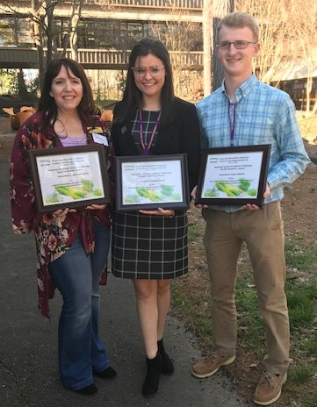
Emilee Webb and Taylor Melton, Southwestern Energy State Science and Engineering Fair Soybean Science Challenge Honorable Mention Winners and Ouachita Mountain Regional Science and Engineering Fair Winners. Amanda Jones, Teacher-Mentor.

