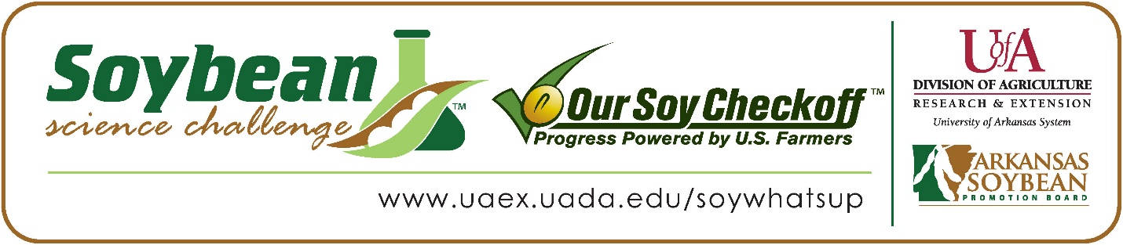

**Sydney Wolf wins 2023 Arkansas Soybean Science Challenge Senior Division at Northeast Arkansas Regional Science Fair**

Sydney Wolf, 16, a junior at The Academies at Jonesboro High School won the 2023 Senior Division award at Northeast Arkansas Regional Science Fair at Arkansas State University Jonesboro March 10.

Wolf received a $300 cash award for her regional win. Awards were provided by the Arkansas Soybean Promotion Board. Her science project titled “How Does Planting Configuration and Irrigation Method Affect Soybean Growth” placed first in plant science, took first place overall, won the Geography Award, and received one of the ISEF finalist awards.

Allyson Goodin, Sydney’s teacher, won the $200 regional award. Goodin stated that the Soybean Science Challenge is a great way to learn about the science behind soybeans in the classroom. “The Challenge allowed my students to gain new knowledge about the impact of soybeans on their everyday life. It also allowed them to participate at their own pace. This helps my students put time management skills into action,” she explained.

Sydney said she was happy to win the Senior Division Soybean Science Challenge. “I have really enjoyed participating in the Soybean Science Challenge the last two years and I was very excited to win,” she replied.

Mr. and Mrs. Wolf, Sydney’s parents, were very proud to see her receive the award. "It was wonderful to see Sydney’s hard work and dedication to her project acknowledged by winning this award,” they stated.

Goodin expounded on why the Soybean Science Challenge is so important. “I offer the Soybean Science Challenge as an opportunity to my students. They choose to participate, and it is not mandatory in my classroom. It is a great self-paced course that allows the students to learn so much about this important Arkansas crop,” she stated.

Sydney explained what she had learned about participating in The Challenge. “I have a greater appreciation for farmers who dedicate their time and hard work to ensure crop success. I also learned in my participation in the Soybean Science Challenge how many other people with different careers help ensure the crop succeeds as well,” she stated.

“The Soybean Science Challenge provides an opportunity for Arkansas junior high and high school students to participate in scientific research that can impact the State of Arkansas as well as the world. Soybean Science Challenge student researchers learn about this important commodity crop and its many uses including feeding the world, development of biofuels and sustainable products. The Soybean Science Challenge helps students develop an understanding of the challenges and complexities of modern farming,” said Dr. Julie Robinson, Associate Professor and director of the program.

“The goal of the Arkansas Soybean Science Challenge is to engage students in “real- world” education to support soybean production and agricultural sustainability,” said Gary Sitzer, a former member of the Arkansas Soybean Promotion Board. “The program also rewards scientific inquiry and discovery that supports the Arkansas Soybean Industry.”

The Arkansas Soybean Science Challenge was launched in January 2014 to 9-12th grade science students. Students who successfully completed the online course were eligible to have their original soybean-related research projects judged at the 2023 ISEF-affiliated Arkansas Science and Engineering Fairs.

Information on the 2023-2024 Arkansas Soybean Science Challenge will be available in summer 2023. For more information, contact Dr. Julie Robinson at [jrobinson@uada.edu](mailto:jrobinson@uada.edu) or Diedre Young at [dyoung@uada.edu](mailto:dyoung@uada.edu).

The Cooperative Extension Service is part of the University of Arkansas System Division of Agriculture.

**Sydney Wolf, The Academies at Jonesboro High School, Jonesboro, Arkansas; Teacher: Allyson Goodin**

**Category: Plant Science**

**Title: How Does Planting Configuration and Irrigation Method Affect Soybean Growth?**

**Abstract:** The purpose of this field study is to observe which planting configuration method produces the highest yield for farmers. The planting configurations of twin row, single row, and broadcast will be used in soybean fields and then observed by their growth as well as their yield. The second part of my field study tests the need for irrigation in farming. Two broadcast fields will be evaluated through one dry farmed field and one irrigation flooded field. I predict the number of soybeans planted in a row, directly affects the yield produced. Also, I predict the irrigated broadcast will have an improved yield and growth pattern compared to the dry farmed broadcast.

The soybean fields were checked on an average of every two weeks for the growth in height and width of the soybean plant, leaf length and width, and any additional changes to the plant. The height of the plant was measured from the ground to the tallest leaf and the width was measured from the furthest leaf to the right to the furthest leaf to the left. Examples of additional observations are bean count, the appearance of blooms, as well as yield. The twin row and single row shared a field equally, while there were two separate broadcast fields. The fields were treated similarly, however, there were a few differences. The twin and single row fields were watered using the furrow irrigation method ten times throughout the growing season, while flood irrigation was used three times on the irrigated broadcast field. The other broadcast field was dry farmed which means it received no extra water other than rainfall. The single row and twin row fields were also sprayed for worms through border application by a crop duster as recommended by the agriculture consultant. Towards the end of the growing season, the single row, twin row, and irrigated broadcast fields were pre-harvest crop desiccated; however, the dry farmed broadcast field was not desiccated due to the dry ground and lack of moisture in the soybean plant. Sodium chloride (desiccate used) provides desiccation of weeds and soybeans plants by drawing moisture out of the plant tissue and seeds. This process allows for a faster harvest versus farmers waiting for the soybean plants to die naturally.

Once the final data was collected and analyzed, it was found the original hypothesis of the number of soybeans directly affecting the yield is supported by the twin row field. At the end of the growing season, the twin row field had the largest growth as well as the highest yield. Overall, the single row and twin row fields grew similarly for most of the study. Additionally, the yield of the twin row was 2.5 bushels per acre higher than the yield of the single row. However, the difference in yield between the irrigated broadcast and the twin row was 18.5 bushels per acre with the twin row having the higher yield. The irrigated broadcast proved that irrigation improves yield and growth patterns in broadcast fields. The dry farmed broadcast was recorded as having the lowest growth for most of the study. It is important to note, the dry farmed broadcast field continued to increase in height, while the irrigated broadcast decreased due to being salted. The irrigation broadcast field had a 63 bushels per acre yield, while the dryland broadcast produced a yield of 24 bushels per acre. There is a 39 bushel per acre difference between irrigation and dry farming.

In conclusion, the student was able to accept both parts of the hypothesis due to the support of the study results. Farmers can utilize twin rows to produce a greater yield. If a farmer were to plant using the broadcast configuration, then it is proven that irrigation will help improve the yield as well. The data from this field study can be used in any area of the world as long as the soil type and the growing season are similar.

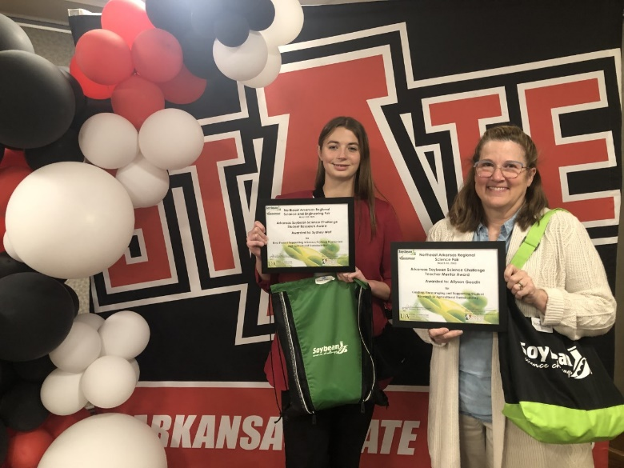

Northeast Arkansas Regional Science Fair SeniorDivision Winner Sydney Wolf and Teacher-Mentor Allyson Goodin.