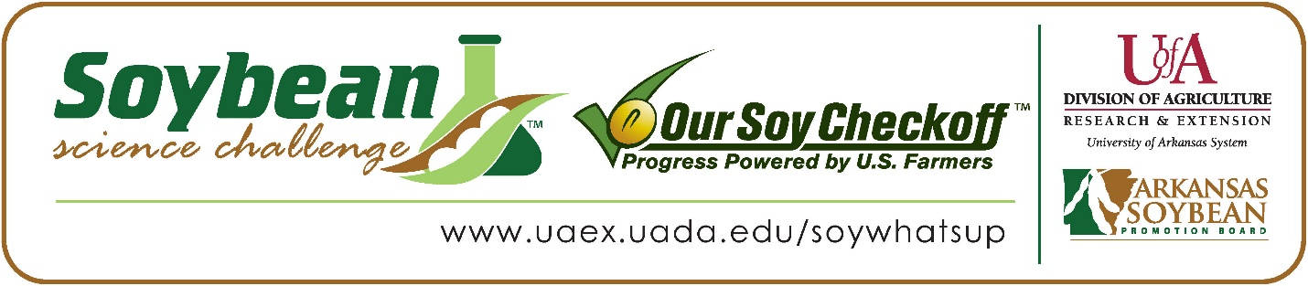

Sydney Wolf wins 2022 Arkansas Soybean Science Challenge Second Place Award at Arkansas State Science and Engineering Fair and regional award at Northeast Arkansas Regional Science Fair
Sydney Wolf, 15, a sophomore at The Academies at Jonesboro High School won the 2022 Soybean Science Challenge (SSC) Second Place Award at the Arkansas State Science and Engineering Fair April 1, and the regional award at Northeast Arkansas Regional Science Fair March 11.
Wolf received a $500 cash award for her SSC Second Place finish at State and a $300 cash award for her regional win. Awards were provided by the Arkansas Soybean Promotion Board. His science project titled “Does overcrowding affect the growth of soybeans” placed first in plant science and was awarded second place overall and one of the ISEF finalist awards at the regional level.

Allyson Goodin, Sydney’s teacher, won the $200 State Soybean Science Challenge Second Place Teacher-Mentor Award and the $200 regional award. Goodin stated that the Soybean Science Challenge is a great way to learn about the science behind soybeans in the classroom. “I offered the Soybean Science Challenge to my students because I thought it was a great opportunity to learn more about agriculture in our state. It also provided a chance to practice their critical thinking skills and communication skills,” she explained.
Wolf said it was amazing to receive Second Place in the State Soybean Science Challenge. “It was a blast to compete in the SSC this year! I learned through the judging process what aspects are appealing to farmers like large yields and low production costs,” she replied.
Mr. and Mrs. Wolf, Sydney’s parents, were very proud to see her receive both awards. "We were very proud of Sydney! It was great to see her hard work recognized,” they stated.
Goodin expounded on why the Soybean Science Challenge is so important. “This experience really is bringing my shy students out of their shells. I also love that they have learned to take the initiative to use the computers and printers in my classroom to create their presentations. They figured out how to print directly from their own laptops. Win! It was also fun to see them share about how much their beans were or weren't growing. Other students would often ask them questions and give comments about the projects,” she replied.
Goodin also explained why soybean research and the Soybean Science Challenge is so important in the classroom. “Since my student's participation in the Soybean Science Challenge, I have gained new knowledge for myself and gained another great tool to get my students engaged in their learning. This challenge enables me to work with students one on one and really help develop those important critical thinking and communication skills. My students and I also learned that it is okay to fail. Sometimes the experiment, presentation or display does not turn out how you thought it would. But you learn, grow and always try to do better the next time.” she stated.
“The Soybean Science Challenge provides an opportunity for Arkansas junior high and high school students to participate in scientific research that can impact the State of Arkansas as well as the world. Soybean Science Challenge student researchers learn about this important commodity crop and its many uses including feeding the world, development of biofuels and sustainable products. The Soybean Science Challenge helps students develop an understanding of the challenges and complexities of modern farming,” said Dr. Julie Robinson, Associate Professor and director of the program.
“The goal of the Arkansas Soybean Science Challenge is to engage students in “real- world” education to support soybean production and agricultural sustainability,” said Gary Sitzer, a former member of the Arkansas Soybean Promotion Board. “The program also rewards scientific inquiry and discovery that supports the Arkansas Soybean Industry.”
The Arkansas Soybean Science Challenge was launched in January 2014 to 9-12th grade science students. Students who successfully completed the online course were eligible to have their original soybean-related research projects judged at the 2022 ISEF-affiliated Arkansas Science and Engineering Fairs.
Information on the 2022-2023 Arkansas Soybean Science Challenge will be available in summer 2022. For more information, contact Dr. Julie Robinson at jrobinson@uada.edu or Diedre Young at dyoung@uada.edu.
The Cooperative Extension Service is part of the University of Arkansas System Division of Agriculture.

Sydney Wolf, The Academies at Jonesboro High School, Jonesboro, Arkansas; Teacher: Allyson Goodin
Category: Plant Science
Title: Does overcrowding affect the growth of soybeans?
Abstract:
To investigate this idea, the student planted one to eight seeds of 2 different varieties of soybeans in 5 containers each. The seeds were spaced the same distance from each other depending on the number of seeds in the container. She tracked the growth over the span of two weeks. Every other day, the soybeans were watered with 3 tablespoons of regular water. Then the next day, the soybeans were watered with a spray bottle. The plants were set on a windowsill to ensure sunlight. Each was planted in the Aquarium Grave on the bottom for drainage then Expert Gardener potting mix, in the cutout bottom of a milk jug. The first variety is Roundup soybeans, and the second variety is Tofu soybeans. The independent variable was the number of soybeans in each container. The dependent variable was the growth of the soybean plants. The controlled variables were the amount and type of water given, the amount of sunlight, the type of plants, and the type of soil.
After analyzing the data, it was found that soybeans could grow more when close together, than when alone. On the sixth day, some of the seeds in both varieties sprouted. The growth of every container of soybeans continued to progress daily. However, contradicting the hypothesis, the containers with higher amounts of seeds grow more exponentially compared to the container with a single seed. On day 10, the average growth of the eight seeds container to the one seed container for variety one is 7.06 to 3.50, which gives us evidence that the null hypothesis is true. The null hypothesis is also true when looking at the variety twos average growth of the two containers which is 3.19 to 2.8. This style of growth was continued throughout the entire experiment. All of the containers had at least the majority of the soybeans sprout.
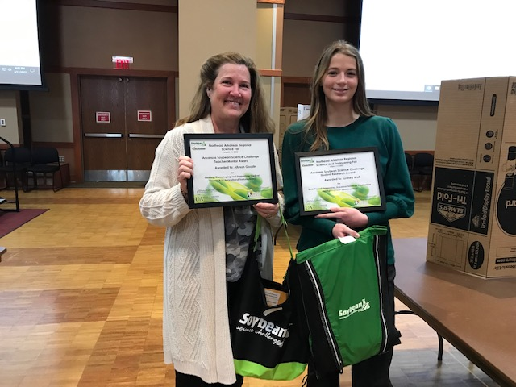
Arkansas State Science Fair Second Place Winner and Northeast Arkansas Regional Science Fair Winner Sydney Wolf on the right and Teacher-Mentor Allyson Goodin on the left.

