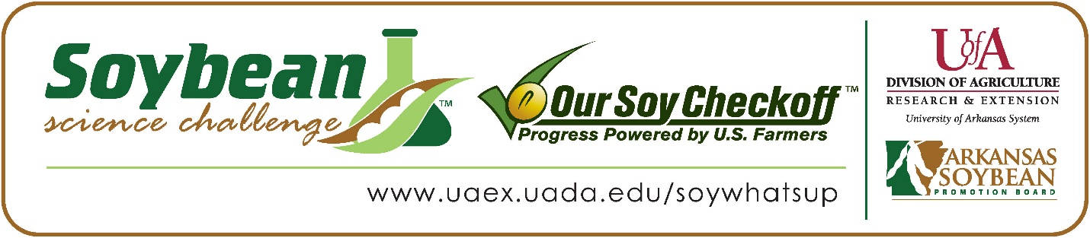
Suleyman Acikgoz wins 2024 Arkansas Soybean Science Challenge Junior Division Award at the Central Arkansas Regional Science and Engineering Fair
Suleyman Acikgoz, 13, an 8th grader at Lisa Academy West Middle School, won the Soybean Science Challenge Junior Division award at the 2024 Central Arkansas Regional Science and Engineering Fair held at the University of Arkansas Little Rock on March 1.
Suleyman received a $200 cash award provided by the Arkansas Soybean Promotion Board. His science project titled “What is the Effect of Magnetic Fields on the Germination and Water Absorption of Soybeans?” also placed first in Environmental Science.
Sevcan Acikgoz, Suleyman’s teacher, won the $100 Soybean Science Challenge Junior Division Teacher-Mentor Award. Acikgoz stated the Soybean Science Challenge is a great way to get students interested in agriculture. “Soybean Science Challenge offers students a chance to learn about soybeans, which is a miracle crop in Arkansas. It prepares them for their future academic opportunities in science and agriculture. Also, involvement in science fairs and competitions with The Challenge can enhance students' resumes and college applications. I encourage all my students to think creatively and come up with innovative solutions to real-world problems,” she replied.
Suleyman was delighted to win the 2024 Junior Division Soybean Science Challenge. “I am proud as well as deeply honored and thankful to my parents, teachers and people who encouraged me to do the Soybean Science Challenge, and I hope to do more projects and expand on soybeans in the future,” he replied.
Bilal and Sevcan Acikgoz, Suleyman’s parents, were very happy to see him receive the award. “We are beyond proud of his hard work, dedication, and passion for agricultural sustainability. His commitment to supporting Arkansas Soybean production is truly commendable. We love him and are excited to see all the amazing things he will achieve in the future,” they stated.
Suleyman was impressed with what he learned from participating in the Soybean Science Challenge. “The interesting and information-containing videos about soybeans, biofuel and other topics were the most appealing part of the Soybean Science Challenge online course to me. I also learned a lot of key topics about soybeans with the course such as how useful they are in not just agriculture but in countless other fields and products. A fascinating sustainability issue of soybeans I found was that they had to be planted at an exact time and if it was too late it wouldn’t grow as well, and this is where I think my project could make a difference,” he explained.
The Soybean Science Challenge provides an opportunity for Arkansas junior high and high school students to participate in scientific research that can impact the State of Arkansas as well as the world. Soybean Science Challenge student researchers learn about this important commodity crop and its many uses including feeding the world, development of biofuels and sustainable products. The Soybean Science Challenge helps students develop an understanding of the challenges and complexities of modern farming,” said Dr. Julie Robinson, Associate Professor, and director of the program.
“The goal of the Arkansas Soybean Science Challenge is to engage students in “real- world” education to support soybean production and agricultural sustainability,” said Gary Sitzer, a former member of the Arkansas Soybean Promotion Board. “The program also rewards scientific inquiry and discovery that supports the Arkansas Soybean Industry.”
The Arkansas Soybean Science Challenge was launched in January 2014 to 9-12th grade science students and in 2021, the SSC added grades 6-8. Students who successfully completed the online course were eligible to have their original soybean-related research projects judged at the 2024 ISEF-affiliated Arkansas Science and Engineering Fairs.
Information on the 2024-2025 Arkansas Soybean Science Challenge will be available in summer 2024. For more information, contact Dr. Julie Robinson at jrobinson@uada.edu or Diedre Young at dyoung@uada.edu or Keith Harris at kharris@uada.edu.
The Cooperative Extension Service is part of the University of Arkansas System Division of Agriculture.
Suleyman Acikgoz, Lisa Academy West Middle School, Little Rock, Arkansas; Teacher, Sevcan Acikgoz
Category: Environmental Science
Title: What is the Effect of Magnetic Fields on the Germination and Water Absorption of Soybeans
Abstract: The aim of this project was to determine the growth and water absorption parameters of soybean plants affected by a magnetic field and to test whether different magnetic forces have a positive or negative effect on soybean growth. The way I did my project was by having 100 grams worth of soybeans in 3 containers each, with 2 magnets (1 strong, 1 weak) in two and no magnet in one to compare them later. Then I tested their water absorption by soaking them in water and waiting 24 hours and measuring their weight again to ﬁnd their water absorption. Afterwards, I measured their germination and growth.
by measuring the percentage of germinated soybean seeds by counting and dividing by the original number. The results I found were the strong magnet had the largest growth out of all in general as well as the best water absorption. In conclusion, my hypothesis was indeed correct, and the results of my research proved that magnetic ﬁelds help boost soybean growth, germination time, and water absorption of soybeans.
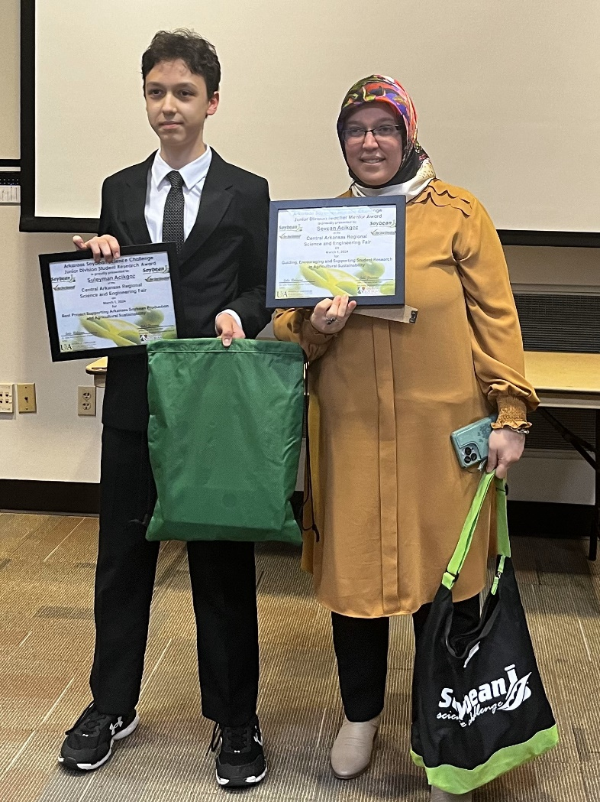

Central Arkansas Regional Science and Engineering Fair Junior Division Soybean Science Challenge winner Suleyman Acikgoz and teacher-mentor, Sevcan Acikgoz.

