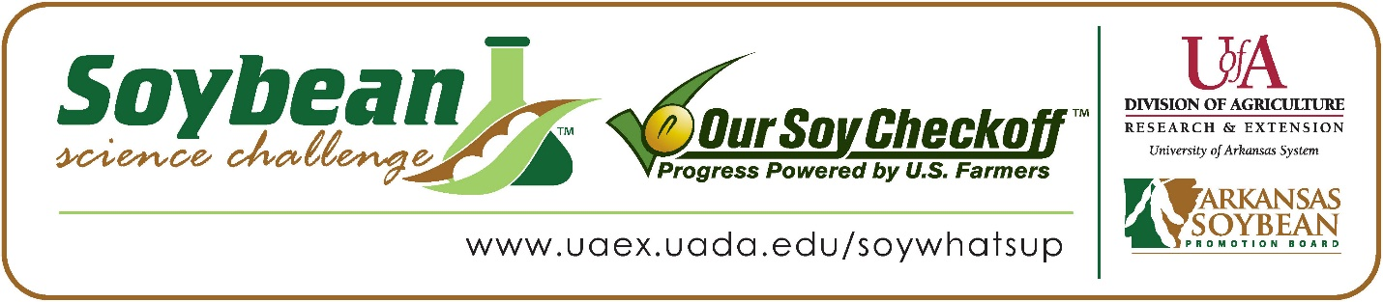
Sara Chen wins 2026 Arkansas Soybean Science Challenge Junior Division Award at the Central Arkansas Regional Science and Engineering Fair
Sara Chen, 13, a 7th grader at Pinnacle View Middle School, won the Soybean Science Challenge Junior Division award at the 2026 Central Arkansas Regional Science and Engineering Fair held at the University of Arkansas Little Rock on February 27. Her project titled ‘Effect of temperature on the germination rate of soybeans’ also placed first in Plant Sciences and qualified for the ThermoFisher Scientific Junior Innovative Challenge.
Kristi Ward, Chen’s teacher, won the $100 Soybean Science Challenge Junior Division Teacher-Mentor Award. Ward stated the Soybean Science Challenge is a great program for students interested in agricultural research. “I encouraged Sara to stay with soybeans a second year and change her variables because I believed she could win. Sarah is self-motivated and enjoys working with soybeans due to their importance in Arkansas,” she replied.
Chen was delighted to win the 2026 Junior Division Soybean Science Challenge. “I was so happy to win this year! I tried last year and didn’t quite get it, so I decided to try and win this year and this year it worked out,” she replied.
Mrs. Chen, Sara’s mother, was very happy to see her receive the award. “I am very proud of her. She put a lot of time and effort into this project. Sara finds that agriculture and careers related to it are interesting, and that agriculture is much more complex than she thought it would be,” she stated.
Sara was impressed with what she learned from participating in the Soybean Science Challenge. “I found soybean’s versatility very interesting. I would never have imagined that soybeans could be used to make animal feed, plastic, and even paint. The most useful part of the SSC online course for me was learning about soybean growth stages, and how important this plant is in the world’s agriculture,” she explained.
The Soybean Science Challenge provides an opportunity for Arkansas junior high and high school students to participate in scientific research that can impact the State of Arkansas as well as the world. Soybean Science Challenge student researchers learn about this important commodity crop and its many uses including feeding the world, development of biofuels and sustainable products. The Soybean Science Challenge helps students develop an understanding of the challenges and complexities of modern farming,” said Dr. Julie Robinson, Professor, and director of the program.
“The goal of the Arkansas Soybean Science Challenge is to engage students in “real- world” education to support soybean production and agricultural sustainability,” said Gary Sitzer, a former member of the Arkansas Soybean Promotion Board. “The program also rewards scientific inquiry and discovery that supports the Arkansas Soybean Industry.”
The Arkansas Soybean Science Challenge was launched in January 2014 to 9-12th grade science students and in 2021, the SSC added grades 6-8. Students who successfully completed the online course were eligible to have their original soybean-related research projects judged at the 2026 ISEF-affiliated Arkansas Science and Engineering Fairs.
Information on the 2026-2027 Arkansas Soybean Science Challenge will be available in summer 2026. For more information, contact Dr. Julie Robinson at jrobinson@uada.edu, or Keith Harris at krharris@uada.edu, or Diedre Young at dyoung@uada.edu.
The Cooperative Extension Service is part of the University of Arkansas Division of Agriculture.
Sara Chen, Pinnacle View Middle School, Little Rock, Arkansas; Teacher, Kristi Ward
Category: Plant Science
Title: Effect of Temperature on the Germination Rate of Soybeans.
Abstract: My project explores the effect of increasing temperature on the germination rate of soybeans. I decided to investigate this question to better understand how changes in temperature due to global warming affect the growth of soybeans, specifically, the rate at which they germinate, as this information would allow farmers to make informed decisions regarding when and where to plant soybeans. I set up 5 different test groups of Korean sprouting soybeans, each at a different temperature (starting at 24℃ and increasing at intervals of 4℃). I germinated soybeans for 3 days under controlled conditions (identical watering time, amount and frequency; volume of soybeans, type of heat pad, etc.) and then determined the percentage of soybeans that germinated in each group. Results showed that my hypothesis, that germination rates decrease as temperatures increase from 24℃ to 40℃ was correct. In addition, the germination rate dropped off rapidly around 32℃. I repeated the experiment at 2-degree intervals from 26 - 34℃, with similar results.

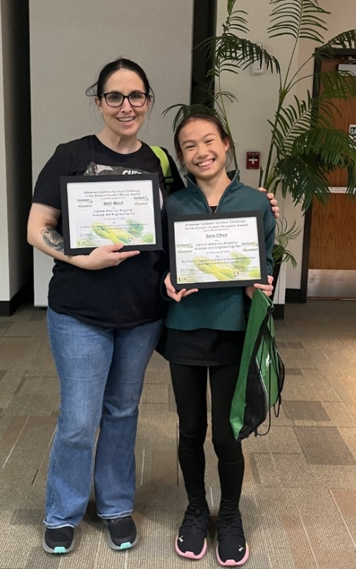

Central Arkansas Regional Science and Engineering Fair Junior Division Soybean Science Challenge winner Sarah Chen and Teacher-mentor, Kristi Ward.

