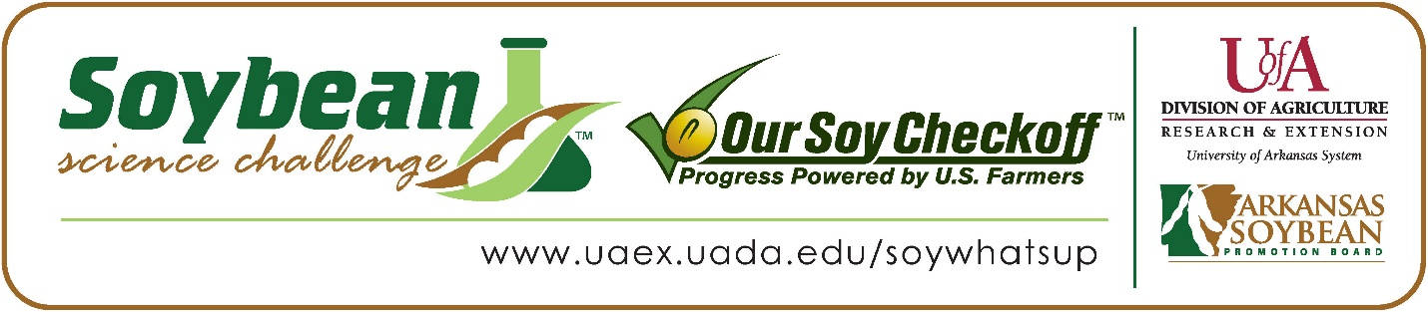

Noah Beard wins 2022 Arkansas Soybean Science Challenge Junior Division Award at the Southwest Arkansas Regional Science Fair
Noah Beard age 13, a 7th grader at Bearden High School in Bearden, won the Soybean Science Challenge Junior Division award at the 2022 Southwest Arkansas Regional Science Fair held Southern Arkansas University on March 11.
Beard received a $200 cash award provided by the Arkansas Soybean Promotion Board. His science project titled “Poop for plants”, also received third place in plant sciences.
Jackie Raney, Beard’s teacher, won the $100 Soybean Science Challenge Junior Division Teacher-Mentor Award. Raney stated that the Soybean Science Challenge is a great way to be introduced to agricultural research. “I allowed my students to choose a project that they would enjoy and be meaningful to them. Noah works with animals through 4H, so this was perfect for him. He enjoyed and learned a lot from this project” she replied.
Beard was thrilled to win the 2022 Junior Division Soybean Science Challenge. “It was an honor, and I was glad to have the chance to participate,” he stated.
Cleo and Shannon Beard, Noah’s parents, were very happy to see him receive the award. “We were very proud to see what he had accomplished,” they responded.
Noah was impressed at what he learned in the online course. “I learned that farmers are using cutting edge technology to grow soybean crops,” he said.
Raney explained that Noah learned a lot from participating in The Challenge this year. “Noah gained knowledge that he would be able to use in the future. He found the courses to be interesting and learned several things from them. He wants to continue to use his animals for other projects to continue his learning,” she replied.
“The Soybean Science Challenge provides an opportunity for Arkansas Junior High and High School students to participate in scientific research that can impact the State of Arkansas as well as the world. Soybean Science Challenge student researchers learn about this important commodity crop and its many uses including feeding the world, development of biofuels and sustainable products. The Soybean Science Challenge helps students develop an understanding of the challenges and complexities of modern farming,” said Dr. Julie Robinson, Associate Professor and director of the program.
“The goal of the Arkansas Soybean Science Challenge is to engage students in “real- world” education to support soybean production and agricultural sustainability,” said Gary Sitzer, a former member of the Arkansas Soybean Promotion Board. “The program also rewards scientific inquiry and discovery that supports the Arkansas Soybean Industry.”
The Arkansas Soybean Science Challenge was launched in January 2014 to 9-12th grade science students. In 2021, the Junior Division award was added for grades 6-8. Students who successfully completed the online course were eligible to have their original soybean-related research projects judged at the 2022 ISEF-affiliated Arkansas Science and Engineering Fairs.
Information on the 2022-2023 Arkansas Soybean Science Challenge will be available in summer 2021. For more information, contact Dr. Julie Robinson at jrobinson@uada.edu or Diedre Young at dyoung@uada.edu.
The Cooperative Extension Service is part of the University of Arkansas System Division of Agriculture.
Noah Beard, Bearden High School, Bearden, Arkansas; Teacher, Jackie Raney
Category: Plant Sciences
Title: Poop for plants
Abstract:
The purpose of this experiment is to figure out which of my animal’s manure I can do my farming with.
My hypothesis is that that chicken manure would help grow faster because it is the most used by famers
I collected a equal amount of chicken rabbit and goat manure and mixed it with potting soil in the same size pots, I let it grow for 5 weeks and measured it at the end of every week.
Data: every plant grew some, and some even shrunk, but the chicken grew the most in width and height
Conclusion: the chicken grew the plant most in width and height, so my hypothesis was correct!

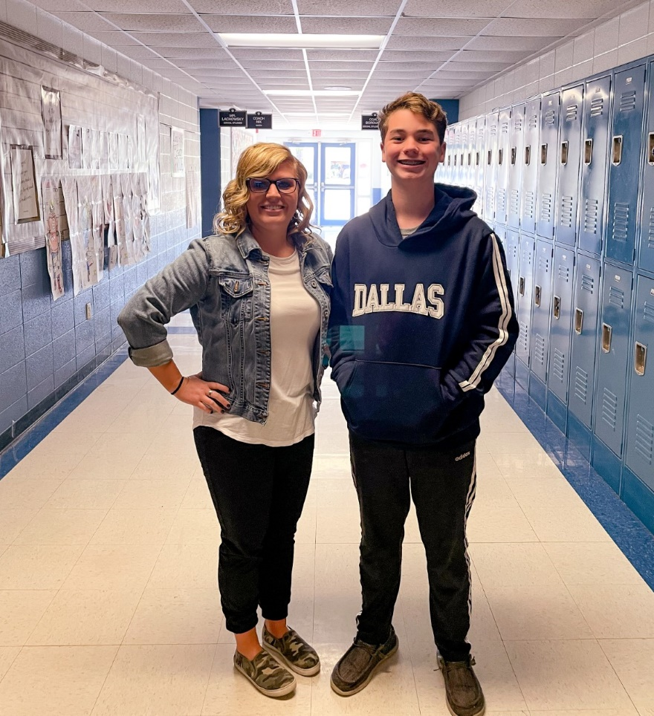

Southwest Arkansas Regional Science Fair Junior Division winner Noah Beard on the right, and Teacher-Mentor, Jackie Raney on the left.

