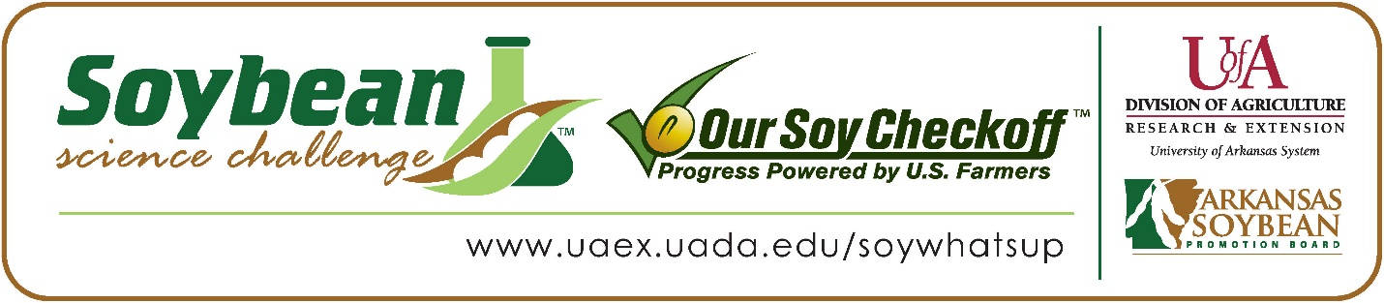

**Aiden Watson wins 2023 Arkansas Soybean Science Challenge Junior Division Award at the Southwest Arkansas Regional Science Fair**

Aiden Watson age 13, a 7th grader at Emerson High School in Emerson, won the Soybean Science Challenge Junior Division award at the 2023 Southwest Arkansas Regional Science Fair held at Southern Arkansas University-Magnolia on March 31.

Watson received a $200 cash award provided by the Arkansas Soybean Promotion Board. His science project is titled “The effect of oil spills on soybean plant growth”, also placed first at Emerson science fair in Agriculture/Environmental Science, and second in the Conservation District category at SAU.

Jessi Glass, Watson’s teacher, won the $100 Soybean Science Challenge Junior Division Teacher-Mentor Award. Glass stated that the Soybean Science Challenge is a great way to become familiar with agricultural research. “The Soybean Science Challenge is a great way to introduce students to the interaction of farming and environmental science” she replied.

Watson was thrilled to win the 2023 Junior Division Soybean Science Challenge. “I was flabbergasted!” he stated.

Amanda Watson, Aiden’s parent, was very proud to see him receive the award. “I am so proud of Aiden for accepting the challenge and following through with it,” she responded.

Aiden was impressed at what he learned in the online course. “I learned all sorts of new things that farmers are using to grow soybean crops,” he said.

Glass explained that she benefited from Aiden’s participating in The Challenge this year. “I learned that soybeans are affected by oil runoff, and oil runoff is a current issue we need to address,” she replied.

“The Soybean Science Challenge provides an opportunity for Arkansas Junior High and High School students to participate in scientific research that can impact the State of Arkansas as well as the world. Soybean Science Challenge student researchers learn about this important commodity crop and its many uses including feeding the world, development of biofuels and sustainable products. The Soybean Science Challenge helps students develop an understanding of the challenges and complexities of modern farming,” said Dr. Julie Robinson, Associate Professor, and director of the program.

“The goal of the Arkansas Soybean Science Challenge is to engage students in “real- world” education to support soybean production and agricultural sustainability,” said Gary Sitzer, a former member of the Arkansas Soybean Promotion Board. “The program also rewards scientific inquiry and discovery that supports the Arkansas Soybean Industry.”

The Arkansas Soybean Science Challenge was launched in January 2014 to 9-12th grade science students. In 2021, the Junior Division award was added for grades 6-8. Students who successfully completed the online course were eligible to have their original soybean-related research projects judged at the 2023 ISEF-affiliated Arkansas Science and Engineering Fairs.

Information on the 2023-2024 Arkansas Soybean Science Challenge will be available in summer 2023. For more information, contact Dr. Julie Robinson at [jrobinson@uada.edu](mailto:jrobinson@uada.edu) or Diedre Young at [dyoung@uada.edu](mailto:dyoung@uada.edu).

The Cooperative Extension Service is part of the University of Arkansas System Division of Agriculture.

**Aiden Watson, Emerson High School, Emerson, Arkansas; Teacher, Jessi Glass**

**Category: Plant Sciences**

**Title: The effect of oil spills on soybean runoff**

**Abstract:**

 This experiment was designed to test how oil spills affected the growth of soybean plants. Seven materials were used, including 2700 mL of soil, 18 pots, 54 soybean seeds, 1,350 mL of water, 1 pint of motor oil, 1 beaker, and 1 dropper. The soybean plants with the most oil grew to the largest size, the plant with nine drops of oil grew up to an average of 21.93 cm, and the plants with just pure water grew only to an average height of 16.71 cm. The hypothesis that the plants with the least amount of oil would grow the tallest was rejected. The first time we watered the plants, the oil stuck to the beaker, which is why we changed to dropping the oil in, allowing us to distribute the oil between the plants equally.

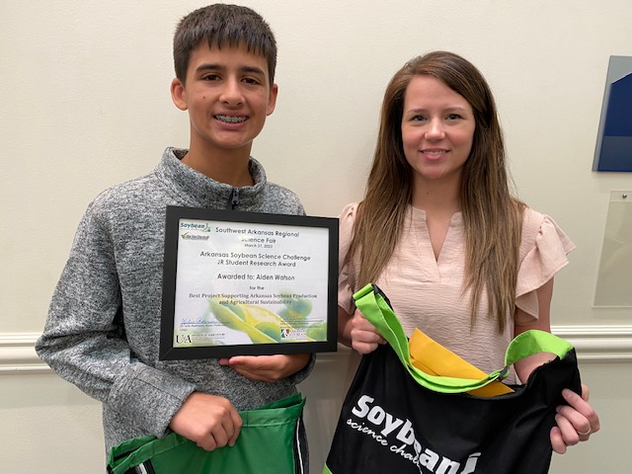

Southwest Arkansas Regional Science Fair Junior Division winner Aiden Watson, and Teacher-Mentor, Jessi Glass.