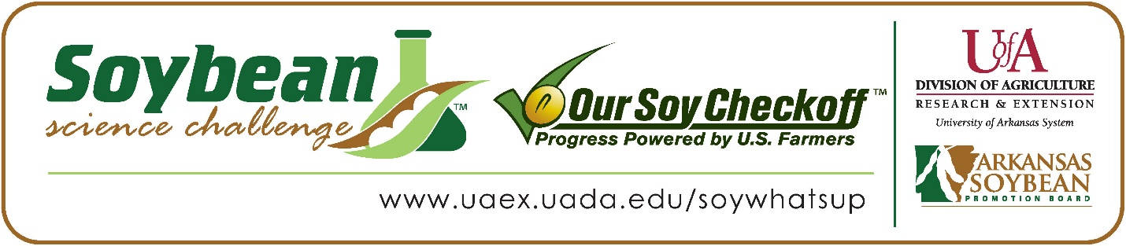

**Rini Eluvathingal wins 2023 Arkansas Soybean Science Challenge Second Place Award at Arkansas State Science and Engineering Fair**

Rini Eluvathingal, 14, a freshman at Little Rock Central High School won the 2023 Soybean Science Challenge (SSC) Second Place Award at the Arkansas State Science and Engineering Fair in Conway, Arkansas April 1.

Rini received a $500 cash award for her SSC Second Place finish at State. Awards were provided by the Arkansas Soybean Promotion Board. Her science project titled “Effects of Biochar and SAPs on water holding capacity of soil” also placed third in Environmental Management, and second in Environmental Sciences for Junior Academy of Sciences.

William Drew, Rini’s teacher, won the $200 State Soybean Science Challenge Second Place Teacher-Mentor Award. Drew stated that the Soybean Science Challenge is a great way to learn about presenting research in a competitive setting. “Rini gained a great deal of confidence by participating.  She did a great deal of work, and it was her chance to show it off,” he explained.

Rini said it was amazing to receive Second Place in the State Soybean Science Challenge. “I honestly wasn't expecting to win. Winning the Soybean Science Challenge was always like something out of reach, so I was very shocked when I heard I got second place, especially when the other projects that won were phenomenal,” she replied.

Mr. and Mrs. Eluvathingal, Rini’s parents, were very proud to see her receive the award. " We were excited when we heard our daughter's name announced for second place,” they stated.

Rini expounded on how she prepared for the Soybean Science Challenge. “To prepare for the State Science Fair, I researched soybean's water consumption needs. How biochar and Super Absorbent Polymers (SAPs) affect water holding capacity and how that will impact soybean growth and yield. I also researched other advantages to using biochar and SAPs like nutrient retention and how biochar and SAPs perform when compared to other methods already in place to increase water holding capacity like no till farming. I also researched how much money goes into buying biochar and how long the effects last” she replied.

“The Soybean Science Challenge provides an opportunity for Arkansas junior high and high school students to participate in scientific research that can impact the State of Arkansas as well as the world. Soybean Science Challenge student researchers learn about this important commodity crop and its many uses including feeding the world, development of biofuels and sustainable products. The Soybean Science Challenge helps students develop an understanding of the challenges and complexities of modern farming,” said Dr. Julie Robinson, Associate Professor and director of the program.

“The goal of the Arkansas Soybean Science Challenge is to engage students in “real- world” education to support soybean production and agricultural sustainability,” said Gary Sitzer, a former member of the Arkansas Soybean Promotion Board. “The program also rewards scientific inquiry and discovery that supports the Arkansas Soybean Industry.”

The Arkansas Soybean Science Challenge was launched in January 2014 to 9-12th grade science students. Students who successfully completed the online course were eligible to have their original soybean-related research projects judged at the 2023 ISEF-affiliated Arkansas Science and Engineering Fairs.

Information on the 2023-2024 Arkansas Soybean Science Challenge will be available in summer 2023. For more information, contact Dr. Julie Robinson at [jrobinson@uada.edu](mailto:jrobinson@uada.edu) or Diedre Young at [dyoung@uada.edu](mailto:dyoung@uada.edu).

The Cooperative Extension Service is part of the University of Arkansas System Division of Agriculture.

**Rini Eluvathingal, Little Rock Central High School, Little Rock, Arkansas; Teacher: William Drew**

**Category: Environmental Management**

**Title: Effects of Biochar and SAPs on water holding capacity of soil**

**Abstract:** A major biological concern that has been brought to our attention multiple times is how pollution affects water. A major reason for water pollution is the use of fertilizers and pesticides for agricultural uses such as farming. Fertilizers and pesticides enter water sources through runoff water, which can lead to health risks and not only affect the quality of water but also bacteria growth and algae.

Biochar has been used for many years. Biochar is a porous substance like charcoal that is made through a process called pyrolysis, a more environmentally friendly way to make charcoal. Biochar also has water filtration properties.

This experiment will test how biochar can remove fertilizers from runoff water by measuring the quality of nitrogen, phosphorus, potassium and pH levels of the water. The results of the experiment supported my hypothesis, the more biochar added, the less contamination from fertilizer in the water.

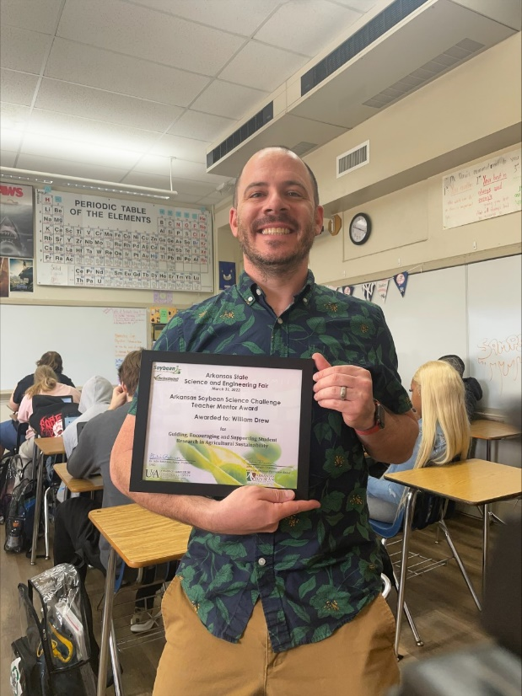

Arkansas State Science Fair Second Place Winner Rini Eluvathingal and Teacher-Mentor William Drew