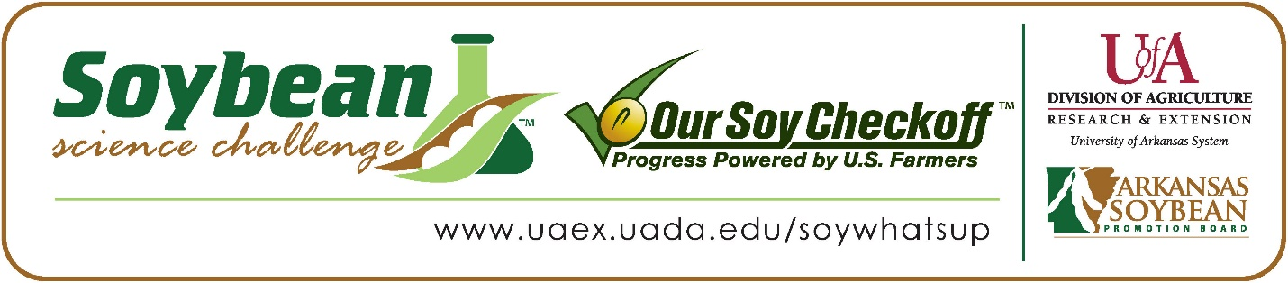
Reagan Smith wins 2026 Arkansas Soybean Science Challenge Award at ASMSA-West Central Arkansas Science Fair
Reagan Smith, 18, a senior at Arkansas School for Mathematics, Sciences, and the Arts (ASMSA) in Hot Springs won the Soybean Science Challenge at the 2026 West Central Science Fair held at ASMSA, February 26.
Reagan received the $400 cash award provided by the Arkansas Soybean Promotion Board at the awards ceremony. Her science fair project titled ‘Soybean salt stress remediation using silica’ also received third place in Plant Sciences.

Dr. Brian Monson, Reagan’s teacher, won the $200 Soybean Science Challenge Teacher Mentor Award. He believes the Soybean Science Challenge helps to motivate students to do better. “The Soybean Science Challenge is one of the most coveted awards at our science fair. It is also beneficial for our students that soybeans germinate quickly and grow well indoors under a grow light which makes them a good choice for wintertime projects,” he explained.
Reagan was honored that her project was chosen to win the Soybean Science Challenge. “I am very honored to receive this award, and I am grateful for the opportunity to have conducted research in a field which such far reaching applications for many people across the world,” she replied.
Raegan’s mother, Lori Smith, was proud that Raegan won the Soybean Science Challenge Award. “It was a moment of great pride because I recognized how much time she dedicated to the quality of her research,” she replied.
Raegan is very appreciative of the Soybean Science Challenge for all that she has learned in the program. “Thanks to the Soybean Science Challenge, I gained both an appreciation for the soybean industry workers in Arkansas’ soybean sector and a newfound love for scientific research,” she explained.

“The Soybean Science Challenge provides an opportunity for Arkansas high school students to participate in scientific research that can impact the State of Arkansas as well as the world. Soybean Science Challenge student researchers learn about this important commodity crop and its many uses including feeding the world, development of biofuels and sustainable products. The Soybean Science Challenge helps students develop an understanding of the challenges and complexities of modern farming,” said Dr. Julie Robinson, Professor, and director of the program.
“The goal of the Arkansas Soybean Science Challenge is to engage students in “real world” education to support soybean production and agricultural sustainability,” said Gary Sitzer, a former member of the Arkansas Soybean Promotion Board. “The program also rewards scientific inquiry and discovery that supports the Arkansas Soybean Industry.”
The Arkansas Soybean Science Challenge was launched in January 2014 for 9-12th grade science students. Students who successfully completed the online course are eligible to have their original soybean-related research projects judged at the 2026 ISEF-affiliated Arkansas Science and Engineering fairs.
Information on the 2026-2027 Arkansas Soybean Science Challenge will be available in summer 2026. For more information, contact Dr. Julie Robinson at jrobinson@uada.edu , Keith Harris at krharris@uada.edu, or Diedre Young at dyoung@uada.edu.
The Cooperative Extension Service is part of the University of Arkansas System Division of Agriculture.
Reagan Smith, Arkansas School for Mathematics, Sciences and the Arts, Hot Springs, AR. Teacher-Dr. Brian Monson
Category: Plant Sciences
Project Title: Soybean salt stress remediation using silica
Soybean farming is an integral part of the U.S. economy, and salt stress on soybean plants can be devastating to crop yield. Previous studies have explored the potential use of silicon and nano-silica to prevent salt stress, but this study explores a novel approach of using amorphous silica gel as a more cost-effective and potentially more effective solution than previous approaches. Silica gel was mixed into soil in 1%, 2%, 5%, and 10% concentrations by weight. The positive control group and negative control group contained no silica gel. The experimental groups and positive control were watered with 1.00 g/L NaCI solution, while the negative control was watered with distilled water. 36 seeds were planted in each group, and the plants grew for 3 weeks during both Trial 1 and Trial 2. Plant height, fresh weight, and dry weight were measured at the conclusion of the experiment. A non-parametric Wilcoxon Rank Sum Test was used to analyze the statistical significance of the data. The Fresh Weight and Dry Weight of Trial 1 resulted in statistically significant p-values, suggesting that silica gel may be an effective method of reducing salt stress in soybean plants. The lack of statistical significance in the second trial can likely be attributed to the fact that the soil was reused for the second trial, which means that the soil already contained salt ions and silica gel. This suggests that silica gel may not be effective over long periods of time.
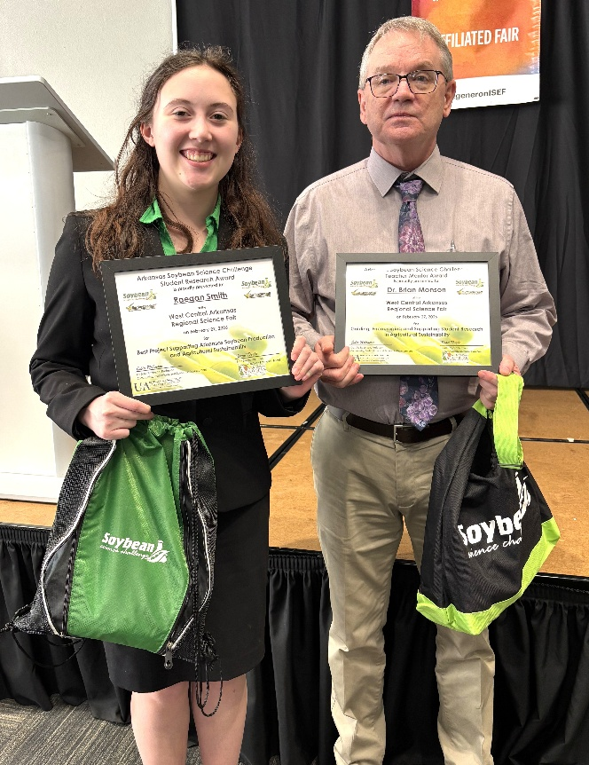

ASMSA West Central Arkansas Science Fair Soybean Science Challenge Winner Raegan Smith and Teacher-Mentor Dr. Brian Monson

