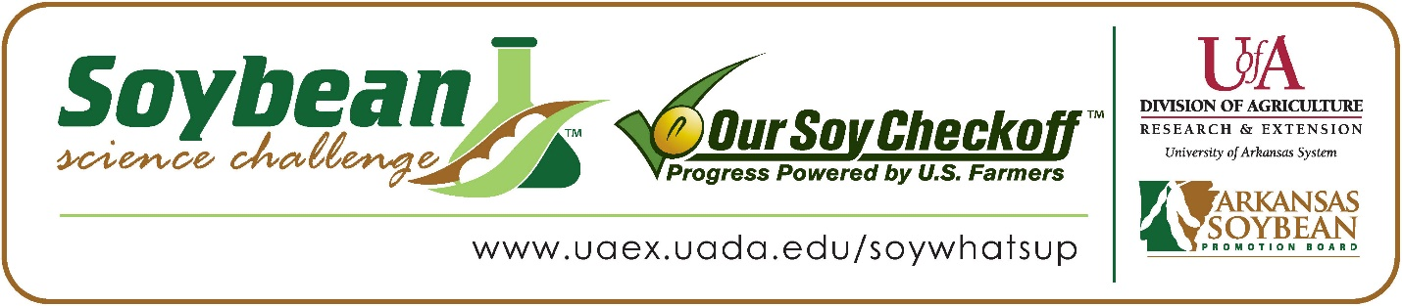
Presley Rogers wins 2026 Arkansas Senior Division Soybean Science Challenge Award at the Ouachita Mountain Regional Science and Engineering Fair
Presley Rogers 14, a freshman at Genoa Central Junior High School in Texarkana, Arkansas, won the Senior Division Soybean Science Challenge at the 2026 Ouachita Mountain Regional Science and Engineering Fair held in Hot Springs, February 20.
Rogers received a $400 cash award provided by the Arkansas Soybean Promotion Board. Her science project is titled ‘How fast can dirty water be cleared using a simple water filter made from common materials’?
Rita Martin, Rogers’ teacher, won the $200 Senior Division Soybean Science Challenge Teacher-Mentor Award. Martin noted that the Soybean Science Challenge allows her students to work with projects that would be a benefit to their area. “I love this award because it gets students interested in how farming works and how important science experimentation is to increase the yield of soybeans each year,” she replied.

Martin also expounded upon what her students learned. “One gain that students always get is practice presenting a project to adult judges. They also gain knowledge about just how much science goes into agriculture and the production of our food,” she explained.
Rogers said winning the 2026 Soybean Science Challenge was quite an honor for her. “It was an incredible honor to win this award. It made me proud of the hard work, research, and time I dedicated to my project, and has motivated me to continue to explore agricultural science and sustainability. Being recognized for my efforts has also encouraged me to explore more advanced research opportunities,” she said.
Crystal Rogers, Presley’s mother, was thrilled about her award. “I am very proud of my daughter for winning the Soybean Science Challenge Award. She worked tirelessly on her own to experiment with various materials to produce an effective water filtration system,” she replied.
The part of the Soybean Science Challenge course that appealed most to Rogers was learning about the impact soybeans have on our everyday lives. “I found it especially interesting to see how soybeans contribute not only to food production but also to products like biodiesel, animal feed, and biodegradable materials. It was eye opening to understand how one crop can play such an important role in sustainable agriculture and the economy,” she explained.
Martin noted how she has learned more about soybeans through her students working on the SSC online course and competition. “When I first got involved, my knowledge of soybeans was limited, but today I really enjoy soybeans. I have them for lunch at school every day. They are high in protein and fiber, and low in calories and carbohydrates,” she noted.

“The Soybean Science Challenge provides an opportunity for Arkansas junior high and high school students to participate in scientific research that can impact the State of Arkansas as well as the world. Soybean Science Challenge student researchers learn about this important commodity crop and its many uses including feeding the world, development of biofuels and sustainable products. The Soybean Science Challenge helps students develop an understanding of the challenges and complexities of modern farming,” said Dr. Julie Robinson, Professor, and director of the program.
“The goal of the Arkansas Soybean Science Challenge is to engage students in “real- world” education to support soybean production and agricultural sustainability,” said Gary Sitzer, a former member of the Arkansas Soybean Promotion Board. “The program also rewards scientific inquiry and discovery that supports the Arkansas Soybean Industry.”
The Arkansas Soybean Science Challenge was launched in January 2014 for 9-12th grade science students. Students who successfully completed the online course were eligible to have their original soybean-related research projects judged at the 2026 ISEF-affiliated Arkansas Science and Engineering Fairs.
Information on the 2026-2027 Arkansas Soybean Science Challenge will be available in summer 2026. For more information, contact Dr. Julie Robinson at jrobinson@uada.edu, Keith Harris at krharris@uada.edu or Diedre Young at dyoung@uada.edu.
The Cooperative Extension Service is part of the University of Arkansas System Division of Agriculture.

Presley Rogers; Genoa Central Junior High School, Texarkana, Arkansas; Teacher: Rita Martin
Category: Earth and Environmental Sciences
Project Title: How fast can dirty water be cleared using a simple water filter made from common materials?
Abstract:
I wanted to do this project because I thought it was interesting that water could be filtered using materials found outside. My question was: How fast can dirty water be cleaned using a simple water filter made from common materials? I hypothesized that if I made a water filter in the order of rocks, sand, activated carbon, sand, and cloth, then the water would filter faster than other trials. To do the experiment, I gathered cotton balls, fine sand, coarse sand, gravel, dirty water, water bottles, scissors, a clear cup, a spoon, and a stopwatch. I cut the bottom off a plastic bottle and placed the top back into the bottom with the cap facing down. I put a cotton ball in the neck of the bottle and added the filter materials in different orders. I made dirty water by mixing water and dirt and measured the same amount each time. I poured the dirty water into the filter, started the stopwatch, and stopped it when the water finished filtering. I repeated the experiment with different filter layer orders. The data showed that the order of the filter layers greatly affected how fast the water was filtered. The filter with activated carbon near the top filtered the fastest, taking about 3 minutes. Other filters were slower, with one taking up to 30 minutes. My hypothesis was not supported because the predicted filter order was not the fastest. This experiment shows that filter design is important and could help people who need cleaner water.
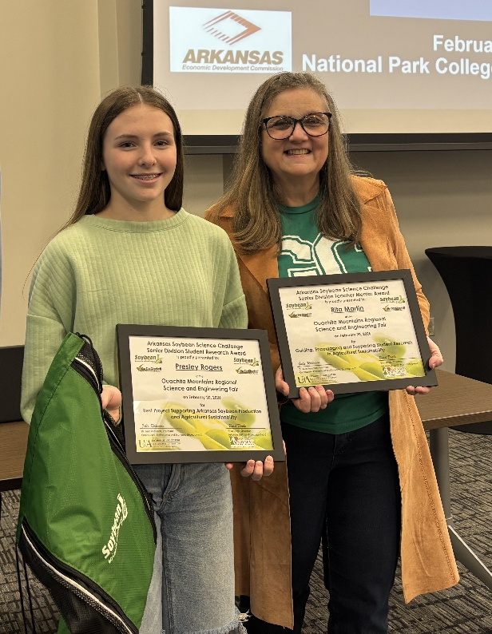

Ouachita Mountain Regional Science and Engineering Fair Senior Division Presley Rogers and teacher-mentor Rita Martin

