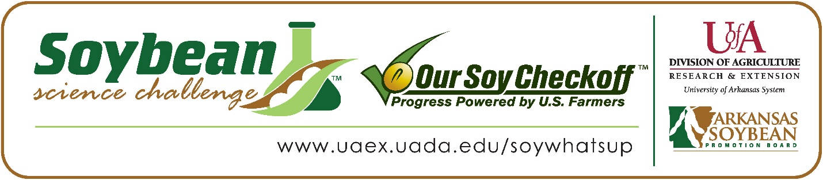

**Bianca Navarro and Nora Medlock win 2025 Arkansas Soybean Science Challenge Honorable Mention Award at the Arkansas State Science and Engineering Fair**

Bianca Navarro and Nora Medlock, 17, juniors at Arkansas School for Mathematics, Sciences, and the Arts (ASMSA) in Hot Springs, won the 2025 Soybean Science Challenge Honorable Mention Award at the Arkansas State Science and Engineering Fair April 4.

Navarro and Medlock split the $250 cash award for their SSC Honorable Mention placement at State. The award was provided by the Arkansas Soybean Promotion Board. Their science project titled “Using Glutathione to increase salt tolerance in soybeans” also took first place in Plant Sciences.

Dr. Lindsey Waddell, Bianca’s and Nora’s teacher, won the $100 State Soybean Science Challenge Honorable Mention Teacher-Mentor Award. Waddell stated that the Soybean Science Challenge course and resources are very applicable to teaching science in the classroom. “The experience my students gained from planning, executing, and presenting their project is invaluable. They got many helpful comments from the judges that should help them greatly improve their project for next year. Nora and Bianca have already started incorporating those suggestions into plans for their continuation project,” she replied.

Bianca and Nora were thrilled to receive the Honorable Mention in the State Soybean Science Challenge. “We are extremely excited and honored to win the Honorable Mention award for the Soybean Science Challenge. It also is very motivating, as we are only juniors and will strive to win the first-place award next year. This is a great start,” they explained.

Alexander Navarro, Bianca’s father, was proud to see her get this award. Mr. and Mrs. Medlock, Nora’s parents, agreed. “We were thrilled for Nora to win the state award. It was something she worked very hard for and to see that work rewarded and her research validated with the award was wonderful,” they explained.

Nora acknowledged she has a whole new perspective about agriculture. “It has helped me consider agriculture as a career by sharing with me how many different types of jobs are available in the agriculture field. Researchers are needed for agricultural innovations just as much as those who work in the field are. This realization encouraged me to see if my interests and skills could be applied to an agricultural job,” she stated.

Dr. Waddell believes that the Soybean Science Challenge is very helpful for agricultural research. “I feel that this competition is important for spreading awareness/ igniting an interest in agricultural research in Arkansas students. I have seen involvement in research projects having a significant influence on what path students choose to pursue in college, which should mean more students working to solve agricultural challenges down the road,” she replied.

“The Soybean Science Challenge provides an opportunity for Arkansas junior high and high school students to participate in scientific research that can impact the State of Arkansas as well as the world. Soybean Science Challenge student researchers learn about this important commodity crop and its many uses including feeding the world, development of biofuels and sustainable products. The Soybean Science Challenge helps students develop an understanding of the challenges and complexities of modern farming,” said Dr. Julie Robinson, Professor, and director of the program.

“The goal of the Arkansas Soybean Science Challenge is to engage students in “real- world” education to support soybean production and agricultural sustainability,” said Gary Sitzer, a former member of the Arkansas Soybean Promotion Board. “The program also rewards scientific inquiry and discovery that supports the Arkansas soybean industry.”

The Arkansas Soybean Science Challenge was launched in January 2014 for 9-12th grade science students. Students who successfully completed the online course were eligible to have their original soybean-related research projects judged at the 2025 ISEF-affiliated Arkansas Science and Engineering Fairs.

Information on the 2025-2026 Arkansas Soybean Science Challenge will be available in summer 2025. For more information, contact Dr. Julie Robinson at [jrobinson@uada.edu](mailto:jrobinson@uada.edu), or Keith Harris at [kharris@uada.edu](mailto:kharris@uada.edu), or Diedre Young at [dyoung@uada.edu](mailto:dyoung@uada.edu).

The Cooperative Extension Service is part of the University of Arkansas System Division of Agriculture.

**Bianca Navarro and Nora Medlock, Arkansas School for Mathematics, Sciences and the Arts, Hot Springs, AR. - Teacher-Dr. Lindsey Waddell**

**Category: Plant Sciences**

**Project Title: Using Glutathione to increase salt tolerance in soybeans**

**Abstract:**

As the demand for soybeans in Arkansas grows steadily, agricultural innovations are necessary to keep up. One issue soybean farmers in southeast Arkansas are facing is the high salinity levels in groundwater irrigation systems used to grow beans. These high salinity levels lead to the effects on the nitrogen fixation, resulting in reduced soybean yields and shoot length. Although efforts have been made to fix this, including genetically modified Excluder Soybeans which resist high salt levels, modern day agricultural fertilizers offer little protection against salt stress. The purpose of this experiment is to investigate whether Glutathione, an intracellular molecule, can improve the salt tolerance of soybeans by reducing the amount of sodium a plant produces, and stabilizing the plasma membrane. This was tested by comparing the height, leaf yellowing, and final biomass of soybeans grown in a hydroponic system with standard Hogland fertilizer and 0.10 g/L of NaCl, and without the 0.10 g/L Glutathione. After a six-week growth period, the hypothesis was not supported as the average height, biomass and yellowing spots for the NaCl treatment were 28.5 +/- 2.46 cm, 6.44 +/- 3.75 g, 10.00 +/- 1.6 respectively, while the NaCl and glutathione were 28.3 +/- 1.93 cm, 6.13 +/- 2.35 g, 7.66 +/- 2.88 respectively. There were also no statistically significant differences between the positive (Hogland and GSH), and negative (Hogland) controls.

Arkansas State Science and Engineering Fair Honorable Mention Soybean Science Challenge Teacher-Mentor Dr. Lindsey Waddell, and winners Bianca Navarro and Nora Medlock