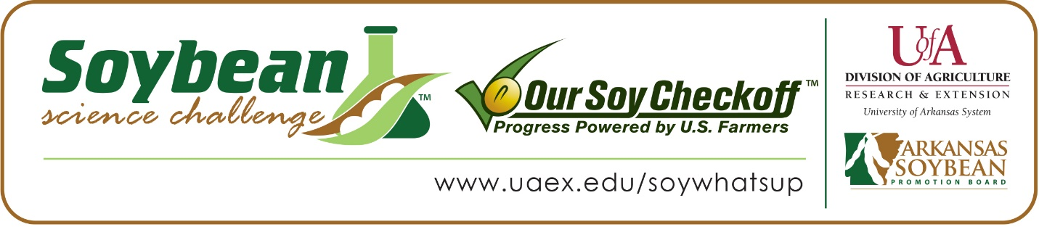

Natalie Blake wins 2020 Arkansas Soybean Science Challenge Award for Southeast Arkansas
Natalie Blake, 17, a senior at Star City High School in Star City won the Soybean Science Challenge award for Southeast Arkansas on March 13.
Blake received a $300 cash award provided by the Arkansas Soybean Promotion Board. Her science project is titled “Induced leaching of high sodium water out of root uptake zone of Glycine max by ionization.”
Shannon Blake, Natalie’s mentor, won the $200 Soybean Science Challenge Teacher Mentor award. Natalie’s mentor believes having students participate in the Soybean Science Challenge is a great idea. “My students learn about the sustainability of soybeans and the effects this crop has on Arkansas jobs and the economy. They get their hands dirty, and they open up connections with others who have the same interests which could be valuable to their futures,” she said.
Natalie says winning the regional Soybean Science Challenge is an honor and she was thrilled just to be able to participate. “I had finished my project but due to the COVID-19 quarantine conditions, science fair participation was not an option. I am glad The Challenge virtually judged by abstract,” she said.
Walt and Shannon Blake, Natalie’s parents, were very proud and elated that Natalie won the regional Soybean Science Challenge Award. “Natalie’s science teacher motivated her to participate in the science fair so she would get hands-on experience in research and communication skills, Natalie has thrived in these situations” they said.
Blake, Natalie’s mentor, discussed what Natalie gained by competing in the Soybean Science Challenge, “By competing in the Soybean Science Challenge, Natalie has gained confidence in her ability to become part of a community of scientists, teachers or engineers. The possibilities are endless,” she explained.
Natalie was also exposed to a different perspective about agriculture while working on her project. “I was able to have some new experience in the testing lab and I met some fascinating people who work with soybeans every day. This opportunity has given me the confidence I need to pursue a career in plant science,” she replied.
Natalie’s parents saw Natalie’s enthusiasm for agriculture grow as she worked through her project. “Natalie possesses a natural curiosity and compassion about living things. Having worked on this project for years now, Natalie has become serious about a career in Agriculture and will be attending Southern Arkansas University to major in Agriculture-Plant Science,” they said.
Blake believes there is a lot of relevance in teaching agriculture in the classroom. Before the Soybean Science Challenge, Natalie’s Mentor admits “I knew very little about soybeans, I knew a few farmers and they were often fretting over weather and planting. I now know soybeans are an important versatile means of feeding people throughout the world.”
“The Soybean Science Challenge provides an opportunity for Arkansas High School students to participate in scientific research that can impact the State of Arkansas as well as the world. Soybean Science Challenge student researchers learn about this important commodity crop and its many uses including feeding the world, development of biofuels and sustainable products. The Soybean Science Challenge helps students develop an understanding of the challenges and complexities of modern farming,” said Dr. Julie Robinson, Assistant Professor and director of the program.
“The goal of the Arkansas Soybean Science Challenge is to engage students in “real world” education to support soybean production and agricultural sustainability,” said Gary Sitzer, a former member of the Arkansas Soybean Promotion Board. “The program also rewards scientific inquiry and discovery that supports the Arkansas Soybean Industry.”
The Arkansas Soybean Science Challenge was launched in January 2014 to 9-12th grade science students. Students who successfully completed the online course were eligible to have their original soybean-related research projects judged at the 2020 ISEF-affiliated Arkansas Science and Engineering Fairs.
Information on the 2020-2021 Arkansas Soybean Science Challenge will be available in summer 2020. For more information, contact Dr. Julie Robinson at jrobinson@uaex.edu or Diedre Young at dyoung@uaex.edu.
The Cooperative Extension Service is part of the University of Arkansas System Division of Agriculture.

Natalie Blake, Star City High School, Star City. Mentor: Shannon Blake
Category: Plant Sciences
Project Title: Induced leaching of high sodium water out of root uptake zone of Glycine max by ionization.
Abstract:
Research Question: The research question for this project is ‘How will the electromagnets ionization of salt water affect the depth of saline in the soil?’
Hypothesis: Ionization of salt water will increase leaching to lower depths of the soil which will avoid the root uptake of Glycine max.
Procedure: The student planted multiple varieties of Glycine max to grow to adults. An average root length was taken from the plants. Next the student built an electromagnetic pump for irrigation. The hose was fitted into the pump. A copper coil was wound around the hose forming a solenoid. The ends were attached to a battery during watering to ionize the saline water. Three 40 cm pots were filled with dirt. The student watered the three pots, one with 1000 mg saline to 1L of water (1000 ppm concentration), one control with plain water and one with 1000 ppm saline run through an electromagnetic pump. The pots were watered with these concentrations and allowed to dry between watering. After one week, samples were taken from the soil removed one layer at a time and test with the saline meter.
Results: The pot of soil irrigated with the electromagnet ha a lower concentration of salt in the level of the root uptake zone.
Conclusion: Evidence suggested that the hypothesis was correct in that the ionization of salt water will increase leaching to lower depths of the soil which will avoid the root uptake zone of Glycine max.

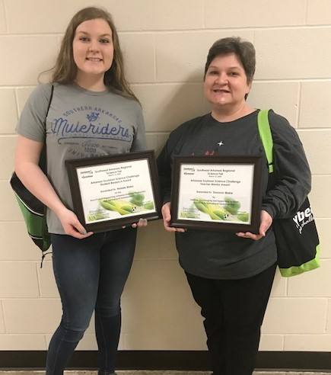Natalie Blake, 2020 SSC Award Winner for SE Arkansas and Teacher Mentor Shannon Blake.

