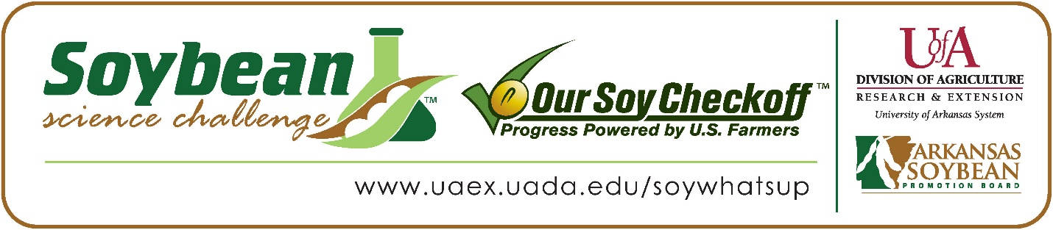

**Keila and Michelle Ortiz Salinas win 2023 Arkansas Soybean Science Challenge Junior Division Award at the Northwest Arkansas Regional Science Fair**

Keila, age 15 and Michelle Ortiz Salinas age 14, a 9th and 8th grader at Lakeside Junior High School, won the Soybean Science Challenge Junior Division award at the 2023 Northwest Arkansas Regional Science Fair held at UofA Fayetteville on March 10.

Keila and Michelle split a $200 cash award provided by the Arkansas Soybean Promotion Board. Their science project was titled “How do magnets affect the germination rate of a soybean plant?” also placed second in Plant Sciences.

Kiersen Deen, Keila and Michelle’s teacher, won the $100 Soybean Science Challenge Junior Division Teacher-Mentor Award. Deen stated that the Soybean Science Challenge is a great way to learn about agriculture today. “I had my students participate for a few different reasons. The first being the real-world connections they can make utilizing the materials. Additionally, having the class and learning set up by the soybean challenge reduced their research time but expanded their learning. I also enjoy the fact that it gets its own category designation for competition,” she replied.

Keila and Michelle were thrilled to win the 2023 Junior Division Soybean Science Challenge. “We honestly did not expect to become the 2023 Junior level winners of the Soybean Science Challenge. It was a very big surprise for us, and it made us very happy knowing that the work we did was enough to not only impress the judges with our work but also hopefully help farmers with their crops,” they stated.

The part of the Soybean Science Challenge Online Course the girls liked the best was sustainability issues. “The soybean topics and sustainability issues covered in the course that we found interesting were all the uses and problems soybeans have been used to help solve or be a part to solve. For example, hunger in the world,” they replied.

Keen was surprised to win the Junior Division Teacher-Mentor Award. “It was unexpected. I know the students did a great job of their work and involvement, but I didn’t have a comparison of what other projects were. I am excited that the girls had such a great success in their initial competition, and I hope that it inspires them to pursue further experiments,” she said.

“The Soybean Science Challenge provides an opportunity for Arkansas Junior High and High School students to participate in scientific research that can impact the State of Arkansas as well as the world. Soybean Science Challenge student researchers learn about this important commodity crop and its many uses including feeding the world, development of biofuels and sustainable products. The Soybean Science Challenge helps students develop an understanding of the challenges and complexities of modern farming,” said Dr. Julie Robinson, Associate Professor and director of the program.

“The goal of the Arkansas Soybean Science Challenge is to engage students in “real- world” education to support soybean production and agricultural sustainability,” said Gary Sitzer, a former member of the Arkansas Soybean Promotion Board. “The program also rewards scientific inquiry and discovery that supports the Arkansas Soybean Industry.”

The Arkansas Soybean Science Challenge was launched in January 2014 to 9-12th grade science students and in 2021, added grades 6-8 for the Junior level award. Students who successfully completed the online course were eligible to have their original soybean-related research projects judged at the 2023 ISEF-affiliated Arkansas Science and Engineering Fairs.

Information on the 2023-2024 Arkansas Soybean Science Challenge will be available in summer 2023. For more information, contact Dr. Julie Robinson at [jrobinson@uada.edu](mailto:jrobinson@uada.edu) or Diedre Young at [dyoung@uada.edu](mailto:dyoung@uada.edu).

The Cooperative Extension Service is part of the University of Arkansas System Division of Agriculture.

**Keila and Michelle Ortiz Salinas, Lakeside Junior High School, Springdale, Arkansas; Teacher, Kiersten Deen**

**Category: Plant Science**

**Title: How do magnets affect the germination rate of a soybean plant?**

**Abstract:**

This project aimed to determine how magnets can affect the germination rate of a soybean plant found through a trial of plantings of the three types of seeds (Tofu, Conventional, and Roundup Ready). We had 4 trays, three with different kinds of soybean seeds, and a singular one with all three types. We began by layering 1 inch of soil across the entirety of all 4 trays adding the seeds over the top of that layer (3 12" by 10" trays had a total of 25 seeds and 1 20" by 10" tray had 10 seeds of each type) and following that up with another inch of soil. We then began our observations by recording the growth and watering of our plants daily or every other day (unless inclement weather is present and we cannot access the plants). Our first recorded sprouts were on 02/06/23. With a total of 5 sprouts (2 Controlled Conventional, 2 Magnetized Conventional, and 1 Magnetized Tofu). Our largest recorded sprout was about 8 ⅝ inches tall on 02/17/23 in the controlled conventional tray. We noticed that we have more sprouts in the trays that are magnetized rather than the controlled tray, but the controlled tray did have the biggest sprouts, We came to the conclusion that the magnets have evened out the growth between the whole tray and that is why the magnetized trays have more sprouts, but it does slow down how high the plant can grow too.

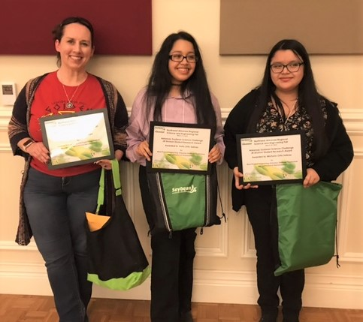

Northwest Arkansas Regional Science Fair Junior Division winners Keila and Michelle Ortiz Salinas and teacher-mentor, Kiersten Deen