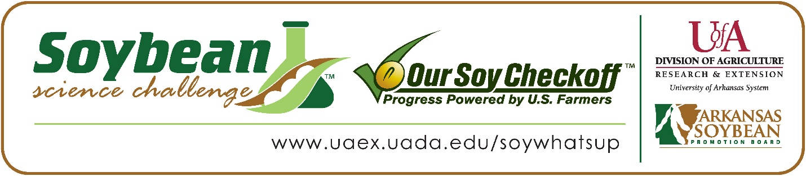

Alex Pagliani wins 2022 Arkansas Soybean Science Challenge Junior Division Award at the Virtual Northwest Arkansas Regional Science Fair
Alex Pagliani, age 13, an 8th grader at Fayetteville Christian School in Fayetteville, won the Soybean Science Challenge Junior Division award at the 2022 Northwest Arkansas Regional Science Fair held virtually on April 11.
Pagliani received a $200 cash award provided by the Arkansas Soybean Promotion Board. His science project was titled “Soybean Pollen Viability under Low Temperature Stress.”
Pat Briney, Alex’s teacher, won the $100 Soybean Science Challenge Junior Division Teacher-Mentor Award. Briney stated that the Soybean Science Challenge is a great way to learn about agricultural research. “I introduced my students to the Soybean Science Challenge to learn about science with a major producer of soybeans (the farmers of Arkansas) and to work with a scientist at the University of Arkansas in Fayetteville,” he replied.

Pagliani was thrilled to win the 2022 Junior Division Soybean Science Challenge. “It was exciting, and it has motivated me to do another soybean project,” he stated.
Pablo and Lisa Pagliani, Alex’s parents, were proud to see him receive the award. “We were very excited and happy for Alexander! It's great to see his project recognized and awarded, and we are extremely proud of the work and research he has put forth to participate in the Soybean Science Challenge,” they replied.
Pagliani found learning about soybeans and agriculture through the online course to be enlightening. “Soybeans are more than food products. They can be made into different oils and are used in thousands of products from plastics to medicines,” he explained.
Briney feels that the Soybean Science Challenge is a great program for students. “I was unaware of the Soybean Science Challenge until one of our students at Fayetteville Christian High school participated in the contest two years ago. I knew soybean farming was a major industry in Arkansas and was glad to hear about the Challenge. It is good for Arkansas, for farming, and for students. I plan to introduce students to the Soybean Science Challenge every year,” he replied.
“The Soybean Science Challenge provides an opportunity for Arkansas junior high and high school students to participate in scientific research that can impact the State of Arkansas as well as the world. Soybean Science Challenge student researchers learn about this important commodity crop and its many uses including feeding the world, development of biofuels and sustainable products. The Soybean Science Challenge helps students develop an understanding of the challenges and complexities of modern farming,” said Dr. Julie Robinson, Associate Professor and director of the program.
“The goal of the Arkansas Soybean Science Challenge is to engage students in “real- world” education to support soybean production and agricultural sustainability,” said Gary Sitzer, a former member of the Arkansas Soybean Promotion Board. “The program also rewards scientific inquiry and discovery that supports the Arkansas Soybean Industry.”
The Arkansas Soybean Science Challenge was launched in January 2014 to 9-12th grade science students and in 2021, added grades 6-8 for the Junior level award. Students who successfully completed the online course were eligible to have their original soybean-related research projects judged at the 2022 ISEF-affiliated Arkansas Science and Engineering Fairs.
Information on the 2022-2023 Arkansas Soybean Science Challenge will be available in summer 2021. For more information, contact Dr. Julie Robinson at jrobinson@uada.edu or Diedre Young at dyoung@uada.edu.
The Cooperative Extension Service is part of the University of Arkansas System Division of Agriculture.

Alex Pagliani, Fayetteville Christian School, Fayetteville, Arkansas; Teacher, Pat Briney
Category: Plant Science
Title: Soybean Pollen Viability under Low Temperature Stress
Abstract:
Low temperature stress can reduce or increase pollen viability in different varieties of soybeans. Twenty-four soybean plants for two varieties (MG4 and MG5) were grown in controlled growth chambers at 26°/18° C and 18°/12° C. MG5 soybean plants flowered less and produced fewer pods under stress of being grown at lower temperatures. In contrast, MG4 plants flowered more and produced more pods at lower temperatures.
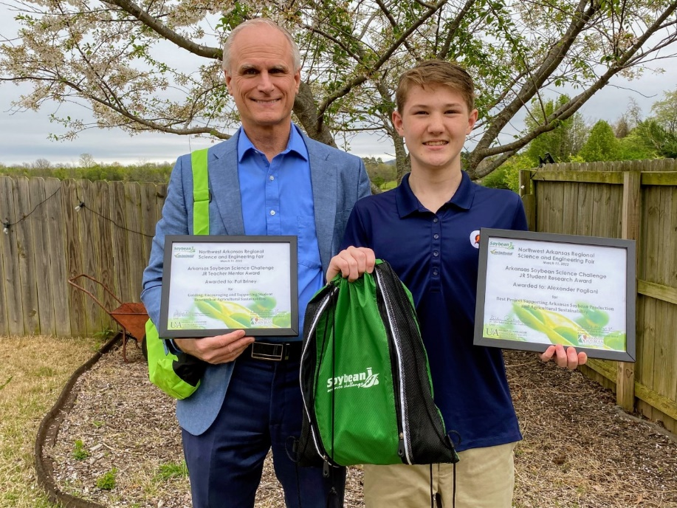
Northwest Arkansas Regional Science Fair Junior Division winner Alex Pagliani on the right and teacher-mentor, Pat Briney on the left.

