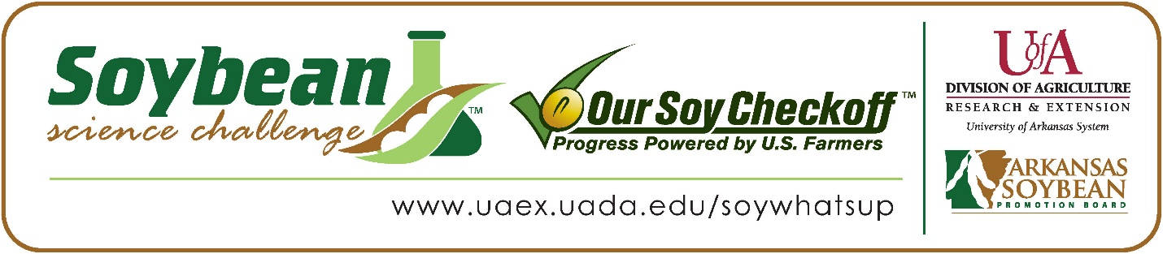

McKenzie Butler wins 2022 Arkansas Soybean Science Challenge Award at the Northwest Arkansas Regional Science and Engineering Fair
McKenzie Butler, age 17, a senior at Alma High School in Alma, won the Soybean Science Challenge at the 2022 Northwest Arkansas Regional Science and Engineering Fair held virtually at the University of Arkansas-Fayetteville on April 11.
Butler received a $300 cash award provided by the Arkansas Soybean Promotion Board. Her science project titled “Drought Resistant” also won First Place in Plant Science.
Tiffany Schrivner, Butler’s teacher, won the $200 Soybean Science Challenge Teacher- Mentor Award. Schrivner stated that the Soybean Science Challenge is a great way to learn about soybean research. “The Soybean Challenge gives students the opportunity to do work that can directly impact local problems that farmers may face. It is a real-world connection to their education,” she replied.

Butler was thrilled to win the 2022 Soybean Science Challenge. “I was very proud that I won this award,” she stated.
Amber Butler, McKenzie’s mother, was very happy to see her receive the award. “I am extremely proud of her accomplishment; she's always puts 100% of her effort into anything academic related,” she replied.
Schrivner feels that the Soybean Science Challenge is a great program for students. “It was very nice to see McKenzie grow as a scientist. She would tell me every day about how the plants were doing. She was so excited when she came to her conclusions. As an educator, times of excitement in the eyes of my students from science research is very rewarding,” she explained.

“The Soybean Science Challenge provides an opportunity for Arkansas junior high and high school students to participate in scientific research that can impact the State of Arkansas as well as the world. Soybean Science Challenge student researchers learn about this important commodity crop and its many uses including feeding the world, development of biofuels and sustainable products. The Soybean Science Challenge helps students develop an understanding of the challenges and complexities of modern farming,” said Dr. Julie Robinson, Associate Professor and director of the program.
“The goal of the Arkansas Soybean Science Challenge is to engage students in “real- world” education to support soybean production and agricultural sustainability,” said Gary Sitzer, a former member of the Arkansas Soybean Promotion Board. “The program also rewards scientific inquiry and discovery that supports the Arkansas soybean industry.”
The Arkansas Soybean Science Challenge was launched in January 2014 to 9-12th grade science students. Students who successfully completed the online course were eligible to have their original soybean-related research projects judged at the 2022 ISEF-affiliated Arkansas Science and Engineering Fairs.
Information on the 2022-2023 Arkansas Soybean Science Challenge will be available in summer 2022. For more information, contact Dr. Julie Robinson at jrobinson@uada.edu or Diedre Young at dyoung@uada.edu.
The Cooperative Extension Service is part of the University of Arkansas System Division of Agriculture.
McKenzie Butler, Alma High School, Alma, Arkansas; Teacher, Tiffany Schrivner
Category: Plant Science
Title: Drought Resistant
Abstract: The purpose of this experiment is to figure out to what extent does sodium polyacrylate in soil affect the drought resistance and growth in soybeans. This was done by mixing various amounts of sodium polyacrylate into planters with soybean seeds in them and watering them every few days until they become large enough and sturdy enough to be left alone. After they reach this point, stop watering them slowly and record how long it takes the plants to die. This took around 108 days for the control plants to be killed off and it took around 112 days for the 5 mg plants to die. At this point the 10 mg plants were still alive and well and showed very little signs of dying. This is when the experiment was ended due to the fact that the plants showed no interest in dying. Ultimately the hypothesis was somewhat rejected because the 5 mg plants ended up growing better than all of the other ones but the 20 mg plants ended up living the longest.
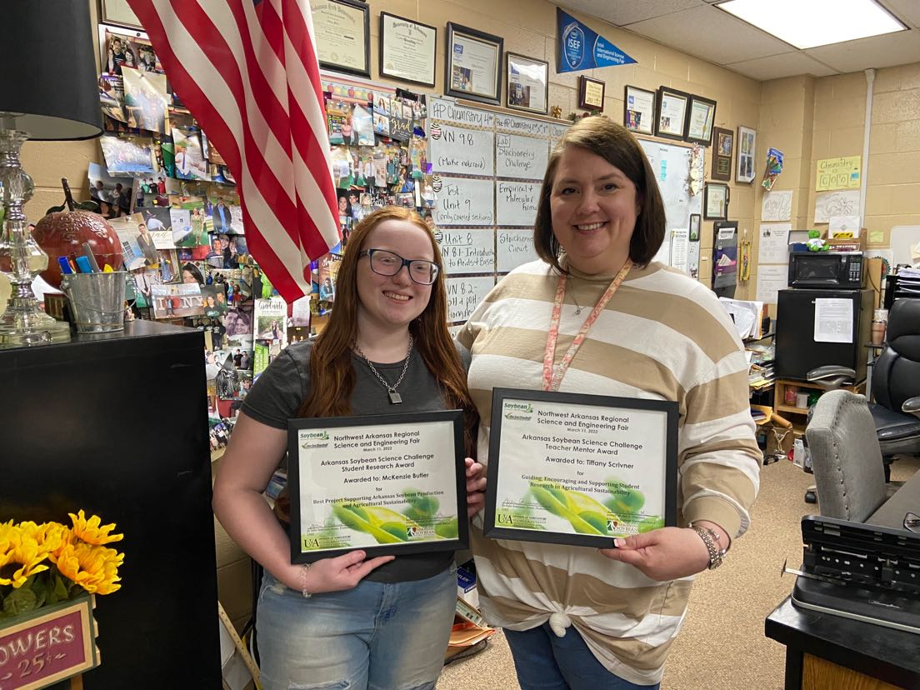
Soybean Science Challenge Senior Division winner McKenzie Butler on the left and Teacher-Mentor Tiffany Schrivner on the right.

