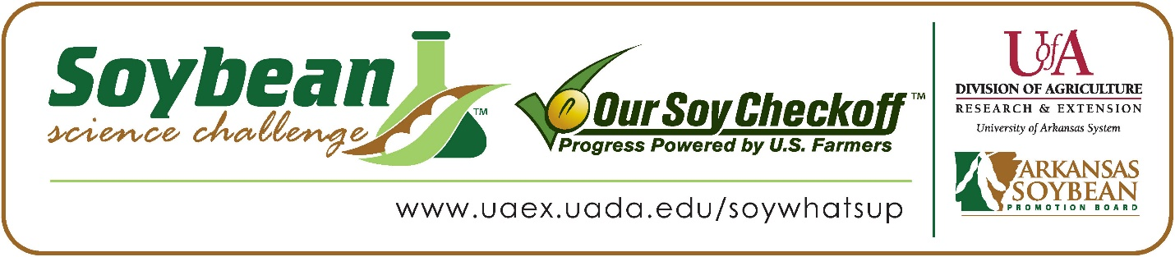
Mabyn Kyles wins 2026 Arkansas Soybean Science Challenge Junior Division Award at the Ouachita Mountain Regional Science and Engineering Fair
Mabyn Kyles, age 13, an eighth grader at Genoa Central Junior High School in Texarkana, Arkansas, won the Soybean Science Challenge in the 2026 Junior Division Ouachita Mountains Regional Science and Engineering Fair held in Hot Springs, February 20.
Kyles received a $200 cash award provided by the Arkansas Soybean Promotion Board. Her science project titled “Do emotions affect Pothos Plants?” also placed first in Plant Sciences.
Adam Bruce, Mabyn’s teacher, won the $100 Soybean Science Challenge Junior Division Teacher-Mentor Award. Bruce noted that he is new to the Soybean Science Challenge. “This was my first year doing the science fair. Going into the competition, I really didn’t know much about the Soybean aspect of it. My honor’s class was required to do the science fair initially and those who did well and wanted to go were offered the opportunity to go to the Soybean challenge. I just thought that it would be a great experience for me and my kids to get more exposure to the science fair for the future,” he replied.
Mabyn said winning the 2026 Soybean Science Challenge was a great moment for her. “I am honored to be this year’s winner and excited and motivated to continue researching ways to improve plant health,” she said.
Sarah Kyles, Mabyn’s mother, was extremely proud of her award. “We were excited to realize that opportunities like this exist in the State of Arkansas. What an opportunity for our students to further develop their interests while also understanding how research can impact a whole economy,” she explained.
The part of the Soybean Science Challenge course that appealed most to Mabyn was learning about the usage of soybeans. “I found the topic of uses of soybeans to be the most interesting and the most useful,” she explained.
Adam Bruce shared what he learned through his student taking the SSC online course. “Before the Soybean Science Challenge, I knew nothing about Arkansas soybeans or farming in general. With Mabyn’s participation in The Challenge, I developed an appreciation for farmers and especially soybean farmers and had a great time with good experience for my continued career as an educator,” he stated.
“The Soybean Science Challenge provides an opportunity for Arkansas junior high and high school students to participate in scientific research that can impact the State of Arkansas as well as the world. Soybean Science Challenge student researchers learn about this important commodity crop and its many uses including feeding the world, development of biofuels and sustainable products. The Soybean Science Challenge helps students develop an understanding of the challenges and complexities of modern farming,” said Dr. Julie Robinson, Professor, and director of the program.
“The goal of the Arkansas Soybean Science Challenge is to engage students in “real- world” education to support soybean production and agricultural sustainability,” said Gary Sitzer, a former member of the Arkansas Soybean Promotion Board. “The program also rewards scientific inquiry and discovery that supports the Arkansas Soybean Industry.”
The Arkansas Soybean Science Challenge was launched in January 2014 for 9-12th grade students, and a regional Junior Division award was added in 2021. Students who successfully completed the online course were eligible to have their original soybean-related research projects judged at the 2026 ISEF-affiliated Arkansas Science and Engineering Fairs.
Information on the 2026-2027 Arkansas Soybean Science Challenge will be available in summer 2026. For more information, contact Dr. Julie Robinson at jrobinson@uada.edu or Keith Harris at krharris@uada.edu, or Diedre Young at dyoung@uada.edu.
The Cooperative Extension Service is part of the University of Arkansas System Division of Agriculture.

Mabyn Kyles Genoa Central Junior High School, Texarkana, Arkansas; Teacher, Adam Bruce
Category: Plant Sciences
Project Title: Do emotions affect Pothos plants?
Abstract: The question I asked was, “Do different emotions behind music affect plants?” My science project aimed to determine if emotions could change a plant's growth. If so, then music could be used to aid horticulturists in their research. I hypothesized that Plant A. (happy music) would grow better than Plant D. (angry music) and that Plant B. (sad music) would wither. I expected Plant C. (no music) to grow normally. I played one hour of music nightly for each plant in different rooms. Plant A. has a height of 22 cm and an average leaf length of 8.2 cm. It has 37 leaves and 9 stems, with dark green coloring. Plant B. has a height of 24 cm and an average leaf length of 8.8 cm. It has 27 leaves and 10 stems, with a green mix with light green coloring. Plant C. has a height of 26 cm and an average leaf length of 12.87 cm. It has 31 leaves and 13 stems, with dark mixed with light green coloring. Plant D. has a height of 30 cm and an average leaf length of 8.83 cm. It has 27 leaves and 9 stems, with a light and yellow green coloring. After eight weeks, the plants all show similar results. My hypothesis was incorrect. Plant C, without music, appeared the best. This shows that emotions don't have a great effect on Pothos.
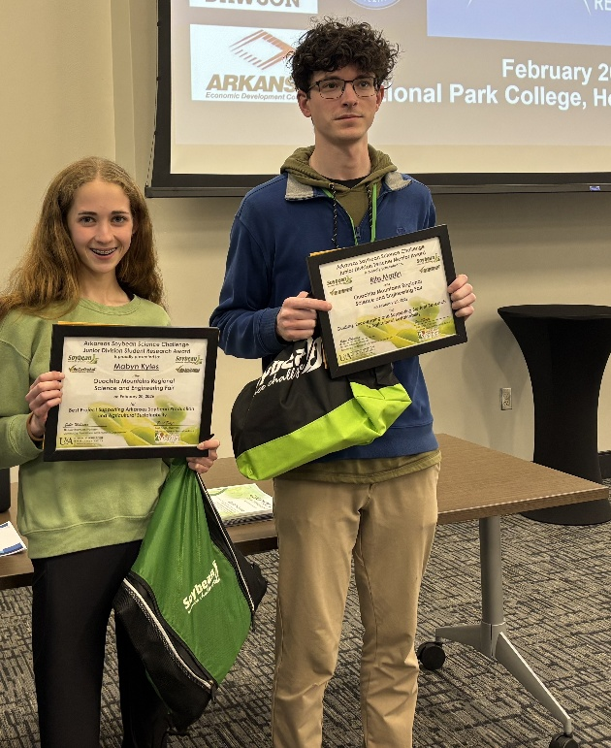

2026 Ouachita Mountain Regional Science and Engineering Fair Junior Division Soybean Science Challenge Winner Mabyn Kyles and Teacher-Mentor Adam Bruce.

