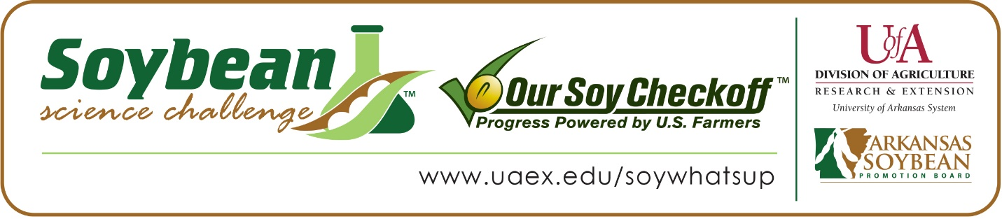

**Layne Smith wins 2023 JR Division Arkansas Soybean Science Challenge Award at the Southeast Arkansas Regional Science Fair**

Layne Smith, 14, an 8th grader at Dumas Middle School in Dumas won the Junior Division Soybean Science Challenge regional award at the Southeast Arkansas Regional Science Fair, held at the University of Arkansas Monticello on March 9.

Layne received a $200 cash award provided by the Arkansas Soybean Promotion Board. His science project titled “Soils and Soybeans” also placed first in plant science.

Preslee Carter, Smith’s teacher, won the $100 Soybean Science Challenge JR Division Teacher-Mentor award. Carter thought it was a great idea for Layne to participate in the Soybean Science Challenge. “The opportunity to compete in the UAM science fair came to me through the SEARK co-op. I could not pass up the opportunity to give students the chance to compete against other kids their age and possibly win money for doing well! This opportunity helped to deepen the students' understanding of the scientific method while doing actual experiments that they were proud to present,” she said.

Layne says winning the regional Soybean Science Challenge was unexpected, and he was glad he decided to participate. “It was definitely fun to challenge myself,” he replied.

The Smiths, Layne’s parents, were excited that Layne won the regional Soybean Science Challenge Award. “We are so proud of him,” they said.

Carter, Layne’s teacher, discussed what Layne gained by competing in the Soybean Science Challenge, “Layne gained a lot of knowledge when it comes to science and agriculture. He was able to utilize Arkansas soil to test his hypothesis and learned how to properly care for plants. As he started growing the soybeans, he realized how much work goes into our food sources and how important it is to understand where it all comes from as well as to respect the process. Layne gained a substantial amount of patience by tediously caring for the plants for weeks before being able to gather data and form his conclusion,” she explained.

Layne learned a lot while working on his project. “I gained knowledge of soybeans and their importance to our economy as well as an eagerness to learn more,” he replied.

“The Soybean Science Challenge provides an opportunity for Arkansas Junior High and High School students to participate in scientific research that can impact the State of Arkansas as well as the world. Soybean Science Challenge student researchers learn about this important commodity crop and its many uses including feeding the world, development of biofuels and sustainable products. The Soybean Science Challenge helps students develop an understanding of the challenges and complexities of modern farming,” said Dr. Julie Robinson, Associate Professor and director of the program.

“The goal of the Arkansas Soybean Science Challenge is to engage students in “real- world” education to support soybean production and agricultural sustainability,” said Gary Sitzer, a former member of the Arkansas Soybean Promotion Board. “The program also rewards scientific inquiry and discovery that supports the Arkansas Soybean Industry.”

The Arkansas Soybean Science Challenge was launched in January 2014 to 9-12th grade science students and in 2021, a junior level award was added for grades 6-8. Students who successfully completed the online course were eligible to have their original soybean-related research projects judged at the 2023 ISEF-affiliated Arkansas Science and Engineering Fairs.

Information on the 2023-2024 Arkansas Soybean Science Challenge will be available in summer 2023. For more information, contact Dr. Julie Robinson at [jrobinson@uada.edu](mailto:jrobinson@uada.edu) or Diedre Young at [dyoung@uada.edu](mailto:dyoung@uada.edu).

The Cooperative Extension Service is part of the University of Arkansas System Division of Agriculture.

**L,ayne Smith, Dumas Middle School, Dumas, Arkansas. Teacher: Preslee Carter**

**Category: Plant Science**

**Project Title: Soil and Soybeans**

**Abstract:** The purpose of my experiment is for farmers to see which soil works best for soybeans. I used clay, sand, and silt soils to test which soil grows the soybeans faster. A few soil functions include providing a medium for plant growth to enable food and feed production. Another function is storage, filtering and transformation of water, minerals and pollutants. My hypothesis is: I believe that the silt soil will help the soybeans grow faster because of the vegetables I have grown in silt. They grow fast because the silt soil has particles that hold water but doesn’t keep it there too long. The particle size of silt is 0.05 to 0.002mm and has a floury texture. The particle size of clay is <0.002 mm and has a sticky texture. The particle size of sand is 2 to 0.05mm and has a gritty texture. The procedure I used was putting one soil sample for each type of soil in a planting container. Dig a two-inch hole and place 2 soybean seeds in each hole. Measure out 2 ounces of water and place into each container. Place containers in a corner with plant light placed directly above the plants. Give either hour of light each day and 2 ounces of water every other day. After soybeans have sprouted, record data on chart until end of experiment.

The results showed the soybeans in the clay and sand sprouted on day 6. On day 7 the silt soybean sprouted. At the end of the experiment, the soybean in the clay soil was the tallest, 17 inches, and healthier than the other soybeans. In conclusion, my hypothesis was wrong. The clay soil worked the best, I think because the clay soil particles are smaller and hold water better.

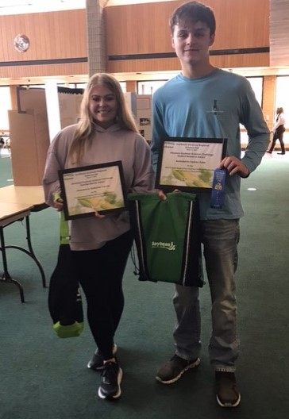

Layne Smith, 2023 SSC JR Division Award Winner for Southeast Arkansas Regional Science Fair and Teacher Mentor Preslee Carter.