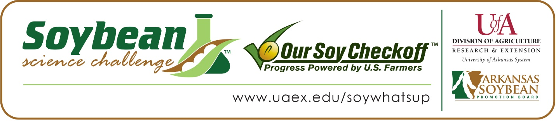

Josh Bryant wins 2020 Arkansas Soybean Science Challenge Award at ASMSA-West Central Arkansas Science Fair
Josh Bryant, 18, a senior at Arkansas School for Mathematics, Sciences and the Arts (ASMSA) in Hot Springs won the Soybean Science Challenge at the 2020 West Central Science Fair held at ASMSA, February 27.
Bryant received a $300 cash award provided by the Arkansas Soybean Promotion Board at the awards ceremony. His science fair project titled “Building the future: Soybean Waste Construction Material” also received second place in Engineering; Materials and Bioengineering at the regional fair.
Shane Thompson, Bryant’s teacher, won the $200 Soybean Science Challenge Teacher Mentor Award. He believes through the Soybean Science Challenge, Josh gained a greater appreciation for the varied uses of soybeans. “I knew that Joshua had an interest in helping his local community. We brainstormed, and came up with the idea of developing a novel material using a waste product, soybean hulls. My department chair had mentioned The Challenge, and Joshua was eager to participate,” he replied.
Bryant was very pleased that his project was chosen to win the Soybean Science Challenge.
Billy and Jacqueline Bryant, Joshua’s parents, were both excited and grateful he won the Soybean Science Challenge Award. “He is very interested in science projects, and Joshua often talks about his interest in how things work or why something is the way it is,” they noted. Thompson also talked about Joshua’s dedication, “Josh is a hard-working student who comes from an impoverished part of rural Arkansas. His family has worked with soybeans for years and he wanted to create a new building material that would use a by-product of soybean production.
The part of the Soybean Science Challenge course that appealed most to Bryant was learning about the many uses of soybeans. “Soybeans can produce anything from biodiesel to livestock feed and I thought that was pretty neat. However, soybean hulls do not have many uses so I decided to find a use for them with my project” He stated.

Bryant noted before he decided to participate in the Soybean Science Challenge he already possessed knowledge of how many crops in the south were grown and how they were processed at different facilities. He felt the information presented in the course was easily digestible and well organized. Bryant was enthralled by the many uses of soybeans. The material he learned inspired him to research other uses for the plant.

Both Thompson and Josh’s parents agree that Josh is a deep thinker and a perpetual learner who always does well in his science classes.
“The Soybean Science Challenge provides an opportunity for Arkansas High School students to participate in scientific research that can impact the state of Arkansas as well as the world. Soybean Science Challenge student researchers learn about this important commodity crop and its many uses including feeding the world, development of biofuels and sustainable products. The Soybean Science Challenge helps students develop an understanding of the challenges and complexities of modern farming,” said Dr. Julie Robinson, Associate Professor and director of the program.
“The goal of the Arkansas Soybean Science Challenge is to engage students in “real world” education to support soybean production and agricultural sustainability’” said Gary Sitzer a former member of the Arkansas Soybean Promotion Board. “The program also rewards scientific inquiry and discovery that supports the Arkansas Soybean Industry.”
The Arkansas Soybean Science Challenge was launched in January 2014 to 9-12th grade science students. Students who successfully completed the online course were eligible to have their original soybean-related research projects judged at the 2020 ISEF affiliated Arkansas Science and engineering fairs.
Information on the 2020-2021 Arkansas Soybean Science Challenge will be available in summer 2020. For more information, contact Dr. Julie Robinson at jrobinson@uaex.edu or Diedre Young at dyoung@uaex.edu.
The Cooperative Extension Service is part of the University of Arkansas System Division of Agriculture.

Joshua Bryant: Arkansas School for Mathematics, Science and the Arts, Hot Springs, AR. Teacher-Dr. Shane Thompson
Category: Materials Engineering
Project Title: Building the Future, Soybean Waste Construction Material
Abstract: A soybean hull is the thin outer layer of a soybean. Soybean hulls are a by-product of soybean processing facilities. The soybean hulls have limited uses and are often discarded or fed to livestock. This project is an attempt to create a use for soybean hulls while eliminating the use of nonrenewable or severely depleted resources. The soybean hulls were procured from a facility in Helena, Arkansas. Two 19 Liter buckets were fill with soybean hulls and several containers of water-based adhesive. The soybean hulls and the water-based adhesive are combined to form a sheet of material. A separate sample of soybean hulls were also combined with a non-environmentally friendly adhesive to determine whether water-based adhesives were effective. The soybean hull sheets were placed under stress to determine its resistance to weight. The soybean material data that was recorded was compared to data collected for other materials. The data showed soybean material is too low stress-wise to be considered for building but would make a decent substitute for cork.
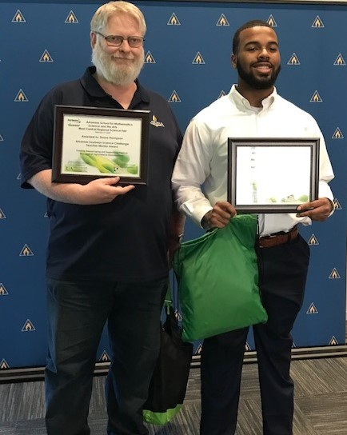
ASMSA West Central Arkansas Science Fair Soybean Science Challenge winner Joshua Bryant and Teacher-Mentor Shane Thompson

