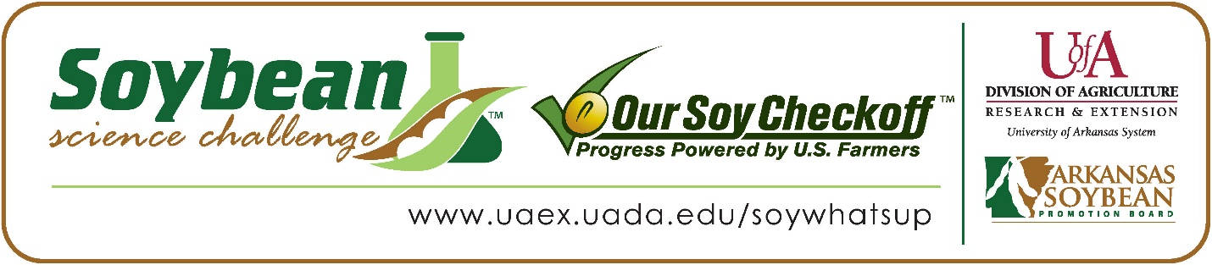

Jenny Garcia-Torres wins 2022 Arkansas Soybean Science Challenge Junior Level FFA Agriscience Award at the FFA State Convention Agriscience Fair
Jenny Garcia-Torres, age 14, a ninth grader at Southwest Junior High School in Springdale, Arkansas, won the 2022 Soybean Science Challenge FFA Junior Level Agriscience Award at the State FFA Convention Agriscience Fair April 26.
Torres received a $200 cash award for her Junior FFA team win. Funds were provided by the Arkansas Soybean Promotion Board. Her science project was titled “Does Temperature matter for Soybean Germination.”

Jonathan Roberts, Jenny’s FFA advisor, won the $100 Regional FFA Advisor Award. Roberts stated the Soybean Science Challenge allows his junior high students to broaden their horizons in agriculture. “I have used the Soybean Challenge in my high school Plant Science class for a few years to introduce content about row crop farming as well as research methods. It was great to introduce these concepts to my junior high students this year through the program,” he replied.
Jenny was thrilled to win the 2022 FFA Agriscience Junior Soybean Science Challenge. “I was really excited! I didn’t think my project was good enough, “she stated.
Roberts was elated to see her receive the award. “Seeing how excited my student was to win the award and get recognized for her hard work was one of the best moments of this school year,” he said.
Jenny also expounded on what she learned from the Soybean Science Challenge Online Course. “It was interesting to learn about how soybean producers use technology and equipment to make the USA the top producer in soybeans,” she explained.
“The Soybean Science Challenge provides an opportunity for Arkansas junior high and high school students to participate in scientific research that can impact the State of Arkansas as well as the world. Soybean Science Challenge student researchers learn about this important commodity crop and its many uses including feeding the world, development of biofuels and sustainable products. The Soybean Science Challenge helps students develop an understanding of the challenges and complexities of modern farming,” said Dr. Julie Robinson, Associate Professor and director of the program.
“The goal of the Arkansas Soybean Science Challenge is to engage students in “real- world” education to support soybean production and agricultural sustainability,” said Gary Sitzer, a former member of the Arkansas Soybean Promotion Board. “The program also rewards scientific inquiry and discovery that supports the Arkansas soybean industry.”
The Arkansas Soybean Science Challenge was launched in January 2014 to 9-12th grade science students, and in 2021, a junior level award was added for grades 6-8. Students who successfully completed the online course were eligible to have their original soybean-related research projects judged at the 2022 ISEF-affiliated Arkansas Science and Engineering Fairs.
Information on the 2022-2023 Arkansas Soybean Science Challenge will be available in summer 2022. For more information, contact Dr. Julie Robinson at jrobinson@uada.edu or Diedre Young at dyoung@uada.edu.
The Cooperative Extension Service is part of the University of Arkansas System Division of Agriculture.

Jenny Garcia-Torres Southwest Junior High School, Springdale, Arkansas; FFA Advisor, Jonathan Roberts
Category: Plant Systems
Title: Does temperature matter for soybean germination
Abstract: Soybeans are important because they provide a lot of protein. Every cell in the human body contains protein. You need protein in your diet to repair cells and make new ones. The purpose of this project is to determine the best temperature to grow soybeans. There is contradicting information on whether soybeans germinate better at 12.8C or 29.4C. 10 plants were planted at 12.8C, 10 plants were planted at 29.4C and ten plants were planted at room temperature. They were given the same amount of light, water and soil. After 14 days, 10 of the plants at 27C germinated, six of the plants germinated at 29.4C and zero plants germinated at 12.8C. In conclusion, the warm climate is more favorable for soybeans because more plants germinated at warmer temperatures.
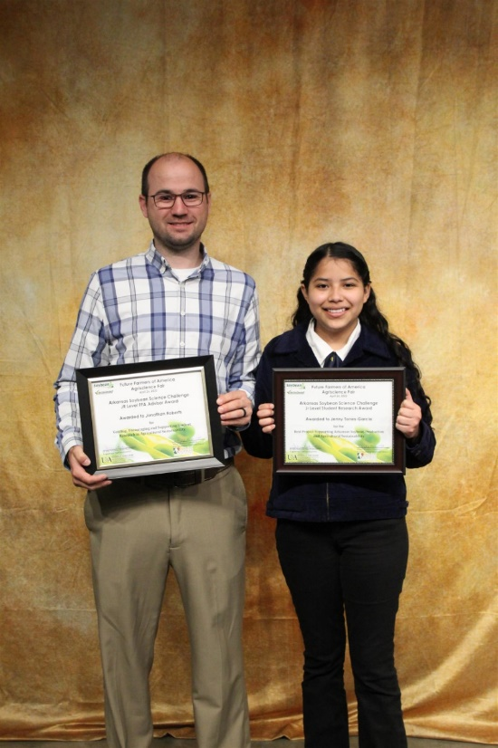

FFA Agriscience Fair Junior SSC Winner Jenny Garcia-Torres and FFA Advisor Jonathan Roberts

