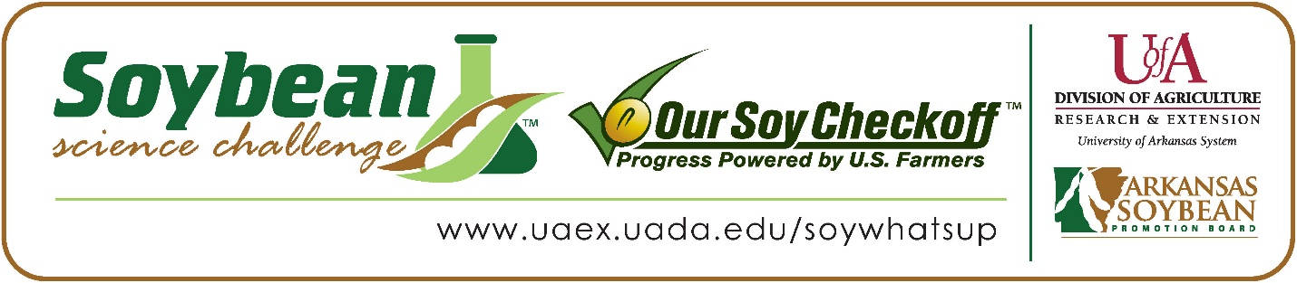

**Holland Stacks wins 2023 Arkansas Soybean Science Challenge Junior Level FFA Agriscience Award at the FFA State Convention Agriscience Fair**

Holland Stacks, age 13, an eighth grader at Taylor High School in Taylor, Arkansas, won the 2023 Soybean Science Challenge FFA Junior Level Agriscience Award at the State FFA Convention Agriscience Fair April 25.

Stacks received a $200 cash award for his Junior FFA win. Funds were provided by the Arkansas Soybean Promotion Board. His science project was titled “Winter Forage.”

Chad Poindexter, Holland’s FFA advisor, won the $100 Regional Junior FFA Advisor Award. Poindexter stated the Soybean Science Challenge allows his junior high students to broaden their horizons in agriculture. “Not only did the Soybean Science Challenge online course allow Holland to compete in The Challenge, but it also showed him the importance of soybeans in agriculture,” he stated.

Holland was thrilled to win the 2023 FFA Agriscience Junior Soybean Science Challenge. “I thought it was really neat to win and the goodie bag was awesome! “he stated.

Poindexter was happy to see Holland receive the award. “Hopefully seeing Holland win this award will encourage other students to want to participate too,” he said.

Holland also expounded on what he learned from the Soybean Science Challenge Online Course. “I knew very little about soybeans and the course really increased my knowledge of this crop,” he explained.

“The Soybean Science Challenge provides an opportunity for Arkansas junior high and high school students to participate in scientific research that can impact the State of Arkansas as well as the world. Soybean Science Challenge student researchers learn about this important commodity crop and its many uses including feeding the world, development of biofuels and sustainable products. The Soybean Science Challenge helps students develop an understanding of the challenges and complexities of modern farming,” said Dr. Julie Robinson, Associate Professor, and director of the program.

“The goal of the Arkansas Soybean Science Challenge is to engage students in “real- world” education to support soybean production and agricultural sustainability,” said Gary Sitzer, a former member of the Arkansas Soybean Promotion Board. “The program also rewards scientific inquiry and discovery that supports the Arkansas soybean industry.”

The Arkansas Soybean Science Challenge was launched in January 2014 to 9-12th grade science students, and in 2021, a junior level award was added for grades 6-8. Students who successfully completed the online course were eligible to have their original soybean-related research projects judged at the 2023 ISEF-affiliated Arkansas Science and Engineering Fairs.

Information on the 2023-2024 Arkansas Soybean Science Challenge will be available in summer 2023. For more information, contact Dr. Julie Robinson at [jrobinson@uada.edu](mailto:jrobinson@uada.edu) or Diedre Young at [dyoung@uada.edu](mailto:dyoung@uada.edu).

The Cooperative Extension Service is part of the University of Arkansas System Division of Agriculture.

**Holland Stacks Taylor High School, Taylor, Arkansas; FFA Advisor, Chad Poindexter**

**Category: Plant Systems**

**Title: Winter Forage**

**Abstract:** This study examined the effects of grazing on three types of winter forage. Wheat, ryegrass, and clover were planted and subsequently cut at heights ranging from 2cm to 8cm, to simulate grazing and determine the effect of grazing upon each type of forage. Forages were measured after two weeks of regrowth, cut again and subsequently measured at one week and two weeks. In this study, it was found that forages grazed (cut) to a height of 8cm recovered more quickly than forages grazed (cut) at any shorter height. Furthermore, winter wheat produced a greater volume of forage than either ryegrass or crimson clover.

FFA Agriscience Fair Junior Soybean Science Challenge Winner Holland Stacks and FFA Advisor Chad Poindexter