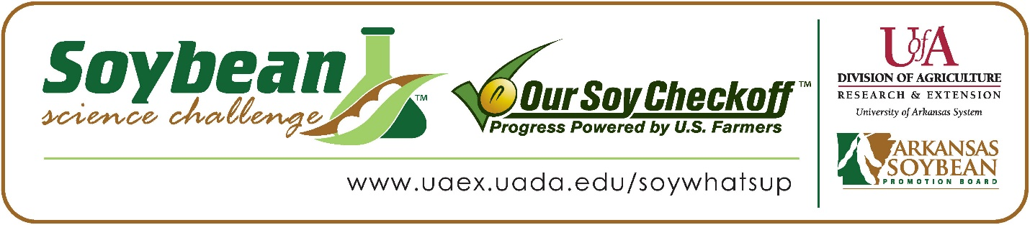

Hadleigh and Hannah Baker win 2023 Arkansas Soybean Science Challenge Senior Level FFA Agriscience Award at the FFA State Convention Agriscience Fair
Hadleigh and Hannah Baker, age 16, 10th graders at Mountain Home High School in Mountain Home, Arkansas, won the 2023 Soybean Science Challenge FFA Senior Level Agriscience Award at the State FFA Convention Agriscience Fair April 24.
The Bakers split a $300 cash award for their Senior FFA team win. Funds were provided by the Arkansas Soybean Promotion Board. Their science project was titled “Improving turkey production through assessment of various feed proteins.”
Hannah and Hadleigh also won the State Division Level 4 Animal Science Award at this fair.

Josh Baker and Carson White, Hadleigh and Hannah’s FFA advisors, jointly won the $200 Regional FFA Advisor Award. Baker stated the Soybean Science Challenge allows his students to broaden their horizons in agriculture. “The Soybean Science Challenge is an excellent way to get students engaged in learning about Agricultural commodities and Agriculture in general,” he replied.
Hadleigh and Hannah were thrilled to win the 2023 FFA Agriscience Soybean Science Challenge. “After doing the Soybean Science Challenge for three years we have learned countless factors about how the use of soybeans plays a pivotal role in all areas of the agricultural industry. We were so happy to learn that our knowledge and hard work throughout this project revolving around soybeans was recognized, “they stated.
Josh Baker and Carson White, Hadleigh and Hannah’s FFA Advisors, were elated to see them receive the award. “We were excited to learn that our students were the regional winners for this challenge. The Baker girls worked extremely hard on this project and to see their hard work recognized at the state level was awesome,” they said.
Hadleigh and Hannah also expounded on what they learned from the Soybean Science Challenge Online Course. “We enjoyed learning about the process of nitrogen fixation through legumes (specifically soybeans) and learned more about rhizobium bacteria which is found through inoculation and incorporated those biological factors into our project. I learned lots of new facts about crop rotation and how rotating soybeans improves the nutrient levels found in soil. We also learned what byproducts and products were created using soybeans,” they explained.
“The Soybean Science Challenge provides an opportunity for Arkansas Junior High and High School students to participate in scientific research that can impact the State of Arkansas as well as the world. Soybean Science Challenge student researchers learn about this important commodity crop and its many uses including feeding the world, development of biofuels and sustainable products. The Soybean Science Challenge helps students develop an understanding of the challenges and complexities of modern farming,” said Dr. Julie Robinson, Associate Professor and director of the program.
“The goal of the Arkansas Soybean Science Challenge is to engage students in “real- world” education to support soybean production and agricultural sustainability,” said Gary Sitzer, a former member of the Arkansas Soybean Promotion Board. “The program also rewards scientific inquiry and discovery that supports the Arkansas Soybean Industry.”
The Arkansas Soybean Science Challenge was launched in January 2014 to 9-12th grade science students. Students who successfully completed the online course were eligible to have their original soybean-related research projects judged at the 2023 ISEF-affiliated Arkansas Science and Engineering Fairs.
Information on the 2023-2024 Arkansas Soybean Science Challenge will be available in summer 2023. For more information, contact Dr. Julie Robinson at jrobinson@uada.edu or Diedre Young at dyoung@uada.edu.
The Cooperative Extension Service is part of the University of Arkansas System Division of Agriculture.

Hadleigh and Hannah Baker Mountain Home High School, Mountain Home, Arkansas; FFA Advisors; Josh Baker and Carson White
Category: Animal Sciences
Title: Improving turkey production through assessment of various feed proteins.
Abstract:
The overall objective of this experiment was to improve the efficiency of turkey production through the implementation of management and nutritional strategies. The three specific goals that we incorporated into our experiment were: finding the protein source that would be the most economical for a poultry farmer, as well as determining which feed source was the most beneficial for the turkeys’ overall health, and most importantly, which protein source would be the most impactful in terms of producing a turkey with the most sound bodily features. To ultimately determine which of the two compared protein sources would surpass the three goals we set for our project, we had to develop a direct experiment.

Over the course of a 30-day experimentation period, we sectioned off our experimental area into two sections. The first section of turkeys would serve as our “control” in this experiment. They would be fed a consecutive diet of a soybean-based protein source. The second section of turkeys would serve as our independent variable. The turkeys would be fed a diet containing a non-soybean-based protein source. To decide which protein source would ultimately be the most effective in producing a well-rounded turkey, we first had to develop a dependent variable to base our results from. Therefore, at both the midpoint and at the end of our experimentation period we averaged out the weight of each group to determine our results. Although the soy-free feed source proved to be the most economical by previous research projects, ultimately our dependent variable displayed that the feed that produced the heaviest average weight for a single bird, was the most economical on a commercial level, and exerted the most nutritional benefits was the soybean-based feed source.

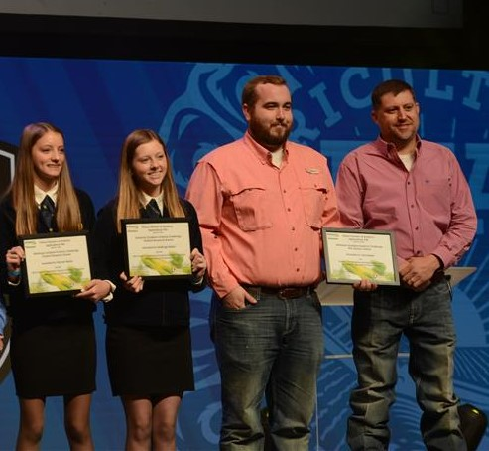
FFA Agriscience Fair SR Division SSC Winners Hadleigh and Hannah Baker with FFA Advisors Carson White and Josh Baker

