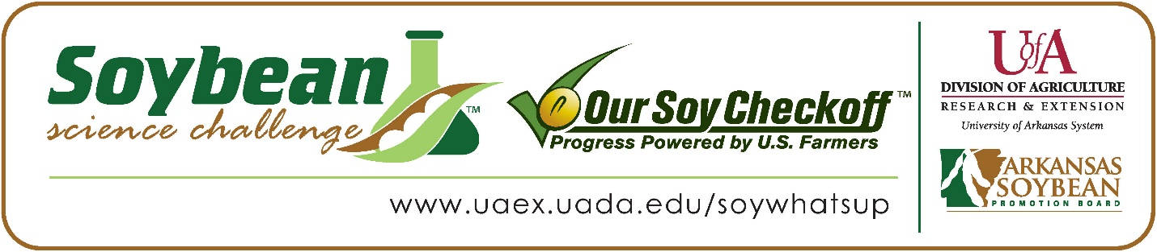

Hadleigh and Hannah Baker win 2022 Arkansas Soybean Science Challenge Senior Level FFA Agriscience Award at the FFA State Convention Agriscience Fair
Hadleigh and Hannah Baker, age 15, 9th graders at Mountain Home Junior High School in Mountain Home, Arkansas, won the 2022 Soybean Science Challenge FFA Senior Level Agriscience Award at the State FFA Convention Agriscience Fair April 26.
The Bakers received a $300 cash award for their Senior FFA team win. Funds were provided by the Arkansas Soybean Promotion Board. Their science project was titled “Measuring early soybean growth response to commercial fertilizer and turkey litter.”
Hannah and Hadleigh also won the State Division Level 4 Plant Systems Award at this fair.

Josh Baker and Carson White, Hadleigh and Hannah’s FFA advisors, jointly won the $200 Regional FFA Advisor Award. Baker stated the Soybean Science Challenge allows his students to broaden their horizons in agriculture. “Any chance we can give our students the ability to diversify and learn new aspects about agriculture is a plus, and the Soybean Science Challenge does just that,” he replied.
Hadleigh and Hannah were thrilled to win the 2022 FFA Agriscience Soybean Science Challenge. “We were so excited to develop a project revolving around soybean science and through the soybean science course last year, and also winning the Soybean Science Challenge last year we have both developed a passion for plant science and soybeans in general,“ they stated.
Josh Baker and Carson White, Hadleigh and Hannah’s FFA Advisors, were elated to see them receive the award. “We were very proud of the girls for working so hard on their project and for winning this award,” they said.
Hadleigh and Hannah also expounded on what they learned from the Soybean Science Challenge online course. “We knew nothing about soybeans. Our area typically is too rocky to grow soybeans, so our knowledge was very limited about soybean science in general. We learned a lot about soybean science and how farmers use soybeans not just as a feed crop,” they explained.
“The Soybean Science Challenge provides an opportunity for Arkansas junior high and high school students to participate in scientific research that can impact the State of Arkansas as well as the world. Soybean Science Challenge student researchers learn about this important commodity crop and its many uses including feeding the world, development of biofuels and sustainable products. The Soybean Science Challenge helps students develop an understanding of the challenges and complexities of modern farming,” said Dr. Julie Robinson, Associate Professor and director of the program.
“The goal of the Arkansas Soybean Science Challenge is to engage students in “real- world” education to support soybean production and agricultural sustainability,” said Gary Sitzer, a former member of the Arkansas Soybean Promotion Board. “The program also rewards scientific inquiry and discovery that supports the Arkansas soybean industry.”
The Arkansas Soybean Science Challenge was launched in January 2014 to 9-12th grade science students. Students who successfully completed the online course were eligible to have their original soybean-related research projects judged at the 2022 ISEF-affiliated Arkansas Science and Engineering Fairs.
Information on the 2022-2023 Arkansas Soybean Science Challenge will be available in summer 2022. For more information, contact Dr. Julie Robinson at jrobinson@uada.edu or Diedre Young at dyoung@uada.edu.
The Cooperative Extension Service is part of the University of Arkansas System Division of Agriculture.

Hadleigh and Hannah Baker, Mountain Home Junior High School, Mountain Home, Arkansas; FFA Advisors; Josh Baker and Carson White
Category: Plant Science
Title: Measuring early soybean growth response to commercial fertilizer and turkey litter
Abstract:
Fertilizer applications to fields cropped with legumes is sensible because soybeans biologically fixate nitrogen gas from the atmosphere. By allowing fertilizers to be applied to fields, we as agriculturists can restore potassium and phosphate levels into the soil to maximize yield potentials in our legumes and soil. The question is: what type of fertilizer would meet the requirement soybeans need to reach maximum soil potential? Our experiment compares the difference in early soybean growth and germination rate with no fertilizer or nutrient altercations (control) to common industrial fertilizer and turkey litter. The purpose of this experiment is to provide soybean farmers with an accurate recommendation of what type of fertilizer will effectively produce the maximum yield potential of soybeans that is also most cost effective. Our hypothesis is the poultry litter application will be the most beneficial.
We found that poultry litter had the best germination rate and growth over a 19-day period, so our hypothesis was correct.

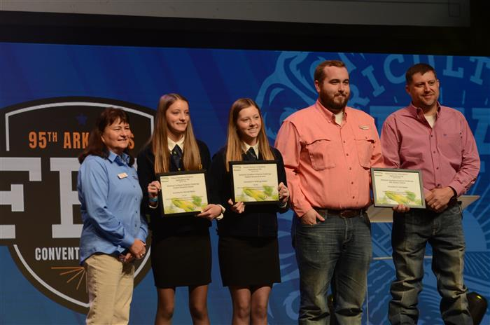
SSC Coordinator Diedre Young, FFA Agriscience Fair Senior Division SSC Winners Hadleigh and Hannah Baker with FFA Advisors Carson White and Josh Baker.

