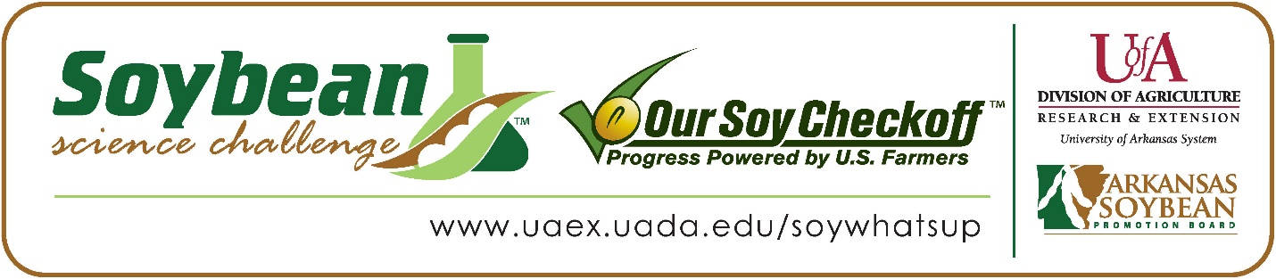

Emily Hudnall wins 2022 Arkansas Soybean Science Challenge Award at the Ouachita Mountain Regional Science and Engineering Fair
Emily Hudnall, age 18, a senior at Mountain Pine High School in Mountain Pine, Arkansas, won the Soybean Science Challenge at the 2022 Ouachita Mountain Regional Science and Engineering Fair held in Hot Springs, March 4.
Hudnall received a $300 cash award provided by the Arkansas Soybean Promotion Board. Her science project titled “Can Plants Stop Soil Erosion?” also placed first in Plant Sciences, won the National Geographic Society That's Geography Award, and the Science Champion Award from the US Agency for International Development.
Bobby Young, Hudnall’s teacher, won the $200 Soybean Science Challenge Teacher- Mentor Award. Young noted that while he has only been running a science fair for a few years, he immediately picked up on the value of the Soybean Science Challenge. “A few years ago, I attended my first regional science fair in Arkansas and learned about the Soybean Science Challenge. I thought it was an interesting initiative so when I started my local science fair, I encouraged students to participate in it,” he replied.
Emily said winning the 2022 Soybean Science Challenge was a wonderful surprise for her. “It was my first time competing and going to a science fair. There were a lot of future improvements and other ways of bettering my project. I thought I had a good project and was in decent standing with competing, but I was not expecting the outcome that happened,” she explained.
Leslie Hudnall, Emily’s mother was thrilled about her award. “I was very proud to see my daughter win this award. She works very hard for what she earns, and she deserves every bit of it. She is so dedicated to what she does. As her mother I couldn’t have been prouder of Emily,” she replied.
The part of the Soybean Science Challenge course that appealed most to Hudnall was learning about how important soybeans are. “I knew very little about soybeans. Previously I have been involved in Ag classes, and we were learning about plant science and plant biology. We slightly touched on a few of various plant species that had a major impact on agriculture in crops. Some things I remember here and there, but the Soybean Challenge has been a great review in reinstating the importance soybeans have on several leading factors - Economy, Hunger, Alternatives, by products, and others,” she explained.
Bobby Young noted how he has learned more about soybeans through his student working on the SSC online course. “I have gained a few nuggets of soybean knowledge from her. As Emily was working through the Soybean Challenge course, she would occasionally tell me something she had found interesting about soybeans and their impact on modern society,” he related.

“The Soybean Science Challenge provides an opportunity for Arkansas junior high and high school students to participate in scientific research that can impact the State of Arkansas as well as the world. Soybean Science Challenge student researchers learn about this important commodity crop and its many uses including feeding the world, development of biofuels and sustainable products. The Soybean Science Challenge helps students develop an understanding of the challenges and complexities of modern farming,” said Dr. Julie Robinson, Associate Professor and director of the program.
“The goal of the Arkansas Soybean Science Challenge is to engage students in “real- world” education to support soybean production and agricultural sustainability,” said Gary Sitzer, a former member of the Arkansas Soybean Promotion Board. “The program also rewards scientific inquiry and discovery that supports the Arkansas Soybean Industry.”
The Arkansas Soybean Science Challenge was launched in January 2014 to 9-12th grade science students. Students who successfully completed the online course were eligible to have their original soybean-related research projects judged at the 2022 ISEF-affiliated Arkansas Science and Engineering Fairs.
Information on the 2022-2023 Arkansas Soybean Science Challenge will be available in summer 2022. For more information, contact Dr. Julie Robinson at jrobinson@uada.edu or Diedre Young at dyoung@uada.edu.
The Cooperative Extension Service is part of the University of Arkansas System Division of Agriculture.

Emily Hudnall, Mountain Pine High School, Mountain Pine, Arkansas; Teacher, Bobby Young
Category: Plant Science
Project Title: Can plants stop soil erosion?
Abstract: The purpose of this experiment is to determine whether the roots of plants reduce soil erosion and if plants are a viable option to help reduce soil erosion globally. The issue of soil erosion goes further than just infertile land and flooding. Studies have shown that this can lead to rising pollution and sedimentation in streams and rivers. So, the question is does the presence of roots have an effect on slowing or stopping the process of soil erosion? Synthetic roots were placed in soil and water was added to the system after which the amount of erosion was determined per system. The results of this experiment were recorded in a lab journal to chart the amount of soil eroded. My data supports my hypothesis that soil containers with synthetic roots all reduced soil erosion in the three trials that were done. Therefore, the presence of roots does influence reducing the amount of soil erosion.

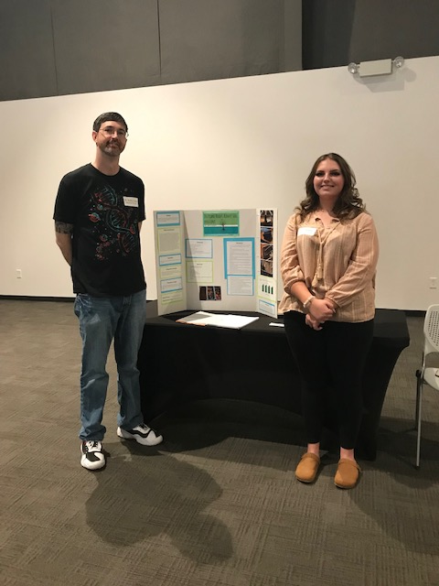

Ouachita Mountain Regional Science and Engineering Fair Senior Division Winner Emily Hudnall on the right, and Teacher-Mentor Bobby Young on the left.

