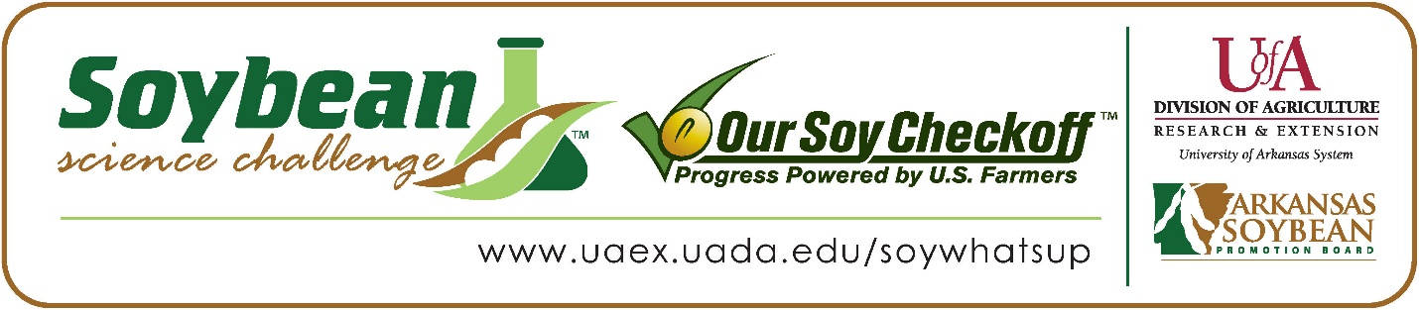
Duyen Do wins the 2024 SR Division Arkansas Soybean Science Challenge Award at the Northwest Arkansas Regional Science and Engineering Fair

Duyen Do, 18, a senior at Fayetteville Christian Academy in Fayetteville, won the Senior Division Soybean Science Challenge at the 2024 Northwest Arkansas Regional Science and Engineering Fair at the University of Arkansas-Fayetteville on March 8.
Duyen received a $300 cash award provided by the Arkansas Soybean Promotion Board. Her science project was titled “The impact of varied light cycles on soybean seed germination.”
Patrick Briney, Duyen’s teacher, won the $200 Soybean Science Challenge Teacher- Mentor Award. Briney stated that the Soybean Science Challenge is a great way to learn about soybean research. “I introduced my students to the Soybean Science Challenge to learn about science with a major producer of soybeans (the farmers of Arkansas) and to work with a scientist at the University of Arkansas in Fayetteville,” he replied.

Duyen was thrilled to win the 2024 Soybean Science Challenge. “It was such a great honor for me for this outstanding title. I was overwhelmed and could not believe my ears when my name was announced at the ceremony. This was the first time I tried in the Plant Sciences category, and I had a challenging time with my experiment. I got the seeds and started the project when it was cold and snowing outside which was not the best weather for soybeans to grow. I changed my topic several times and had to repeat the experiment over and over until several days before the fair. I was extremely focused on my project and wanted to perfect it as best as I can. I am still new to the field and trying my best to improve my skills. However, this award gave me great confidence in what I do and inspired me to challenge myself more in the future,” she explained.
Trang Do, Duyen’s parent, was surprised and happy for Duyen’s winning this award. “Duyen had not been confident about her project due to several incidents and challenges while the experiment was conducted. She thought the results could have been better, and improved, and was frustrated when she could not perfect the project like she wished. I think this award has cheered her up and granted her the confidence she lacks. This will be a huge step for her in the research field and maybe encourage her to investigate Plant Sciences for college,” he stated.
Duyen also feels that the Soybean Science Challenge is a great program for students. “I was fascinated to know how valuable soybeans are in our daily lives. Soybeans can fix nitrogen, have fiber, omega-3 fatty acids, and antioxidants that are crucial for human health. Soybeans can also become animal feed or biodiesel. There are so many benefits of soy that I didn't know about, but the course did a great job of explaining everything and how it worked. All the materials taught me in a way that was easy for me, an international student who speaks English as my second language, to understand and remember. The course went into detail about what I needed to do in terms of germinating and plating, and what the soybeans needed to have to grow up healthy. It taught me all the factors that can affect soybean growth such as light, water, oxygen. It also guided me through the steps of growing soybeans and how to properly care for them. I entered the course with minimal to no knowledge about the subject and came out with so much. I felt confident to pursue Soybeans as my subject for the Science Fair, and the course had helped me to think of a variety of different experiments that I could do,” she replied.
“The Soybean Science Challenge provides an opportunity for Arkansas junior high and high school students to participate in scientific research that can impact the State of Arkansas as well as the world. Soybean Science Challenge student researchers learn about this important commodity crop and its many uses including feeding the world, development of biofuels and sustainable products. The Soybean Science Challenge helps students develop an understanding of the challenges and complexities of modern farming,” said Dr. Julie Robinson, Professor and director of the program.
“The goal of the Arkansas Soybean Science Challenge is to engage students in “real- world” education to support soybean production and agricultural sustainability,” said Gary Sitzer, a former member of the Arkansas Soybean Promotion Board. “The program also rewards scientific inquiry and discovery that supports the Arkansas Soybean Industry.”
The Arkansas Soybean Science Challenge was launched in January 2014 to 9-12th grade science students. Students who successfully completed the online course were eligible to have their original soybean-related research projects judged at the 2024 ISEF-affiliated Arkansas Science and Engineering Fairs.
Information on the 2024-2025 Arkansas Soybean Science Challenge will be available in summer 2024. For more information, contact Dr. Julie Robinson at jrobinson@uada.edu, Diedre Young at dyoung@uada.edu, or Keith Harris at kharris@uada.edu.
The Cooperative Extension Service is part of the University of Arkansas System Division of Agriculture.
Duyen Do, Fayetteville Christian School, Fayetteville, Arkansas; Teacher, Pat Briney
Category: Plant Sciences
Title: The impact of varied light cycles on soybean seed germination.

Abstract: This study investigates the impact of life cycles on soybean germination. It was suggested that different light cycles would affect the growth rate of soybean germination due to the way soybeans utilize light to convert carbon dioxide into glucose during photosynthesis during germination. Glucose may also increase the concentration of ABA, which can increase the germination rate of soybean seeds. However, photosynthesis requires leaves and chlorophyll. It was hypothesized that seeds grown in less light would germinate faster and more successfully due to the absence of leaves on the seeds.
Three different light cycles were tested: 100% light (24 hours a day), 50% light (12 hours a day), and 0% light (germination in the dark). To ensure accuracy and reliability, each cycle was tested three times with 50 seeds used in each trial, for a total of 450 seeds. Only one variety of soybean seeds were used in the experiment. The germination process took four days, and the germination rate and growth were analyzed to determine the optimal light cycle for soybean germination.
The findings of this project indicate that seeds grown in the dark germinated at the highest rate. The 50% light was also suitable for germination but had a lower percentage of sprouted seeds than the dark cycle. Seeds grown in the 24-hour light had the least number of sprouted seeds.

