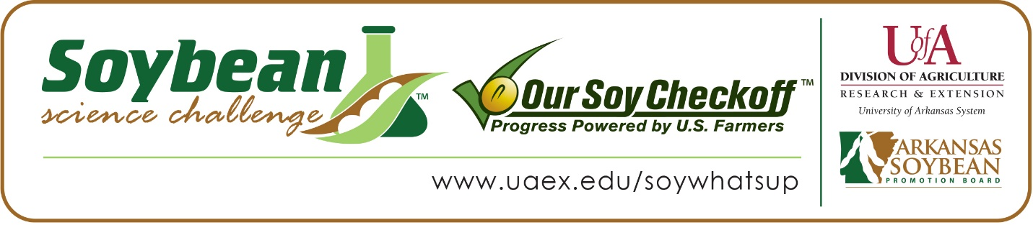

Cooper Bassham wins 2020 Arkansas Soybean Science Challenge Award at Northeast Arkansas Regional Science Fair
Cooper Bassham,18, a senior at Salem High School in Salem won the Soybean Science Challenge at the 2020 Northeast Arkansas Regional Science Fair held at Arkansas State University-Jonesboro, March 13.
Bassham received a $300 cash award provided by the Arkansas Soybean Promotion Board at the awards ceremony. His science project titled “Utilizing desk top fabricated sensors to measure transpiration rates in Glycine max” also received first place in Materials Engineering, the Office of Naval Research Award, first place overall Best of Fair, and the ISEF Finalist Award.
Bassham competed at the Virtual Arkansas State Science and Engineering Fair, April 3. Amanda Smith, Bassham’s teacher, won the $200 Soybean Science Challenge Teacher Mentor Award. Smith said the Soybean Science Challenge is a wonderful opportunity for her students. “The Soybean Science Challenge provides them with sources to help them with their project along every step of the way. I really like the spiral bound soybean science challenge science fair project booklet. I have even used it as a source for my non-agricultural students who need help with their projects,” she said.
Bassham felt especially honored to be the winner of the 2020 Soybean Science Challenge, particularly since there were so many other great projects. Cooper’s parents, Alan and Carla Bassham are very proud he won this award. “Wow! We are so proud of him for his commitment to this project. He has worked hard and continues to amaze us with his desire to learn and achieve success,” they replied.
Bassham enjoyed the Soybean Science Challenge online course. “I liked the overall design and the course was easy to follow. It helped to maximize the knowledge that I needed for my project. I found the uses of soybeans to be most interesting. I had never imagined that soybeans were in so many items that we use in our daily lives,” he said.
Smith noted that Bassham’s interest in the Soybean Science Challenge this last few years has helped him gain important knowledge in research. “Cooper actually decided to participate in the soybean challenge. He had participated last year with a plant project and after learning more about soybeans, he decided to do a project this year that could help soybean farmers. Cooper conducted a lot of research, and he learned how technology can improve farming. He used a lot of the same robotics components to measure and record that I use to teach coding in class,” she said.
Both Smith and Bassham mentioned the impact the Soybean Science Challenge has had on them. “Prior to my participation in the Soybean Science Challenge, I had very little knowledge about Arkansas soybeans and their incredibly far-reaching range of influence,” replied Bassam.
Smith had this to say about the impact of the Soybean Science Challenge. “Because of the Soybean Science Challenge, I have gained more knowledge about soybean production in Arkansas. I have a great respect for farmers in my home state that are encouraging students to participate in science fairs with agricultural type projects which benefit all of us.”
“The Soybean Science Challenge provides an opportunity for Arkansas High School students to participate in scientific research that can impact the State of Arkansas as well as the world. Soybean Science Challenge student researchers learn about this important commodity crop and its many uses including feeding the world, development of biofuels and sustainable products. The Soybean Science Challenge helps students develop an understanding of the challenges and complexities of modern farming,” said Dr. Julie Robinson, Associate Professor and director of the program.
“The goal of the Arkansas Soybean Science Challenge is to engage students in “real world” education to support soybean production and agricultural sustainability’” said Gary Sitzer, a former member of the Arkansas Soybean Promotion Board. “The program also rewards scientific inquiry and discovery that supports the Arkansas Soybean Industry.”
The Arkansas Soybean Science Challenge was launched in January 2014 to 9-12th grade science students. Students who successfully completed the online course were eligible to have their original soybean-related research projects judged at the 2020 ISEF-affiliated Arkansas Science and Engineering Fairs.
Information on the 2020-2021 Arkansas Soybean Science Challenge will be available in summer 2020. For more information, contact Dr. Julie Robinson at jrobinson@uaex.edu or Diedre Young at dyoung@uaex.edu.
The Cooperative Extension Service is part of the University of Arkansas System Division of Agriculture

Cooper Bassham, Salem High School, Salem, AR – Teacher: Amanda Smith
Category: Materials Engineering
Project Title: Utilizing desk top fabricated sensors to measure transpiration rates in Glycine max
Abstract:
Purpose: the focus of this experiment was to find a more cost effective and accurate method for analyzing transpiration rates in soybeans (Glycine max). By using three-dimensional printing technology and low-cost electrical components, the data collection process will become much cheaper and less labor intensive.
Method: An Arduino board was attached to three probes, each consisting of thermocouple wire. These probes were inserted into soybean stems and a system was designed to deliver a heat pulse at regular intervals, then recorded the time it took for the pulse to reach a heat detection probe. This time frame over a known distance is how the transpiration measurements are taken.
Data: The field data recorded between April 8, 2019 and May 30, 2019 utilizing the eddy covariance method indicated that the average hourly transpiration rate was 0.14 mm/hour and the average daily transpiration rate was 3.27 mm/day. Hummingbird Arduino records temperature.
Conclusion: The results of this study are intended to increase the sample size of individual measurements, creating an overall more accurate view of a region’s irrigation requirements rather than small, representative samples of the entire area’s requirements and therefore increase aquifer conservation and economic returns. The results of this study on the plant scale will inform field scale evapotranspiration rates in the region. Testing has revealed that the sensors do indeed record transpiration, supporting my hypothesis that a partially 3D printed sensor is a contender for a less expensive yet practical transpiration measurement method.
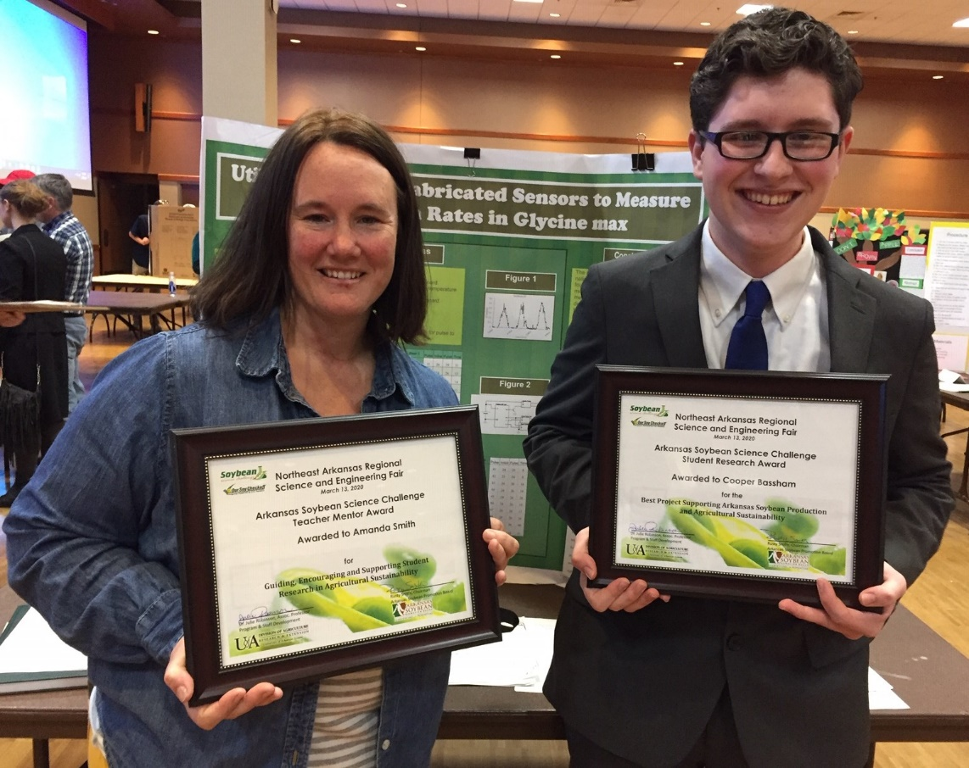
2020 Northeast Arkansas Regional Science and Engineering Fair Soybean Science Challenge Winner Cooper Bassham and Teacher Mentor Amanda Smith.

