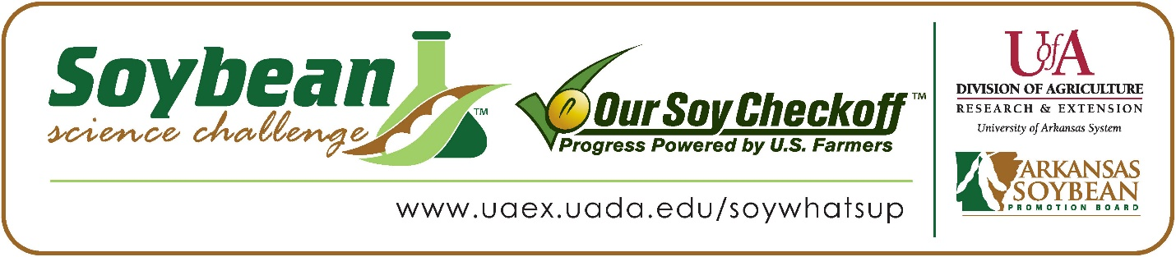
Evelyn Clark and Agustin Rosso win the 2026 Arkansas Soybean Science Challenge Junior Division Award at the Northwest Arkansas Regional Science and Engineering Fair
Evelyn Clark and Agustin Rosso, age 14, 8th graders at St. Vincent De Paul Catholic School, Rogers, AR, won the Soybean Science Challenge Junior Division award at the 2026 Northwest Arkansas Regional Science Fair held at UofA Fayetteville on March 6.
Clark and Rosso will split the $200 cash award provided by the Arkansas Soybean Promotion Board. Their science project titled ‘Fuel for the Future’ also placed first in Mathematics.
Sean Grom, Clark and Rosso’s teacher, won the $100 Soybean Science Challenge Junior Division Teacher-Mentor Award. Grom stated that the Soybean Science Challenge is a great way to learn about agriculture today. “As a science teacher in Arkansas, I wanted my students to experience how science connects to real-world agriculture. The Soybean Science Challenge was a great opportunity for them to explore the science behind one of our state’s most important crops while practicing inquiry and problem-solving,” she replied.
Clark was thrilled to win the 2026 Junior Division Soybean Science Challenge. “It felt unreal. They called my partner’s name and my entire school started cheering. I felt bad for my classmates because they had worked so hard, but I also felt so elated,” Clark stated. Rosso simply enjoyed the competition. “It was fun to compete against my friends, especially since I won,” he stated.
The part of the Soybean Science Challenge Online Course Clark and Rosso liked the best was the use of soybeans for fuel. “It gave us more information on why soybeans are the most efficient for biodiesel,” they replied.
Allison Clark, Evelyn’s mother, and Araceli Keen, Agustin Rosso’s mother, were thrilled to see them win. “I was so happy for them. They worked so hard and spent many hours on their project. What a joy to be there when they reached the goal of winning first place,” Allison Clark explained. Araceli Keen agreed. “I was very proud of them. They put a lot of effort into the project and worked very hard on it,” she replied.
“The Soybean Science Challenge provides an opportunity for Arkansas junior high and high school students to participate in scientific research that can impact the State of Arkansas as well as the world. Soybean Science Challenge student researchers learn about this important commodity crop and its many uses including feeding the world, development of biofuels and sustainable products. The Soybean Science Challenge helps students develop an understanding of the challenges and complexities of modern farming,” said Dr. Julie Robinson, Professor, and director of the program.
“The goal of the Arkansas Soybean Science Challenge is to engage students in “real- world” education to support soybean production and agricultural sustainability,” said Gary Sitzer, a former member of the Arkansas Soybean Promotion Board. “The program also rewards scientific inquiry and discovery that supports the Arkansas Soybean Industry.”
The Arkansas Soybean Science Challenge was launched in January 2014 for 9-12th grade science students and in 2021, added grades 6-8 for the Junior level award. Students who successfully completed the online course were eligible to have their original soybean-related research projects judged at the 2026 ISEF-affiliated Arkansas Science and Engineering Fairs.
Information on the 2026-2027 Arkansas Soybean Science Challenge will be available in summer 2026. For more information, contact Dr. Julie Robinson at jrobinson@uada.edu or Keith Harris at krharris@uada.edu, or Diedre Young at dyoung@uada.edu.
The Cooperative Extension Service is part of the University of Arkansas Division of Agriculture.
Evelyn Clark and Agustin Rosso - St. Vincent De Paul Catholic School, Rogers, Arkansas
Teacher: Sean Grom
Category: Mathematical Sciences
Title: Fuel for the future
Abstract: This experiment tested how changing the molar ratio of methanol to soybean oil affects biodiesel yield. Biodiesel was produced using soybean oil, methanol, and sodium hydroxide in a chemical reaction that separates glycerol from the fuel product. The hypothesis stated that a 6:1 molar ratio of methanol to soybean oil would produce the greatest yield because it uses less methanol and is commonly recommended for biodiesel production. In each trial, 360 mL of soybean oil was heated to about 55°C. Sodium hydroxide was dissolved in different amounts of methanol (90 mL, 104.3 mL, and 122 mL) and then mixed with the heated oil. The mixture was stirred for fifteen minutes and then allowed to settle overnight so the biodiesel and glycerol layers could separate. The biodiesel layer was removed and measured. Each molar ratio was tested three times, and the average yield was compared using a bar graph. The results showed that the 8:1 molar ratio produced the highest average yield, which did not support the hypothesis. The higher amount of methanol helped more of the soybean oil fully react, increasing the amount of biodiesel produced. These results suggest that slightly increasing the methanol ratio can improve biodiesel yield. Future experiments could test even higher ratios and measure fuel purity to determine the most cost-effective method for biodiesel production.

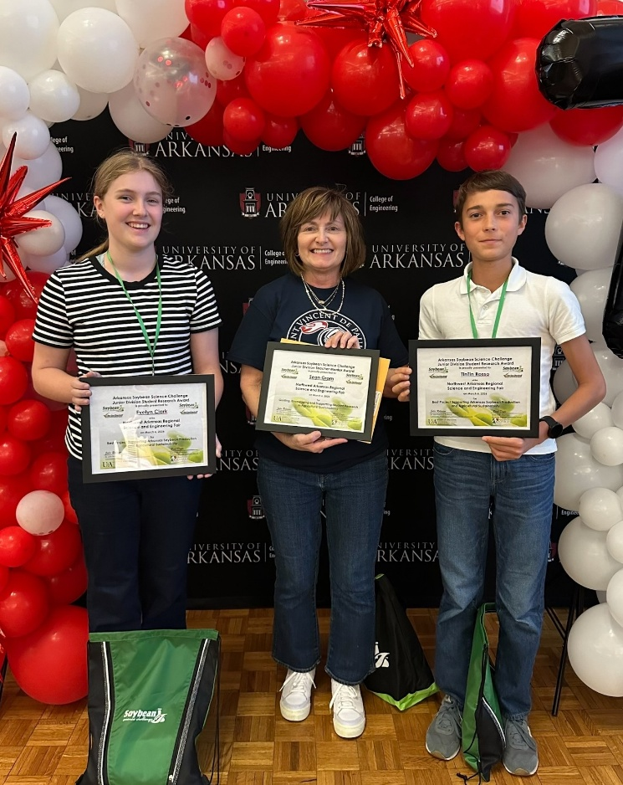

Northwest Arkansas Regional Science Fair Junior Division winners Evelyn Clark and Agustin Rosso, and teacher-mentor, Sean Grom

