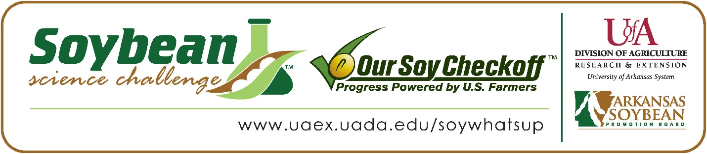

**Charis Xiong and Amanda Navarro win 2023 Arkansas Soybean Science Challenge Award at ASMSA-West Central Arkansas Science Fair**

Charis Xiong and Amanda Navarro age 17, seniors at Arkansas School for Mathematics, Sciences, and the Arts (ASMSA) in Hot Springs won the Soybean Science Challenge at the 2023 West Central Science Fair held at ASMSA, February 24.

Xiong and Navarro split the $300 cash award provided by the Arkansas Soybean Promotion Board at the awards ceremony. Their science fair project titled “Development of a novel AI Soybean Root-Knot Nematode stress assessment model in soybean plants (field and home grown)” also received first place in Plant Science, placed sixth overall, and are ISEF Finalists.

Nicholas Seward, Xiong and Navarro’s teacher, won the $200 Soybean Science Challenge Teacher Mentor Award. He believes the Soybean Science Challenge is a wonderful chance for students to learn about soybeans. “Not being a plant scientist, I am new to soybean science. I am continually amazed by the number of applications from the beans and their byproducts.  It was great to watch my students focus on keeping them healthy during cultivation” he replied.

Charis and Amanda were thrilled that their project was chosen to win the Soybean Science Challenge. “We were very honored and excited when our project was chosen to win the Soybean Science Challenge at ASMSA. Our hard work in learning more about soybeans and root-knot nematodes (RKN), growing Conventional Soybean plants for home-grown data, and visiting actual soybean fields with RKN infestation felt like it took the first step in introducing deep learning algorithms to potential problems in the soybean industry in Arkansas.” They explained.

Charis’ parent Lin Xie, and Amanda’s parents, Mr. and Mrs. Navarro were excited that Charis and Amanda won the Soybean Science Challenge Award. “I was proud of my daughter for winning the award with her partner, as she mentioned to me the workload and research that she has put into developing her science fair project concerning building a NASRKNSA model to detect RKN stress in soybean plants. My daughter’s diligence in research, hardworking nature, and desire to help improve the world little by little has shown throughout this project.” Lin stated. The Navarro’s’ said they were happy and proud of Amanda’s accomplishments.

The part of the Soybean Science Challenge course that appealed most to Charis was learning about the many uses of soybeans, especially Biodiesel. “I think that learning about the various usages of soybeans in industries like the biodiesel process (very clean and bio-degradable), grazing food, and other usages. really put things into perspective for me on the importance of increasing the yield of soybeans around Arkansas and the world. Soybeans are more influential than I realized, and by trying to tackle a relevant problem to soybeans, I hoped that I could help increase that sustainability,” she stated. Amanda liked the videos and interactive activities. “I enjoyed being able to engage myself in what I’m learning and found these very helpful toward my learning experience.” She replied.

“The Soybean Science Challenge provides an opportunity for Arkansas High School students to participate in scientific research that can impact the state of Arkansas as well as the world. Soybean Science Challenge student researchers learn about this important commodity crop and its many uses including feeding the world, development of biofuels and sustainable products. The Soybean Science Challenge helps students develop an understanding of the challenges and complexities of modern farming,” said Dr. Julie Robinson, Associate Professor and director of the program.

“The goal of the Arkansas Soybean Science Challenge is to engage students in “real world” education to support soybean production and agricultural sustainability’” said Gary Sitzer a former member of the Arkansas Soybean Promotion Board. “The program also rewards scientific inquiry and discovery that supports the Arkansas Soybean Industry.”

The Arkansas Soybean Science Challenge was launched in January 2014 to 9-12th grade science students. Students who successfully completed the online course were eligible to have their original soybean-related research projects judged at the 2023 ISEF-affiliated Arkansas Science and engineering fairs.

Information on the 2023-2024 Arkansas Soybean Science Challenge will be available in summer 2023. For more information, contact Dr. Julie Robinson at [jrobinson@uada.edu](mailto:jrobinson@uada.edu) or Diedre Young at [dyoung@uada.edu](mailto:dyoung@uada.edu).

The Cooperative Extension Service is part of the University of Arkansas System Division of Agriculture.

**Charis Xiong and Amanda Navarro, Arkansas School for Mathematics, Science and the Arts, Hot Springs, AR. Teacher-Nicholas Seward**

**Category: Plant Science**

**Project Title: Development of a novel AI Soybean Root-Knot Nematode stress assessment model in soybean plants (field and home grown).**

**Abstract:**

Southern Root-Knot Nematodes (Meloidogyne incognita) are microscopic roundworms that act as parasites, causing devastating crop damage worldwide. These parasites primarily target the roots of soybeans and other plants, especially in most soybean-producing counties in Arkansas with possible grain yield losses as significant (>75%) with a high population of Southern Root-Knot Nematodes (SRKN). The variety of soybean, Conventional Soybeans, were planted in potting pots, to minimize nematode damage, with and without the nematodes and photographed throughout the growing season to see the effects of the infection. Infected and non-infected soybean plant data were collected from both field and home-grown plants, ensuring proper identification with similar growing conditions. The data, consisting of pictures taken every few days, was processed in Google Colaboratory and placed into a student-built Convolutional Neural Network to see if a computer could recognize and classify soybean plants infected with SRKN from those without the disease. It was hypothesized that an NASRKNSA model could quickly and more accurately detect early signs of nematode infection in soybean plants than the current detection process with photographic data of infected and non-infected soybean plants. The NASRKNSA model was able to achieve an average mean score above 50%, showing that infected plants can be identified, not far from real-time. This study showed that the NASRKNSA model has potential to detect soybean plants infected with Root-Knot Nematodes more efficiently, indicating that the usage of this model in real-time could help soybean farmers potentially avoid major crop losses earlier on.

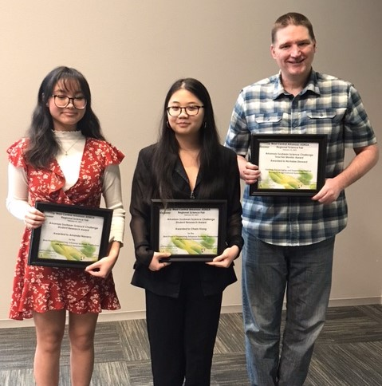

ASMSA West Central Arkansas Science Fair Soybean Science Challenge winners Amanda Navarro and Charis Xiong, and Teacher-Mentor Nicholas Seward.