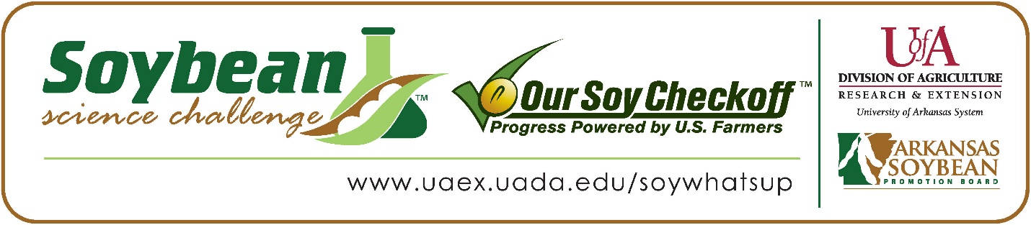

Cameryn Berryhill wins 2022 Arkansas Soybean Science Challenge Honorable Mention Award at the Southwestern Energy Arkansas State Science and Engineering Fair
Cameryn Berryhill, 17, a senior at Arkansas School for Mathematics, Science and the Arts, in Hot Springs, Arkansas, won the 2022 Soybean Science Challenge Honorable Mention Award at the Southwestern Energy Arkansas State Science and Engineering Fair April 1.
Berryhill received a $250 cash award for her SSC Honorable Mention finish at State. The award was provided by the Arkansas Soybean Promotion Board. Her science project title was “Using stream bacteria to promote soybean growth.” Berryhill also placed first in Microbiology and won the Stockholm Junior Water Prize at the West Central Arkansas Regional Science Fair.

Dr. Lindsey Waddell, Cameryn’s teacher, won the $100 State Soybean Science Challenge Honorable Mention Teacher-Mentor Award. Waddell stated that the Soybean Science Challenge course and resources are very applicable to teaching science in the classroom. “As an environmental science instructor, I would say soybean research is very relevant. Soy factors into a lot of discussions including food supply, sustainable agriculture, soil fertility, and other areas. They are also so easy and fast to grow compared to many other plants, which makes them perfect for use in student experiments,” she replied.

Cameryn was surprised and thrilled to receive Honorable Mention in the State Soybean Science Challenge. “I thought it was crazy at all the stuff I got for receiving honorable mention, and it was great my project received recognition,” she exclaimed.
Cameryn’s father, John Berryhill, was proud to see her receive the award.
Cameryn acknowledged she really enjoyed the online course. “I thought it was interesting to learn about the current state of soybean farming since I was aiming to do my project on soybean growth. I thought the section about soybeans as a biofuel was interesting, and the final module about soybean research was the most useful,” she stated.

“The Soybean Science Challenge provides an opportunity for Arkansas junior high and high school students to participate in scientific research that can impact the State of Arkansas as well as the world. Soybean Science Challenge student researchers learn about this important commodity crop and its many uses including feeding the world, development of biofuels and sustainable products. The Soybean Science Challenge helps students develop an understanding of the challenges and complexities of modern farming,” said Dr. Julie Robinson, Associate Professor and director of the program.
“The goal of the Arkansas Soybean Science Challenge is to engage students in “real- world” education to support soybean production and agricultural sustainability,” said Gary Sitzer, a former member of the Arkansas Soybean Promotion Board. “The program also rewards scientific inquiry and discovery that supports the Arkansas soybean industry.”
The Arkansas Soybean Science Challenge was launched in January 2014 to 9-12th grade science students. Students who successfully completed the online course were eligible to have their original soybean-related research projects judged at the 2022 ISEF-affiliated Arkansas Science and Engineering Fairs.
Information on the 2022-2023 Arkansas Soybean Science Challenge will be available in summer 2022. For more information, contact Dr. Julie Robinson at jrobinson@uada.edu or Diedre Young at dyoung@uada.edu.
The Cooperative Extension Service is part of the University of Arkansas System Division of Agriculture.

Cameryn Berryhill, Arkansas School of Mathematics, Science and the Arts; Hot Springs, Arkansas; Teacher, Dr. Lindsey Waddell
Category: Microbiology
Title: Using stream bacteria to promote soybean growth
Abstract:
As the world’s population steadily grows, agricultural innovations are becoming more necessary to meet food demand. Unlike increasing the use of pesticides that are hazardous to human health and synthetic fertilizers that produce harmful nutrient runoff, developments in the field of biotechnology have the potential to increase yields without damaging the environment. One form of biotechnology that has recently gained popularity is the use of plant growth promoting (PGP) bacteria. These bacteria are in abundance in both soil and water, and have many different mechanisms through which they benefit plants, such as through the production of the plant growth hormone indoleacetic acid (IAA). This project aimed to determine if aquatic bacteria found in Hot Springs, Arkansas, could promote the growth of soybeans, an extremely important agricultural product in the state. Through the use of Salkowski’s reagent, microorganisms sampled from three streams were qualitatively tested for production of IAA. Soybean seeds and soil were then primed with no bacteria or bacteria that produced high, low, or no IAA. Soybeans that were primed with non-IAA producing bacteria showed significantly longer roots than the control, as well as significantly greater shoot height and growth rate than the other experimental groups. The results did not support the hypothesis that IAA producing bacteria would significantly promote growth, but show the importance of further experimentation to determine the mechanisms through which growth was promoted. Identification of the bacteria could also have commercial uses, as there are a limited number of PGP microorganisms on the market today.
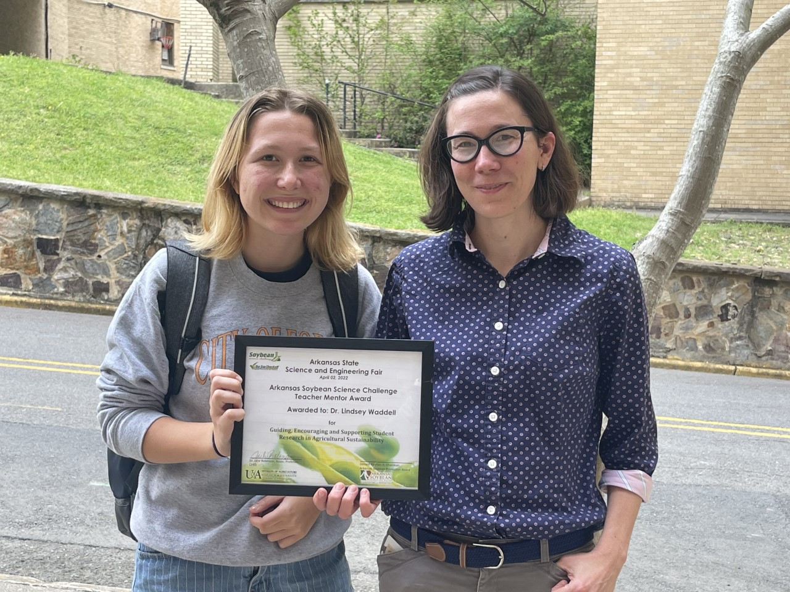
State Science Fair Honorable Mention Winner Cameryn Berryhill with Teacher-Mentor Dr. Lindsey Waddell

